DROUGHT MONITORING TASK FORCE
Drought Status Report
June 23, 2008

Statewide precipitation for the previous water year (October 1, 2006 through September 30, 2007) was below normal (81% of normal). Statewide precipitation for the period from October 1, 2006 through June 20, 2008 was below normal (82% of normal). Statewide precipitation for the period from January 1, 2008 through June 20, 2008 is in the normal range (88% of normal). Precipitation greater than 85% of normal is considered to be in the normal range. The period from June 1 through June 20 was characterized by very dry conditions in areas in the southern portion of the Commonwealth (south of Interstate 64) and resulted in below normal statewide precipitation (76% of normal). The following drought evaluation regions are currently below normal for the period beginning October 1, 2006; Big Sandy (73%), New River (78%), Roanoke (78%), Upper James (81%), Northern Piedmont (81%), Northern Coastal Plain (83%) and York-James (84%). Cumulative precipitation deficits for the period beginning October 1, 2006 increased slightly percentage points across the Commonwealth since the last report. The Middle James, Shenandoah, Northern Virginia, Chowan, Southeast Virginia and Eastern Shore drought evaluation areas currently are in the normal range of precipitation for this extended period. Appendix A contains precipitation tables for periods dating to October 1, 2006. The long-range monthly climatologic outlook calls for equal chances of below normal, normal and above normal precipitation and temperatures for the Commonwealth through July of 2008. The long-range seasonal outlook calls for equal chances of below normal, normal and above normal precipitation for the Commonwealth through September 2008. The long range seasonal outlooks calls for above normal temperatures in the eastern two thirds of the Commonwealth and for equal chances of below normal, normal and above normal temperatures for the western third of the Commonwealth through September 2008

The latest NOAA drought monitor indicates intensification of drought conditions in the western and southern portions of the Commonwealth during the last month and is included as Appendix B. Appendix C contains information from the national drought monitor with only Virginia displayed. Currently almost 25% of the Commonwealth is experiencing drought conditions, a three fold increase since May 19. The NOAA seasonal drought outlook through September 2008 indicates that drought conditions are likely to persist in southwest Virginia. The seasonal drought outlook is included as Appendix D.

Seven day average streamflows for June 21 are below normal in the majority of the Commonwealth. Areas in the New, upper Roanoke, and Chowan river basins are exhibiting flows indicative of severe drought conditions (< 5th percentile). While drought monitoring ground water levels data is scarce, ground water levels are generally in the lower range of expected water levels in areas east of Route 95 and are generally lower than normal in the area west of Route 95. Ten dedicated drought monitoring wells are at levels indicative of normal ground water levels, seven are at levels indicative of moderate hydrologic drought (10th to 24th percentiles), and two are at levels indicative of severe hydrologic drought conditions (< 10th percentile) . Ground water levels in the vast majority of dedicated monitoring wells have shown decreases in water levels in the last month due to a relatively short period of very high temperatures and low precipitation. Levels of most large reservoirs have remained near normal over the last month but inflows have dropped significantly, especially for those reservoirs located in the western half of the Commonwealth.

While the Virginia Department of Health has not reported any impacts to public water supplies that have compromised their ability to provide the needs of their customers’ 22 systems remain on voluntary water conservation requirements and 4 systems remain on mandatory water conservation requirements. Appendix E contains a table of waterworks that includes systems that have initiated water conservation requirements.

The Department of Forestry reports that increasing drought intensity has resulted in an increase in the number of lighting caused wildfires over the last two weeks. Since the beginning of the second week of June, the agency has responded to 34 wildfires which have burned just over 900 acres. The agency has also provided assistance to 7 other significant fires on federal lands in Virginia, all caused by lightning. Although lightning is normally only responsible for around 1 % of the wildfires in Virginia in a given year, dry forest fuel conditions caused by an extended period of less than normal rainfall makes conditions much more favorable for lightning caused wildfires. The agency expects this trend to continue until significant rainfall can return fuel moisture levels into the normal ranges. Statewide, Keetch-Byram drought indices (KBDI) as measured at the agency’s six regional offices range from 277 to 530. The normal range for this time of year is in the 100 - 200 range. In rough terms, it takes about one inch of rainfall to lower the index by 100 points. The agency is fully prepared to respond to the developing summertime fire situation in the Commonwealth and is not expecting a significant change in the current situation anytime in the near future.

The Virginia Department of Game and Inland Fisheries reports that all boating access facilities are open with the exception of those where maintenance and repairs are underway (check web-site at www.dgif.virginia.gov ). River flows across the Commonwealth are varied however the larger rivers remain available for recreational users and reservoir levels remain stable. The trout stocking program suffered from low flows in 2007 that resulted in smaller and fewer fish produced at the Department's hatcheries. The spring 2008 rainfall events provided good flows for stocking and fishing, and the hatcheries are in full production with next years fish (Coursey Springs Hatchery is closed for renovations through 2008). Additional rainfall events in the near future are needed to insure continued recreation and fish production through the summer. Current stream flows in several river basins are slightly below normal with rivers in the far southwestern part of the Commonwealth particularly impacted. Many boaters and anglers are choosing to stay closer to home for their recreation this summer, and areas near population centers are being heavily utilized while recreation is down in rural areas and "destination" locations.

The intensity of drought impacts has increased during the last month due to a relatively short period of record high temperatures coupled with below normal rainfall. The lower than normal ground water levels, especially in the western portions of the Commonwealth, have resulted in very rapid decreases in streamflows. These below normal streamflows raise concerns regarding future reservoir conditions, especially in the western half of the Commonwealth. It should also be noted that the areas that are currently experiencing drought conditions in western Virginia are the same areas that experienced the greatest agricultural drought impacts last year. It is important to remember that localized drought impacts, particularly agricultural drought impacts, are a normal occurrence in an “average” Virginia summer.

Reports from the Climatology Office of the University of Virginia, the National Weather Service, the Virginia Department of Agriculture and Consumer Services, the Virginia Department of Environmental Quality, and the United States Geological Survey follow.

Report of the Climatology Office of the University of Virginia

As expected for this time of year, the last thirty days have seen widely varying amounts of precipitation across the Commonwealth. This is the nature of rainfall from thunderstorm activity, which usually proves to be the most common rainfall source during the summer. Even in cases where the thunderstorm activity is formed into organized lines (as has been experienced earlier this month), these rarely sweep across the entire state and rainfall totals from embedded storms can cover a large range of values.

Coupling this uncertain rainfall pattern with the seasonally high rates of evaporation and transpiration (water consumption by plants), a complex pattern of rainfall deficit or surplus can emerge even within a given Drought Evaluation Region. If rainfall amounts and temperatures were both normal across all regions, a considerable net loss of moisture would still occur during the summer. As such, the prospects of sufficient rainfall to penetrate past topsoil layers before being lost are poor. Groundwater reserves are not be expected to receive widespread replenishment until the end of the growing season.

Early June was marked by a period of high temperatures rarely seen so early in the year. This contributed to increased evapo-transpiration. Although not necessarily linked by identifiable atmospheric processes, there is a statistical tendancy for such early extremes to be reflected in temperature averages for the remainder of the summer. The longer-range outlooks (through September) from NOAA suggest temperatures somewhat above normal, but give little useful guidance regarding precipitation.

As the summer progresses, there is an increasing likelihood that tropical cyclone activity will bring precipitation to the Commonwealth. Since this hurricane season is forecast to be more active than average, tropical systems (or their remnants) may yet be an important factor in summer water availability.

Report of the National Weather Service

The 6-10 day and 8-14 day outlooks both suggest the potential for above normal precipitation. Any potential benefits from additional precipitation will probably be counteracted by predicted above normal temperatures in the same time periods. During the last 30 days areas along and north if Interstate 64 have fared much better than areas south of this region. Several areas of thunderstorms have moved across this area, providing enough rain to at least maintain the status quo from May. However, the southern 1/3 to 1/4 of VA has missed much of this rainfall, and conditions have dried significantly. At present, the mid and long term forecast do not suggest a trend toward wetter conditions, with the 30 to 90 day outlooks showing no trend toward either drier than, wetter than or near normal conditions. Should the trends of the last 3-4 weeks persist, conditions in southern Virginia are expected to deteriorate significantly over the next 30 days, as even normal rainfall would result in a moisture deficit due to high seasonal evapo-transpiration rates. It should be noted that longer term precipitation forecasts tend to have very high errors, so an error on the wet side is certainly possible, especially if any tropical influence occurs.

Virginia Department of Agriculture and Consumer Services
Status of Agricultural Drought

According to the USDA Crop Weather Report released on June 16, 2008, 92% of topsoil moisture ranged from adequate to surplus. Despite scattered showers this week, most of Virginia continued to suffer from drought stress. Early May produced adequate rainfall for planting and establishment of new crops. However, the unusually warm weather near the end of May and the extreme heat over the last few weeks have caused considerable concern for the new crops. Corn is perhaps the crop most in need of rainfall. The corn crop improved slightly in areas that experienced the recent light showers. However, twisting and drought stress has slowed growth. Pastures in the Southeastern portions of the state are also very dry. While recent weather has been perfect for wheat harvesting, many growers are very concerned that without rainfall in the next few days we could see another year of significant agricultural drought issues. The quality of hay not yet cut diminished due to the heat and lack of water. Most of the full season soybeans are planted.

Impact on the Dairy Industry
Many dairymen did not fertilize hay crops as much as usual because of the very high prices for nitrogen and potash. In cases where adequate fertilizer was used, spring hay crop yield was above normal.

Impact on Crops
South Central Virginia: Even though there have been some scattered thundershowers in the region during the past few days, the overall soil moisture condition is dry. Crop conditions have not been negatively affected to a great degree to this point. The tobacco crop is probably in average condition for this time of year, although a few growers have started to irrigate. The spring hay crop yielded well. Wheat harvest is underway with good yields being reported. Planting of double crop soybeans following wheat harvest could be negatively affected if reasonable rainfall is not received.
Southwest Virginia: The recent rains in Southwestern Virginia have helped ease the current situation but producers are hopeful that cooler temperatures and more moisture is on the way. The first cuttings of hay have been of good quality and yields.
Wheat crops: The wheat crop looks very good as harvest has just begun. Dry conditions throughout harvest would be ideal as the test weight would remain high. Rainy conditions now could drive test weights down leading to price discounts for producers.

Impact on Streams and Wells
Recent rains temporarily swelled small streams, creeks and rivers, but water levels quickly returned to below normal indicating low ground water levels. Southwest Virginia producers report that creeks and rivers are lower than they were late last summer.

Waivers for Hauling of Emergency Supplies Extended
Temporary waivers of registration and license requirements along with normal weight and width restrictions for carriers transporting emergency supplies of hay or animal feed expired on June 15, 2008

Virginia Department of Environmental Quality
Condition of Major Reservoirs

Although overall most major reservoirs are full or near full, inflows are declining precipitously in the south central and south west part of the state. Water levels are starting to fall at rates that are cause for concern this early in the summer.
The watershed of Smith Mountain Lake is probably the driest basin in the state at the current time. Although the lake is only 10 inches below full pond, it is falling at a rate of half a foot every 10 days. A stakeholder’s conference call on lake and river levels was held on June 19, 2008 to discuss the situation. No action was taken other than to set a meeting again on June 30, 2008. Further upstream in the very dry Roanoke River watershed, Carvins Cove and Spring Hollow Reservoirs, the water supply for much of the Roanoke area, are at 84 and 87 per cent of useable storage capacity, respectively, which is adequate for this time of year but represents a notable decrease in storage over the last thirty days.
Philpott Lake, also in the driest part of the State, is 1.4 feet below the guide curve at the start of the recreation season. This lake will continue to Fall below the guide curve unless the Corps of Engineers decides to intervene and reduce power production from this project. Kerr Reservoir has fallen two feet so far this month but is still about 0.4 feet above guide curve. The release decision is made on a weekly basis following discussions with a drought monitoring work group.
Further north in the State things are better, Lake Anna is full. The Lake Moomaw project in the headwaters of the James is 93% full. The often vulnerable Rivanna Water and Sewer Authority system is 99% full.

United States Geological Survey
Streamflow and Ground Water Levels

Stream gages in the northeast portion of the State (Shenandoah, Potomac, Rappahannock, and York River Basins) are recording flow the normal range for statistics based on historic June flows. Above normal precipitation in May and continued precipitation from thunderstorms associated with frontal passages in the northern half of the State in June have kept streamflows in the normal to above normal range for most of the month.

Stream gages in the remainder of the State are recording flows in the below normal and well below normal ranges. Streamflows are statistically lowest in the Roanoke and Kanawha River Basins. Graphs of current flow conditions plotted over flow-duration statistics show flow recessions that are steeper than normal at gages in these two basins. The rapid recessions of streamflow indicate that ground-water storage in these areas is low. Precipitation from thunderstorms in these areas has been scattered.

Ground-water wells in the southern half of the State generally show levels well below normal while wells in the northern half of the State generally show levels in the normal range.

Streamflow conditions based on daily values for June 22 are presented in Appendix F. Area summaries of 7-day average streamflows from the USGS drought watch web page show similar flow conditions and are presented in Appendix G. Current conditions are generally higher than depicted by seven day average stream flows as flows continue to increase due to the recent significant precipitation events. Ground water levels based on conditions on June 22 are presented in Appendix H.

APPENDIX A

Precipitation departures by Drought Evaluation Region.
 | PRELIMINARY PRECIPITATION SUMMARY |  |  |  | Prepared:
 |  |  |  |  | 06/22/08
 | DROUGHT |  | Jun 1, 2008 | - Jun 20, 2008
 | REGION | OBSERVED | NORMAL | DEPARTURE | % OF NORM.
1 | Big Sandy | 1.68 | 2.76 | -1.08 | 61%
2 | New River | 1.21 | 2.57 | -1.35 | 47%
3 | Roanoke | 0.91 | 2.59 | -1.69 | 35%
4 | Upper James | 1.49 | 2.47 | -0.98 | 60%
5 | Middle James | 1.34 | 2.34 | -1.00 | 57%
6 | Shenandoah | 2.78 | 2.47 | 0.30 | 112%
7 | Northern Virginia | 4.15 | 2.57 | 1.58 | 161%
8 | Northern Piedmont | 4.62 | 2.67 | 1.95 | 173%
9 | Chowan | 0.63 | 2.43 | -1.80 | 26%
10 | Northern Coastal Plain | 3.45 | 2.37 | 1.08 | 145%
11 | York-James | 1.25 | 2.27 | -1.03 | 55%
12 | Southeast Virginia | 1.53 | 2.41 | -0.88 | 63%
13 | Eastern Shore | 3.34 | 1.99 | 1.36 | 168%
 | Statewide | 1.93 | 2.53 | -0.60 | 76%
 | DROUGHT |  | May 1, 2008 | - Jun 20, 2008
 | REGION | OBSERVED | NORMAL | DEPARTURE | % OF NORM.
1 | Big Sandy | 4.93 | 7.58 | -2.65 | 65%
2 | New River | 4.32 | 6.78 | -2.45 | 64%
3 | Roanoke | 5.47 | 6.92 | -1.45 | 79%
4 | Upper James | 4.57 | 6.75 | -2.18 | 68%
5 | Middle James | 6.72 | 6.58 | 0.14 | 102%
6 | Shenandoah | 6.19 | 6.31 | -0.12 | 98%
7 | Northern Virginia | 10.92 | 6.91 | 4.01 | 158%
8 | Northern Piedmont | 8.02 | 6.89 | 1.12 | 116%
9 | Chowan | 6.34 | 6.52 | -0.18 | 97%
10 | Northern Coastal Plain | 8.57 | 6.53 | 2.04 | 131%
11 | York-James | 6.11 | 6.54 | -0.43 | 93%
12 | Southeast Virginia | 7.64 | 6.27 | 1.37 | 122%
13 | Eastern Shore | 7.33 | 5.51 | 1.83 | 133%
 | Statewide | 6.38 | 6.79 | -0.41 | 94%

 | DROUGHT |  | Apr 1, 2008 | - Jun 20, 2008
 | REGION | OBSERVED | NORMAL | DEPARTURE | % OF NORM.
1 | Big Sandy | 9.15 | 11.34 | -2.19 | 81%
2 | New River | 9.02 | 10.33 | -1.30 | 87%
3 | Roanoke | 10.71 | 10.72 | -0.02 | 100%
4 | Upper James | 9.30 | 10.15 | -0.86 | 92%
5 | Middle James | 12.63 | 9.92 | 2.71 | 127%
6 | Shenandoah | 11.28 | 9.23 | 2.04 | 122%
7 | Northern Virginia | 16.96 | 10.21 | 6.74 | 166%
8 | Northern Piedmont | 13.59 | 10.18 | 3.40 | 133%
9 | Chowan | 12.78 | 9.95 | 2.82 | 128%
10 | Northern Coastal Plain | 12.84 | 9.62 | 3.22 | 133%
11 | York-James | 12.85 | 9.84 | 3.01 | 131%
12 | Southeast Virginia | 14.11 | 9.52 | 4.59 | 148%
13 | Eastern Shore | 11.68 | 8.43 | 3.25 | 139%
 | Statewide | 11.69 | 10.21 | 1.48 | 115%
 | DROUGHT |  | Mar 1, 2008 | - Jun 20, 2008
 | REGION | OBSERVED | NORMAL | DEPARTURE | % OF NORM.
1 | Big Sandy | 12.95 | 15.59 | -2.64 | 83%
2 | New River | 11.57 | 14.00 | -2.43 | 83%
3 | Roanoke | 13.74 | 14.99 | -1.25 | 92%
4 | Upper James | 11.78 | 13.94 | -2.17 | 84%
5 | Middle James | 15.73 | 13.98 | 1.75 | 113%
6 | Shenandoah | 13.79 | 12.43 | 1.36 | 111%
7 | Northern Virginia | 19.69 | 13.87 | 5.81 | 142%
8 | Northern Piedmont | 16.21 | 13.99 | 2.22 | 116%
9 | Chowan | 16.51 | 14.32 | 2.18 | 115%
10 | Northern Coastal Plain | 16.15 | 13.90 | 2.25 | 116%
11 | York-James | 17.53 | 14.53 | 3.00 | 121%
12 | Southeast Virginia | 17.24 | 13.72 | 3.52 | 126%
13 | Eastern Shore | 13.81 | 12.74 | 1.07 | 108%
 | Statewide | 14.76 | 14.25 | 0.51 | 104%
 | DROUGHT |  | Feb 1, 2008 | - Jun 20, 2008
 | REGION | OBSERVED | NORMAL | DEPARTURE | % OF NORM.
1 | Big Sandy | 15.43 | 19.17 | -3.74 | 81%
2 | New River | 13.32 | 16.93 | -3.61 | 79%
3 | Roanoke | 15.95 | 18.30 | -2.36 | 87%
4 | Upper James | 13.67 | 16.79 | -3.13 | 81%
5 | Middle James | 18.33 | 17.10 | 1.23 | 107%
6 | Shenandoah | 15.74 | 14.84 | 0.89 | 106%
7 | Northern Virginia | 22.35 | 16.54 | 5.80 | 135%
8 | Northern Piedmont | 18.61 | 16.96 | 1.65 | 110%
9 | Chowan | 19.27 | 17.49 | 1.78 | 110%
10 | Northern Coastal Plain | 18.66 | 17.04 | 1.61 | 109%
11 | York-James | 21.22 | 18.06 | 3.16 | 117%
12 | Southeast Virginia | 20.86 | 17.22 | 3.65 | 121%
13 | Eastern Shore | 16.99 | 15.93 | 1.07 | 107%
 | Statewide | 17.18 | 17.38 | -0.20 | 99%

 | DROUGHT |  | Jan 1, 2008 | - Jun 20, 2008
 | REGION | OBSERVED | NORMAL | DEPARTURE | % OF NORM.
1 | Big Sandy | 17.70 | 22.90 | -5.20 | 77%
2 | New River | 14.56 | 20.14 | -5.58 | 72%
3 | Roanoke | 16.84 | 22.22 | -5.38 | 76%
4 | Upper James | 14.93 | 20.07 | -5.14 | 74%
5 | Middle James | 19.30 | 20.76 | -1.46 | 93%
6 | Shenandoah | 16.72 | 17.69 | -0.97 | 95%
7 | Northern Virginia | 23.73 | 19.82 | 3.90 | 120%
8 | Northern Piedmont | 21.50 | 20.48 | 1.02 | 105%
9 | Chowan | 20.46 | 21.60 | -1.15 | 95%
10 | Northern Coastal Plain | 19.87 | 20.79 | -0.92 | 96%
11 | York-James | 22.63 | 22.20 | 0.43 | 102%
12 | Southeast Virginia | 22.37 | 21.38 | 1.00 | 105%
13 | Eastern Shore | 18.80 | 19.49 | -0.69 | 96%
 | Statewide | 18.55 | 21.02 | -2.47 | 88%
 | DROUGHT |  | Dec 1, 2007 | - Jun 20, 2008
 | REGION | OBSERVED | NORMAL | DEPARTURE | % OF NORM.
1 | Big Sandy | 20.61 | 26.54 | -5.93 | 78%
2 | New River | 17.01 | 22.85 | -5.84 | 74%
3 | Roanoke | 20.06 | 25.47 | -5.41 | 79%
4 | Upper James | 17.90 | 23.02 | -5.13 | 78%
5 | Middle James | 21.98 | 23.93 | -1.95 | 92%
6 | Shenandoah | 19.67 | 20.28 | -0.61 | 97%
7 | Northern Virginia | 26.76 | 22.92 | 3.84 | 117%
8 | Northern Piedmont | 24.41 | 23.76 | 0.65 | 103%
9 | Chowan | 24.60 | 24.62 | -0.03 | 100%
10 | Northern Coastal Plain | 22.62 | 24.07 | -1.46 | 94%
11 | York-James | 26.74 | 25.59 | 1.15 | 104%
12 | Southeast Virginia | 26.03 | 24.56 | 1.47 | 106%
13 | Eastern Shore | 23.37 | 22.73 | 0.64 | 103%
 | Statewide | 21.62 | 24.14 | -2.52 | 90%
 | DROUGHT |  | Nov 1, 2007 | - Jun 20, 2008
 | REGION | OBSERVED | NORMAL | DEPARTURE | % OF NORM.
1 | Big Sandy | 22.31 | 29.82 | -7.51 | 75%
2 | New River | 17.46 | 25.88 | -8.42 | 67%
3 | Roanoke | 20.54 | 28.83 | -8.29 | 71%
4 | Upper James | 18.30 | 26.38 | -8.08 | 69%
5 | Middle James | 22.50 | 27.44 | -4.94 | 82%
6 | Shenandoah | 20.78 | 23.33 | -2.56 | 89%
7 | Northern Virginia | 28.34 | 26.33 | 2.01 | 108%
8 | Northern Piedmont | 25.28 | 27.56 | -2.29 | 92%
9 | Chowan | 25.05 | 27.73 | -2.69 | 90%
10 | Northern Coastal Plain | 23.72 | 27.21 | -3.49 | 87%
11 | York-James | 27.56 | 28.96 | -1.40 | 95%
12 | Southeast Virginia | 26.59 | 27.63 | -1.03 | 96%
13 | Eastern Shore | 24.21 | 25.67 | -1.46 | 94%
 | Statewide | 22.42 | 27.37 | -4.95 | 82%

 | DROUGHT |  | Oct 1, 2007 | - Jun 20, 2008
 | REGION | OBSERVED | NORMAL | DEPARTURE | % OF NORM.
1 | Big Sandy | 24.27 | 32.70 | -8.43 | 74%
2 | New River | 21.17 | 29.05 | -7.88 | 73%
3 | Roanoke | 24.16 | 32.54 | -8.38 | 74%
4 | Upper James | 20.67 | 29.63 | -8.96 | 70%
5 | Middle James | 26.12 | 31.28 | -5.16 | 84%
6 | Shenandoah | 22.98 | 26.52 | -3.54 | 87%
7 | Northern Virginia | 31.59 | 29.81 | 1.78 | 106%
8 | Northern Piedmont | 28.28 | 31.55 | -3.27 | 90%
9 | Chowan | 28.14 | 31.31 | -3.17 | 90%
10 | Northern Coastal Plain | 29.10 | 30.72 | -1.63 | 95%
11 | York-James | 31.40 | 32.49 | -1.09 | 97%
12 | Southeast Virginia | 31.86 | 31.29 | 0.58 | 102%
13 | Eastern Shore | 27.57 | 28.88 | -1.30 | 95%
 | Statewide | 25.73 | 30.87 | -5.14 | 83%
 | DROUGHT |  | Sep 1, 2007 | - Jun 20, 2008
 | REGION | OBSERVED | NORMAL | DEPARTURE | % OF NORM.
1 | Big Sandy | 25.52 | 36.16 | -10.64 | 71%
2 | New River | 22.81 | 32.46 | -9.65 | 70%
3 | Roanoke | 26.24 | 36.77 | -10.53 | 71%
4 | Upper James | 22.93 | 33.13 | -10.21 | 69%
5 | Middle James | 26.94 | 35.41 | -8.47 | 76%
6 | Shenandoah | 24.93 | 30.19 | -5.26 | 83%
7 | Northern Virginia | 32.76 | 33.88 | -1.13 | 97%
8 | Northern Piedmont | 29.27 | 35.83 | -6.56 | 82%
9 | Chowan | 29.11 | 35.74 | -6.64 | 81%
10 | Northern Coastal Plain | 30.34 | 34.81 | -4.47 | 87%
11 | York-James | 33.30 | 37.39 | -4.09 | 89%
12 | Southeast Virginia | 32.59 | 35.72 | -3.13 | 91%
13 | Eastern Shore | 29.13 | 32.49 | -3.35 | 90%
 | Statewide | 27.15 | 34.87 | -7.72 | 78%
 | DROUGHT |  | Aug 1, 2007 | - Jun 20, 2008
 | REGION | OBSERVED | NORMAL | DEPARTURE | % OF NORM.
1 | Big Sandy | 26.70 | 39.99 | -13.29 | 67%
2 | New River | 24.00 | 35.77 | -11.77 | 67%
3 | Roanoke | 27.07 | 40.49 | -13.42 | 67%
4 | Upper James | 24.37 | 36.46 | -12.09 | 67%
5 | Middle James | 29.65 | 39.23 | -9.58 | 76%
6 | Shenandoah | 27.70 | 33.52 | -5.82 | 83%
7 | Northern Virginia | 34.62 | 37.73 | -3.12 | 92%
8 | Northern Piedmont | 31.65 | 39.65 | -8.00 | 80%
9 | Chowan | 31.11 | 40.05 | -8.94 | 78%
10 | Northern Coastal Plain | 31.79 | 38.67 | -6.89 | 82%
11 | York-James | 35.63 | 42.26 | -6.64 | 84%
12 | Southeast Virginia | 36.07 | 40.84 | -4.77 | 88%
13 | Eastern Shore | 31.63 | 36.36 | -4.73 | 87%
 | Statewide | 29.02 | 38.70 | -9.68 | 75%

 | DROUGHT |  | Jul 1, 2007 | - Jun 20, 2008
 | REGION | OBSERVED | NORMAL | DEPARTURE | % OF NORM.
1 | Big Sandy | 31.19 | 44.47 | -13.28 | 70%
2 | New River | 26.93 | 39.56 | -12.63 | 68%
3 | Roanoke | 30.35 | 44.88 | -14.54 | 68%
4 | Upper James | 26.71 | 40.50 | -13.79 | 66%
5 | Middle James | 32.01 | 43.64 | -11.63 | 73%
6 | Shenandoah | 29.70 | 37.28 | -7.58 | 80%
7 | Northern Virginia | 37.08 | 41.50 | -4.42 | 89%
8 | Northern Piedmont | 33.19 | 44.05 | -10.87 | 75%
9 | Chowan | 34.17 | 44.56 | -10.39 | 77%
10 | Northern Coastal Plain | 33.21 | 43.12 | -9.92 | 77%
11 | York-James | 39.07 | 47.36 | -8.29 | 82%
12 | Southeast Virginia | 39.38 | 45.91 | -6.53 | 86%
13 | Eastern Shore | 33.72 | 40.36 | -6.64 | 84%
 | Statewide | 31.75 | 43.04 | -11.29 | 74%
 | DROUGHT |  | Jun 1, 2007 | - Jun 20, 2008
 | REGION | OBSERVED | NORMAL | DEPARTURE | % OF NORM.
1 | Big Sandy | 33.94 | 48.61 | -14.67 | 70%
2 | New River | 29.96 | 43.41 | -13.44 | 69%
3 | Roanoke | 33.27 | 48.77 | -15.51 | 68%
4 | Upper James | 30.46 | 44.21 | -13.75 | 69%
5 | Middle James | 35.37 | 47.15 | -11.78 | 75%
6 | Shenandoah | 32.97 | 40.99 | -8.02 | 80%
7 | Northern Virginia | 39.02 | 45.36 | -6.34 | 86%
8 | Northern Piedmont | 35.34 | 48.06 | -12.73 | 74%
9 | Chowan | 36.39 | 48.21 | -11.83 | 75%
10 | Northern Coastal Plain | 35.06 | 46.68 | -11.62 | 75%
11 | York-James | 41.26 | 50.77 | -9.51 | 81%
12 | Southeast Virginia | 42.60 | 49.52 | -6.92 | 86%
13 | Eastern Shore | 38.97 | 43.34 | -4.37 | 90%
 | Statewide | 34.61 | 46.83 | -12.22 | 74%
 | DROUGHT |  | May 1, 2007 | - Jun 20, 2008
 | REGION | OBSERVED | NORMAL | DEPARTURE | % OF NORM.
1 | Big Sandy | 35.69 | 53.43 | -17.74 | 67%
2 | New River | 31.74 | 47.62 | -15.87 | 67%
3 | Roanoke | 35.24 | 53.10 | -17.86 | 66%
4 | Upper James | 32.49 | 48.49 | -16.01 | 67%
5 | Middle James | 37.83 | 51.39 | -13.56 | 74%
6 | Shenandoah | 35.16 | 44.83 | -9.67 | 78%
7 | Northern Virginia | 40.28 | 49.70 | -9.42 | 81%
8 | Northern Piedmont | 37.43 | 52.28 | -14.86 | 72%
9 | Chowan | 39.27 | 52.30 | -13.03 | 75%
10 | Northern Coastal Plain | 36.31 | 50.84 | -14.54 | 71%
11 | York-James | 42.81 | 55.04 | -12.23 | 78%
12 | Southeast Virginia | 44.56 | 53.38 | -8.81 | 83%
13 | Eastern Shore | 40.71 | 46.86 | -6.15 | 87%
 | Statewide | 36.64 | 51.09 | -14.45 | 72%

 | DROUGHT |  | Apr 1, 2007 | - Jun 20, 2008
 | REGION | OBSERVED | NORMAL | DEPARTURE | % OF NORM.
1 | Big Sandy | 40.15 | 57.19 | -17.04 | 70%
2 | New River | 34.86 | 51.17 | -16.31 | 68%
3 | Roanoke | 38.45 | 56.90 | -18.45 | 68%
4 | Upper James | 35.99 | 51.89 | -15.91 | 69%
5 | Middle James | 41.06 | 54.73 | -13.67 | 75%
6 | Shenandoah | 38.74 | 47.75 | -9.01 | 81%
7 | Northern Virginia | 44.01 | 53.00 | -8.99 | 83%
8 | Northern Piedmont | 40.52 | 55.57 | -15.05 | 73%
9 | Chowan | 43.71 | 55.73 | -12.03 | 78%
10 | Northern Coastal Plain | 40.02 | 53.93 | -13.92 | 74%
11 | York-James | 46.85 | 58.34 | -11.49 | 80%
12 | Southeast Virginia | 49.08 | 56.63 | -7.55 | 87%
13 | Eastern Shore | 45.26 | 49.78 | -4.52 | 91%
 | Statewide | 40.28 | 54.51 | -14.23 | 74%
 | DROUGHT |  | Mar 1, 2007 | - Jun 20, 2008
 | REGION | OBSERVED | NORMAL | DEPARTURE | % OF NORM.
1 | Big Sandy | 43.29 | 61.44 | -18.15 | 70%
2 | New River | 38.90 | 54.84 | -15.94 | 71%
3 | Roanoke | 42.14 | 61.17 | -19.03 | 69%
4 | Upper James | 39.62 | 55.68 | -16.06 | 71%
5 | Middle James | 44.11 | 58.79 | -14.68 | 75%
6 | Shenandoah | 41.62 | 50.95 | -9.34 | 82%
7 | Northern Virginia | 47.17 | 56.66 | -9.50 | 83%
8 | Northern Piedmont | 42.95 | 59.38 | -16.43 | 72%
9 | Chowan | 46.27 | 60.10 | -13.83 | 77%
10 | Northern Coastal Plain | 42.83 | 58.21 | -15.39 | 74%
11 | York-James | 48.57 | 63.03 | -14.46 | 77%
12 | Southeast Virginia | 51.02 | 60.83 | -9.81 | 84%
13 | Eastern Shore | 47.04 | 54.09 | -7.05 | 87%
 | Statewide | 43.35 | 58.55 | -15.20 | 74%
 | DROUGHT |  | Feb 1, 2007 | - Jun 20, 2008
 | REGION | OBSERVED | NORMAL | DEPARTURE | % OF NORM.
1 | Big Sandy | 44.69 | 65.02 | -20.33 | 69%
2 | New River | 40.55 | 57.77 | -17.22 | 70%
3 | Roanoke | 44.19 | 64.48 | -20.29 | 69%
4 | Upper James | 42.08 | 58.53 | -16.46 | 72%
5 | Middle James | 46.08 | 61.91 | -15.83 | 74%
6 | Shenandoah | 43.67 | 53.36 | -9.69 | 82%
7 | Northern Virginia | 50.01 | 59.33 | -9.33 | 84%
8 | Northern Piedmont | 45.39 | 62.35 | -16.96 | 73%
9 | Chowan | 48.44 | 63.27 | -14.83 | 77%
10 | Northern Coastal Plain | 45.33 | 61.35 | -16.02 | 74%
11 | York-James | 50.32 | 66.56 | -16.25 | 76%
12 | Southeast Virginia | 53.29 | 64.33 | -11.04 | 83%
13 | Eastern Shore | 49.83 | 57.28 | -7.45 | 87%
 | Statewide | 45.44 | 61.68 | -16.24 | 74%

 | DROUGHT |  | Jan 1, 2007 | - Jun 20, 2008
 | REGION | OBSERVED | NORMAL | DEPARTURE | % OF NORM.
1 | Big Sandy | 47.87 | 68.75 | -20.88 | 70%
2 | New River | 43.51 | 60.98 | -17.47 | 71%
3 | Roanoke | 48.07 | 68.40 | -20.33 | 70%
4 | Upper James | 45.08 | 61.81 | -16.73 | 73%
5 | Middle James | 49.66 | 65.57 | -15.91 | 76%
6 | Shenandoah | 45.23 | 56.21 | -10.98 | 80%
7 | Northern Virginia | 52.25 | 62.61 | -10.36 | 83%
8 | Northern Piedmont | 47.91 | 65.87 | -17.96 | 73%
9 | Chowan | 50.96 | 67.38 | -16.42 | 76%
10 | Northern Coastal Plain | 49.57 | 65.10 | -15.53 | 76%
11 | York-James | 52.93 | 70.70 | -17.78 | 75%
12 | Southeast Virginia | 56.46 | 68.49 | -12.03 | 82%
13 | Eastern Shore | 52.00 | 60.84 | -8.84 | 85%
 | Statewide | 48.50 | 65.32 | -16.82 | 74%
 | DROUGHT |  | Dec 1, 2006 | - Jun 20, 2008
 | REGION | OBSERVED | NORMAL | DEPARTURE | % OF NORM.
1 | Big Sandy | 49.86 | 72.39 | -22.53 | 69%
2 | New River | 45.29 | 63.69 | -18.39 | 71%
3 | Roanoke | 50.25 | 71.65 | -21.40 | 70%
4 | Upper James | 47.08 | 64.76 | -17.69 | 73%
5 | Middle James | 51.24 | 68.74 | -17.50 | 75%
6 | Shenandoah | 46.35 | 58.80 | -12.45 | 79%
7 | Northern Virginia | 53.91 | 65.71 | -11.80 | 82%
8 | Northern Piedmont | 49.66 | 69.15 | -19.49 | 72%
9 | Chowan | 53.13 | 70.40 | -17.27 | 75%
10 | Northern Coastal Plain | 51.27 | 68.38 | -17.11 | 75%
11 | York-James | 54.75 | 74.09 | -19.35 | 74%
12 | Southeast Virginia | 58.91 | 71.67 | -12.76 | 82%
13 | Eastern Shore | 54.75 | 64.08 | -9.33 | 85%
 | Statewide | 50.35 | 68.44 | -18.09 | 74%
 | DROUGHT |  | Nov 1, 2006 | - Jun 20, 2008
 | REGION | OBSERVED | NORMAL | DEPARTURE | % OF NORM.
1 | Big Sandy | 52.62 | 75.67 | -23.05 | 70%
2 | New River | 49.25 | 66.72 | -17.47 | 74%
3 | Roanoke | 55.64 | 75.01 | -19.37 | 74%
4 | Upper James | 50.86 | 68.12 | -17.27 | 75%
5 | Middle James | 56.98 | 72.25 | -15.27 | 79%
6 | Shenandoah | 50.50 | 61.85 | -11.35 | 82%
7 | Northern Virginia | 59.71 | 69.12 | -9.41 | 86%
8 | Northern Piedmont | 55.97 | 72.95 | -16.99 | 77%
9 | Chowan | 60.50 | 73.51 | -13.01 | 82%
10 | Northern Coastal Plain | 56.57 | 71.52 | -14.95 | 79%
11 | York-James | 60.42 | 77.46 | -17.05 | 78%
12 | Southeast Virginia | 66.53 | 74.74 | -8.21 | 89%
13 | Eastern Shore | 59.63 | 67.02 | -7.39 | 89%
 | Statewide | 55.51 | 71.67 | -16.16 | 77%

 | DROUGHT |  | Oct 1, 2006 | - Jun 20, 2008
 | REGION | OBSERVED | NORMAL | DEPARTURE | % OF NORM.
1 | Big Sandy | 57.59 | 78.55 | -20.96 | 73%
2 | New River | 54.23 | 69.89 | -15.65 | 78%
3 | Roanoke | 61.68 | 78.72 | -17.04 | 78%
4 | Upper James | 57.79 | 71.37 | -13.59 | 81%
5 | Middle James | 64.67 | 76.09 | -11.42 | 85%
6 | Shenandoah | 55.75 | 65.04 | -9.30 | 86%
7 | Northern Virginia | 64.49 | 72.60 | -8.11 | 89%
8 | Northern Piedmont | 62.50 | 76.94 | -14.45 | 81%
9 | Chowan | 68.21 | 77.09 | -8.89 | 88%
10 | Northern Coastal Plain | 62.65 | 75.03 | -12.38 | 83%
11 | York-James | 68.41 | 80.99 | -12.58 | 84%
12 | Southeast Virginia | 71.59 | 78.40 | -6.80 | 91%
13 | Eastern Shore | 66.56 | 70.23 | -3.67 | 95%
 | Statewide | 61.75 | 75.17 | -13.42 | 82%

APPENDIX B

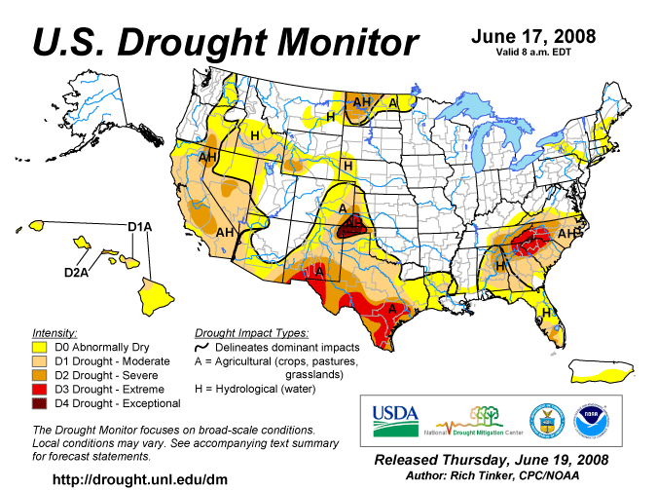

APPENDIX C

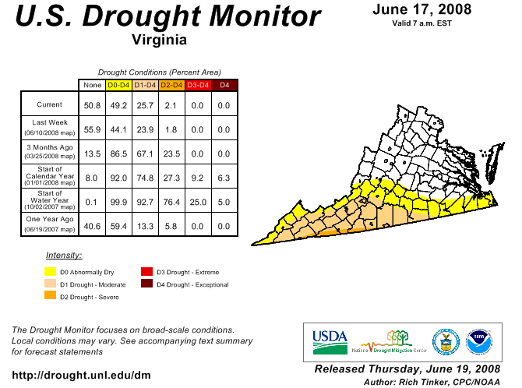
APPENDIX D

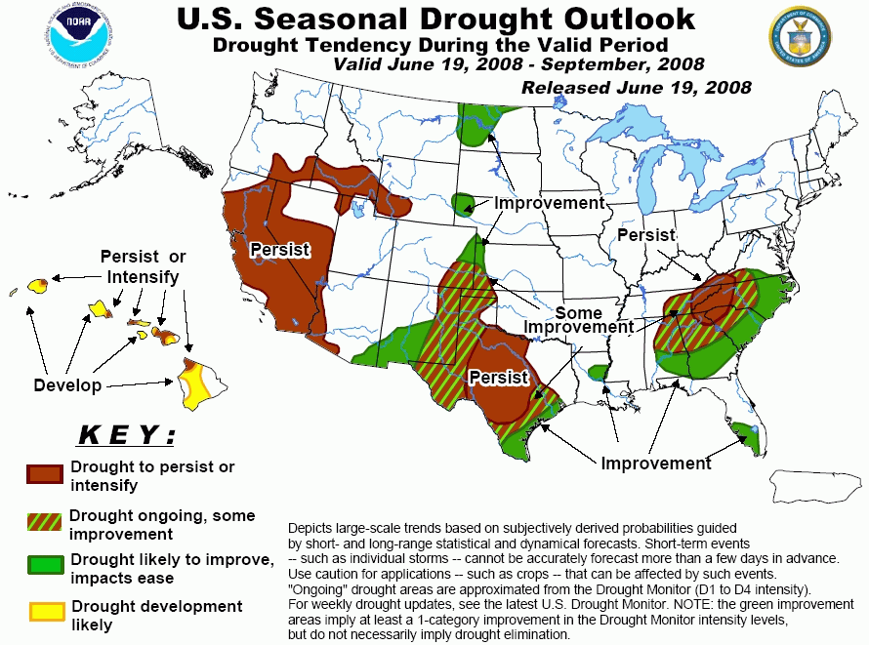

APPENDIX E
Condition of Public Water Supplies
June 19, 2008

ODW Drought Situation Report |  |  |  | Restriction totals
Date: | 6/19/08 |  | Mandatory | 4
 |  |  | Voluntary | 22
 |  |  | Total | 26
 |  |  | N-None | B-Better
 |  |  | M-Mandatory | S-Stable/Same
 |  |  | V-Voluntary | W-Worse
PWSID | Waterworks | Source Name | Restrictions | Situation | Population Served
1195050 | Town of Appalachia | reservoir | M | W 6/19/08: down 2'-4" from overflow. 85 MG left, 187 days ± 10 left. Level was 9.5" down on 5/12/08. Our concern about this source is low due to their ability, achieved last year, to pump from the Powell River into the reservoir. Not currently pumping from river.
1195100 | Town of Big Stone Gap | Big Cherry Reservoir | M | W 6/19/08: Reservoir down 1.25 ft from overflow. 570 MG, 198 days left. Reservoir was full on 04/14/08 and removed from drought report at that time.
2003250 | Albemarle County / Crozet | Beaver Creek Reservoir | N | B - Beaver Creek Reservoir is full. Drought Watch lifted 5/13/08 | 5,900
2003600 | Charlottesville/Albemarle County | Sugar Hollow and Ragged Mountain Reservoirs (Observatory WTP) | N | B - Sugar Hollow reservoir is full. Drought Watch lifted 5/13/08 | 40,743
2003675 | Albemarle County / Scottsville | Totier Creek Reservoir | N | B - Totier Creek reservoir is full. Drought Watch lifted 5/13/08 | 700
2003725 | Charlottesville/Albemarle County | South Fork Rivanna (South Rivanna WTP) | N | B - South Fork Rivanna reservoir is full. Drought Watch lifted 5/13/08 | 54,400
2023720 | Town of Troutville | Five Drilled Wells | N | S - Town reported the pumping rate of their No. 3 well dropped from 123 gpm to 40 gpm. The pumping rates of the other four wells are the same. | 500
2043125 | Berryville, Town of | Shenandoah River | V | S - Voluntary conservation requested on 11 December 2007. | 2,965
2065250 | Fluvanna Correctional Center for Women | Mechunk Creek and on-site Raw Water Reservoir | V | S - Reservoir is 90% full (~36 MG stored). Moderate Drought Condition continues to conserve water. | 1,650
2171750 | Town of Strasburg | North Fork Shenandoah River | V | S - Voluntary conservation has been requested. Stream flow approx 487 cfs on 17 April 2008 | 4,500
2560100 | Town of Clifton Forge | Smith Creek | V | S - Voluntary conservation has been requested. This has not been implemented as a result of limited or low source water quantity, but rather at the request of the Governor's letter requesting conservation | 4,679
2660345 | City of Harrisonburg | North River, Dry River/Switzer Reservoir (Rawley Springs) | V | S - Voluntary conservation has been requested. This has not been implemented as a result of limited low source water quantity, but rather at the request of the Governor's letter requesting conservation. | 44,500
3081550 | GCWSA - Jarratt | Nottoway River | N | S - 6/18/08 - Waterworks production rate still reduced due to lower demand; river level and discharge less than last month, sufficient to allow plant operation at 2.0 mgd | 7,190
3093120 | Isle of Wight County | Suffolk | V | B - follows Suffolk's lead on conservation. | 1,284
3550050 | Chesapeake - Western Branch system | City of Portsmouth | V | S -6/17/08 This portion of the city is consecutive to (receives water from) the city of Portsmouth. City Council voted to go to voluntary conservation city-wide - it took effect on 24 Oct 2007. Still following Portsmouth's lead on conservation. | 36,444
3550051 | Chesapeake | Northwest River, City of Norfolk Raw Water (Lake Gaston) | V | S - City Council voted to go to voluntary conservation city-wide - took effect on 24 Oct 2007. Chlorides are used as an indicator of drought, the higher the levels the more concentrated the contaminant in a lesser amount of surface water. The chlorides have been average (46 mg/l) since the recent rains. City is still encouraging voluntary conservation measures. | 101,428
3550052 | Chesapeake - South Norfolk system | City of Norfolk | V | S - 6/17/08-This portion of the city is consecutive to (receives water from) the city of Norfolk. City Council voted to go to voluntary conservation city-wide - it took effect on 24 Oct 2007. Still following Norfolk's lead on conservation. | 38,611
3595250 | Emporia | Meherrin River | N | S - 6/18/08 - Water is going over the dam. River discharge levels less than historic low and power production stopped for 2 days as a preventative measure to maintain acceptable reservoir level. | 5,600
3670800 | Virginia-American Water Company (Hopewell) | Appomattox & James Rivers | N | B - 6/18/08 - Intake levels are at mid-range or higher. The turbidity levels have not gone up considerably, but alkalinity values have decreased significantly. | 25000 - Primary / 42463 Total including Consecutive System (Ft. Lee)
3710100 | Norfolk | Lake Prince, Lake Burnt Mills, Western Branch reservoir, Nottoway River, Blackwater River, 4 western wells; Little Creek reservoir, Lakes Smith, Lawson, Whitehurst, and Wright. Lake Gaston. | V | S - As of 06/17, reservoirs at 86.1% (down from 95.8% on 05/12). Historic reservoir capacity is 92.0%. Avg. pumping: Lake Gaston = 48.2 MGD; Spillway elev.: Western Branch -3.5 ft; Lake Prince 0.2 ft; Burnt Mils -3.8 ft; Lake Wright -0.5 ft; Lake Smith 0.2 ft. Called for voluntary conservation 11/1/07. | 261,250 - Primary / 755,617 - Total including consecutive systems (Va Beach + military bases).
3740600 | Portsmouth | Lakes Cohoon, Meade, Kilby, and Speights Run | V | S - As of 06/13, reservoirs at 97% (down from 100% on 05/12). Median reservoir capacity is 98%, average capacity is 96% (period of 1969-2006). Both emergency wells are OFF. Estimated 205 days of reservoir storage remaining at current pumpage and no rainfall. Called for voluntary conservation on 10/10/07. | 100,400 - Primary / 120,400 Total including consecutive systems (military bases)
3800805 | Suffolk | Lone Star Lakes, Cumps Mill Pond | V | B - Will follow Portsmouth's lead and the region as far as conservation. As of 6/17/08-Reservoir levels look good. Southern Lakes at 79.97% capacity, for the Northern Lakes at 105.09% and Crumps Mill Pond at 87.48% The Southern Lakes are for emergency use only. Still purchasing water from Portsmouth per their contract, no drought measure taken to date. | 62,562
3810900 | Virginia Beach | Norfolk | V | S - obtains water from Norfolk. Called for voluntary conservation on 9/19/07. | 423,743
4041035 | APPOMATTOX RIVER WATER AUTHORITY | Surface water; Lake Chesdin | N | S- Wholesaler to Chesterfield County, Prince George County, Dinwiddie County; Cities of Petersburg and Colonial Heights. Water level is normal. | 200,000
4041845 | CHESTERFIELD CO CENTRAL WATER SYSTEM | Surface water; Swift Creek reservoir; purchases finished water | N | S- Purchases water from the City of Richmond and the Appomattox River Water Authority. Reservoir is normal. | 263,000
4057800 | TAPPAHANNOCK, TOWN OF | Groundwater wells | N | S | 2,100
4073311 | GLOUCESTER CO WATER TREATMENT PLT | Surface water, Beaverdam reservoir; 2 deep groundwater wells | N | S-Reservoir at 100%. | 8,870
4075283 | EASTERN GOOCHLAND CENTRAL WATER SYSTEM | Purchased surface water | N | S-purchases water from Henrico County | 2,500
4075735 | JAMES RIVER CORRECTIONAL CTR | Surface water; James River | N | S | 9,300
4085398 | HANOVER SUBURBAN WATER SYSTEM | Surface water; North Anna River; some groundwater wells; purchases finished water | N | S | 71,000
4085770 | SPRING MEADOWS-MEADOW GATE | Groundwater wells | N | S- A replacement well will be drilled shortly and other improvements are proposed in the PER. | 2,300
4087125 | HENRICO COUNTY WATER SYSTEM | Surface water; James River | N | S- Similar to City of Richmond | 289,000
4101900 | WEST POINT, TOWN OF | Groundwater wells | N | S | 3,000
4127110 | DELMARVA PROPERTIES | Groundwater wells | V | S-New Kent Co. encourages conservation at all county owned waterworks. | 7,700
4145675 | POWHATAN COURTHOUSE | Groundwater wells | N | S | 2,600
4193280 | COLONIAL BEACH, TOWN OF | Groundwater wells | N | S | 3,300
4760100 | RICHMOND, CITY OF | Surface water; James River | N | S-water levels in the James River are back to normal; under James River Regional Flow Management Plan; counties of Henrico, Chesterfield, Goochland, and Hanover counties purchase water from the City. | 197,000
5515050 | City of Bedford | Stoney Creek Reservoir and Wells 1 to 5 | N | S - good levels | 6,946
5143210 | Town of Gretna | Georges Creek Res | N | S- Town indicated on 6/18 recent dry weather has had no impact so far | 2,500
5031150 | CCUSA | Surface - Big Otter River | N | W - Current stream flow 55 cfs | 20,000
5029085 | Buckingham County | Troublesome Creek Reservoir | N | W- water is only trickling over spillway | 5,751
5037300 | Town of Keysville | Keysville Reservoir | N | S | 800
5083550 | Town of Halifax | Bannister River Reservoir | N | S | 1,389
5780600 | Town of South Boston | Dan River | N | S | 9,726
5141640 | Town of Stuart | South Mayo River | N | S | 1,500
5147170 | Town of Farmville | Appomattox River | N | S | 7,011
5011050 | Town of Appomattox | Wells | V | B - Operation reports show water levels rising in the wells. The town is actively looking for additional water sources. | 1,708
5135160 | Town of Crewe | Crystal Lake | N | B - good levels | 3,500
5111450 | Town of Kenbridge | Flat Rock Creek and Offstream Reservoir | N | S - good levels | 1,400
5067785 | Ridgscrest | Wells | N | B | 52
5067265 | Hales Point | Wells | N | B | 46
5067937 | Stripers Landing | Wells | N | B | 125
5680200 | City of Lynchburg | Pedlar Reservoir | N | B - Overflowing spillway | 76,000
6047070 | Emerald Hill Elementary School | Groundwater | N | S - Well EHS-3 is onstream at a reliable production rate of 12 gpm. Well 1 has been reworked for improved production. Water hauling is no longer needed. | 977
6047500 | Town of Culpeper | Lake Pelham | N | S - On Tuesday, June 17, 2008, Lake Pelham continued to be full. | 14,200
6061200 | Marshall | Groundwater | M | S - No water was hauled in May. Water ditribution system repairs and line replacements are being done. | 2,134
6061600 | Town of Warrenton | Reservoir on Cedar Run and groundwater | N | S - On Wednesday, 6/18/08, Warrenton Reservoir is full. Airlie Reservoir is full. | 11,160
6107150 | Town of Hamilton | Groundwater | M | S - 6/18/08 Water levels in wells satisfactory. No water supply problems. Town Council voted to maintain Mandatory water use restrictions until new Well 14 is placed in service. | 2,000
6107200 | Town of Hillsboro | Spring/Well | N | S - Increased flow from spring has been adequate to meet current demand. A leak survey revealed 10 potential leaks in the distribution system. | 58
6107221 | LCSA Lenah Farms | Groundwater | V | S - 6/18/08 Voluntary conservation in place beginning 3/11/08 due to one well out of service. | 810
6107400 | Town of Lovettsville | Groundwater | V | S - 6/18/08 Voluntary water use restrictions remain in place; however there is no problem with water supply. | 1,280
6107450 | Town of Middleburg | Groundwater | V | B - 6/18/08 - Voluntary water use restrictions replace mandatory water use restrictions on 4/10/08. | 590
6107600 | Town of Purcellville | Hirst Reservoir and groundwater | V | B -- 6/18/08 Reservoir is full. Mandatory water conservation replaced with voluntary water conservation, 4/2/08. | 6,300
6107650 | Town of Round Hill | Groundwater | V | B - 6/18/08 - Voluntary water use restrictions replace mandatory water use restrictions on 4/1/08. | 3,156
6113200 | Town of Madison | White Oak Run | N | S -- Stream flow remains adequate to meet normal demands. | 778
6137300 | Rapidan Service Authority - Rt. 15 | Purchase treated surface water from Town of Orange (Rapidan River) | N | S - Town of Orange raw water availability is well above minimum. | 273
6137400 | Town of Gordonsville | Purchase treated surface water from RSA and Town of Orange | N | S--No water use restrictions are in place. | 1,800
6137500 | Town of Orange | Rapidan River | V | S - 6/17/08 - Fourteen day running average of Rapidan River flow is 1369 cfs (withdrawal restrictions are imposed below 44 cfs). | 4,500
6137999 | Rapidan Service Authority - Wilderness and Lake of the Woods | Rapidan River | N | Rapidan River flow has been steady at an adequate level. | 11,331
6153260 | Woodbridge Mobile Home Park | Groundwater | M | S -- 6/18/08 Waterworks continues to have low pressure due to inadequate sources and leaks in the distribution system. This problem is indirectly related to drought as source problems existed previously. | 320
6179100 and 6179775 | Stafford County | Smith Lake and Abel Lake | V | S -- Both lakes are full. Mandatory restrictions went into effect 9/17/07, were increased 10/8/07, and were reduced 2/19/08. Mandatory restrictions lifted 3/18/08. | 53,086
Notes of interest:
(1) Metropolitan Washington Council of Governments lifted the drought Watch, returning to Normal status, lifting a region-wide voluntary conservation advisory, on 4/1/08, covering DC, Maryland, and Northern Virginia.
(2) Interstate Commission on the Potomac River Basin (ICPRB) gathers meterological, drought, and water supply data from all of the major water suppliers in the Metro Washington area and determines the need for upstream reservoir releases, if any, to augment the flow in the Potomac River for water supply withdrawal. ICPRB has predicted that likelihood of releases from upstream reservoirs is slightly below normal.

APPENDIX F

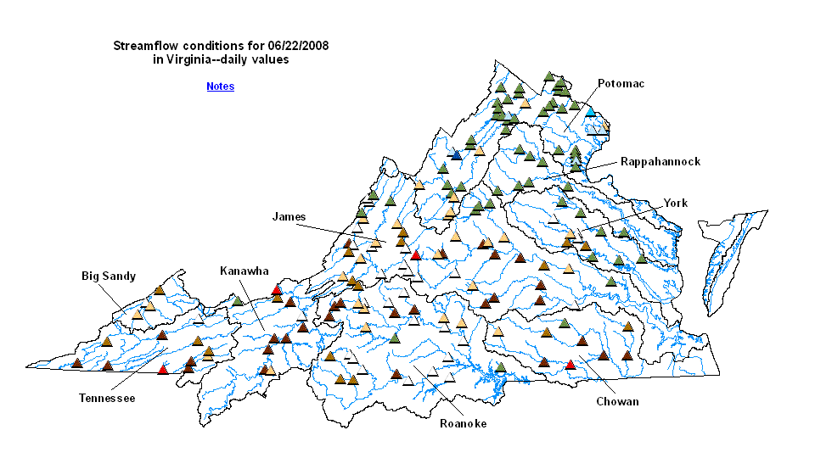
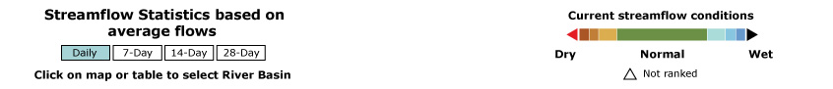

APPENDIX G
Drought Watch -- USGS State Information on Drought
Map of below normal 7-day average streamflow

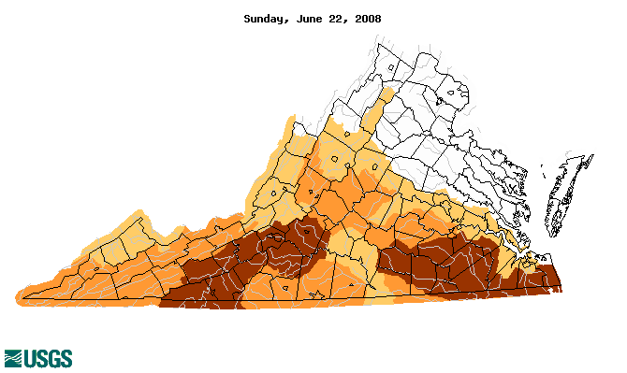
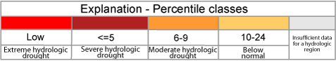

APPENDIX H
Virginia Climate Response Network
June 22, 2008



