DROUGHT MONITORING TASK FORCE
Drought Status Report
March 25, 2009

Statewide precipitation for the previous water year (October 1, 2007 through September 30, 2008) was in the normal range (85% of normal). Statewide precipitation for the period from October 1, 2007 through March 15, 2009 was normal (87% of normal). Precipitation greater than 85% of normal is considered to be in the normal range. Statewide precipitation for the current water year (from October 1, 2008 through March 15, 2009) was below normal (76%), with below normal precipitation in the following drought evaluation areas: Big Sandy (75), Eastern Shore (78%), Middle James (69%), Northern Coastal Plain (78%), Northern Piedmont (76%), Roanoke (71%), Shenandoah (69%), Southeast Virginia (78%), and Upper James (83%). Previpitation during the months of January and February were far below normal, with just over 3.6 inches of precipitation falling during the two-month period. The following drought evaluation regions are currently below normal for the period beginning October 1, 2007: Northern Caostal Plain (79%), Northern Piedmont (80%), Northern Virginia (83%), and Southeast Virginia (80%). The Big Sandy, Chowan,, Eastern Shore, Middle James, New River, Roanoke, Shenandoah, Upper James, and York-James drought evaluation areas are currently in the normal range of precipitation for the extended period from October 1, 2007 to March 15, 2009. Appendix A contains precipitation tables for periods dating from October 1, 2007 provided by the Climatology Office of the University of Virginia and the Virginia Department of Environmental Quality. The monthly climatologic outlook calls for equal chances of below normal, normal and above normal temperatures and below normal precipitation for the Commonwealth through April of 2009. The three month outlook calls for equal chances of below normal, normal and above normal temperatures and precipitation for the Commonwealth through June 2009.

The latest NOAA drought monitor indicates that the entire state is now considered to be either “abnormally dry” or in “moderate drought”. However, the incidence of areas considered to be under “severe drought” or “extreme drought” conditions has bee eliminated. The drought monitor is included as Appendix B. Appendix C contains information from the national drought monitor with only Virginia displayed. The NOAA seasonal drought outlook through May 2009 indicates that drought conditions are likely to improve in the areas of western Virginia currently experiencing drought. The seasonal drought outlook is included as Appendix D.

While the Virginia Department of Health has not reported any impacts to public water supplies that have compromised their ability to provide the needs of their customers’, 25 systems have initiated voluntary water conservation requirements and 3 systems have initiated mandatory water conservation requirements. Water conservation requirements at public water supplies have decreased considerably since the last report when 48 systems were on voluntary restrictions and 3 systems required mandatory conservation. Appendix E contains a table of waterworks that includes systems that have initiated water conservation requirements.

Streams in the western and southwestern areas of the state are very low for this time of year. Many streams are currently at levels of what we would expect to see during the mid-summer period. Trout stockings are still continuing on all designated trout waters. Spring flows in the hatcheries are also below normal for this time of the year. So far, it seems like recreational fishing and boating are not being impacted.

Reports from the Climatology Office of the University of Virginia, the National Weather Service, the Virginia Department of Environmental Quality, the United States Geological Survey, and the Virginia Department of Agriculture and Consumer Services, follow.

Report of the Climatology Office of the University of Virginia

The first two months of 2009 have brought a serious shortfall of precipitation throughout the Commonwealth. Winter storms, although relatively consistent, have not generally moved along tracks favorable for large amounts of precipitation in Virginia.

The first half of March has brought significant precipitation to all but some of the northern and northwestern regions. Nonetheless, a climatological analysis indicates that the likelihood of reaching even 85% of the statewide normal precipitation total for the October through March period is only about 3% at this point.

Ample precipitation during these colder months is critical to recovery from the long-term moisture deficits much of Virginia has experienced. The low temperatures greatly decrease evaporation and water use by plants—precipitation, therefore, has a much better opportunity to positively affect deep soil and groundwater reserves.

As a result, with only a few weeks to go before the onset of the growing season, the likelihood of making substantial headway against those long-term moisture deficits left over from last year (and before) is dwindling. The continuation and augmentation of these deficits into the warmer months of 2009 has a high probability.

Report of the National Weather Service

Between 1/2 and 3 inches of rain fell across the Commonwealth in early March. The heaviest rain fell across southern Virginia. While the rain was welcome and much needed, it was not enough to erase the deficits created by the dry weather in January/February. As much as 2 inches is expected to fall south of Interstate 64 with at least an inch falling in the rest of the Commonwealth. The Northern Shenandoah should see this much needed rainfall. Temperatures through the end of March should average at or above normal.

United States Geological Survey
Streamflow and Ground Water Levels

Despite rainfall and snow last week, streamflow conditions across the northern half of the State are well below normal. The majority of the precipitation was south of Interstate 64 and gages in this area recorded flows increasing into the normal range of flows for March and slowly declining into the below normal range. Gages north of Interstate 64 generally recorded very little increase in flow and most have shown flows decline into the well below normal range of flows. Climate conditions are similar to last year with little precipitation in January and February and very little winter recharge of the ground-water system. However, last year significant precipitation fell in April and May that boosted the ground-water reserve enough that the early summer months were not especially dry. Without significant spring precipitation, summer streamflows will be well below normal.

Observation wells across the State show similar conditions in the ground-water system. North of Interstate 64, most of the observation wells are recording levels well below normal while south of Interstate 64, most of the observation well are recording levels in the normal to below normal ranges. For the most part, observation wells recorded no or very little recharge during the winter. The few wells that have recorded some recharge to the ground-water system have been in decline since mid December. Recharge to the ground-water system from last week’s precipitation has not been observed.

Virginia Department of Environmental Quality
Condition of Major Reservoirs

Levels of large reservoirs in the western portion of the Commonwealth have generally rebounded. Water surface elevations of major reservoirs in southwestern, northern and eastern Virginia are mostly normal. Lake Moomaw on the Jackson River has reached 82% of its conservation storage. The Lake is expected to reach full pond by the end of April—on par with the late refill in 2002. Smith Mountain Lake is at full pond and has surcharged enough for the spring striped bass release. Philpott Lake is almost at guide curve, having gained significantly in the past month. Energy production is being transferred from Lake Philpott to Kerr Reservoir until the Lake reached guide curve. In the extreme southwestern part of the State, South Holston Lake, straddling the Tennessee – Virginia line is at 1718.2 feet which is above guide curve. The two major reservoirs for the Roanoke area Carvins Cove and Spring Hollow Reservoirs are 4.5 feet and 16 feet below full, respectively. Lake Anna is full at 250 feet. The often vulnerable Rivanna Water and Sewer Authority reservoirs serving Charlottesville water supply are also full. Kerr Reservoir remains 5 feet above guide curve at 304 feet.

Virginia Department of Agriculture and Consumer Services
Status of Agricultural Drought

In 2008 thirty-seven counties requested the Governor’s assistance in obtaining federal agricultural disaster designation due to drought conditions. As of February 5, 2009, the United States Secretary of Agriculture had named thirty-five of the localities primary disaster areas due to drought and excessive heat: Albemarle, Amelia, Amherst, Bedford, Brunswick, Buckingham, Campbell, Caroline, Charlotte, Craig, Dinwiddie, Fluvanna, Franklin, Gloucester, Goochland, Greene, Halifax, Hanover, Henry, Isle of Wight, King and Queen, Louisa, Lunenburg, Mecklenburg, Nelson, Nottoway, Patrick, Pittsylvania, Powhatan, Prince Edward, Prince George, Rockbridge, Russell, Scott, and Surry. Governor Kaine also sent a letter to U. S. Secretary of Agriculture Tom Vilsack requesting disaster designation for King William County, which is pending a response from USDA. Secretary of Agriculture and Forestry Bob Bloxom was advised by the Farm Service Agency (FSA) that the request for a loss assessment report for Greensville County was denied because the county did not make its request within 90 days of the end of the drought event. VDACS has notified Greensville County of FSA’s decision.

At the request of VDACS, the Virginia Departments of Transportation and Motor Vehicles granted temporary waivers of registration and license requirements along with normal weight and width restrictions for carriers transporting emergency supplies of hay or animal feed to disaster areas. The exemptions, which became effective January 30, 2009, will expire on March 30, 2009.

Impact on Dairies:

Many Virginia dairy farmers are still affected by last year's drought due to lower than normal feed stockpiles. The high price of feedstuffs, coupled with the significant decline in milk prices, is exacerbating this effect, although some dairymen are reporting recent significant declines in costs for fuel, fertilizer and feed.

This past winter has been dryer than normal; however, recent snows and rain have provided adequate moisture in the upper layers of the soil to make a spring crop. Spring rye normally chopped to make silage is reported to be a little early this year and growing well. The water table is below normal in most areas with some wells still low and creek flows small. If we have a dry spring it will be a problem to make normal crop production this summer.

Impact on Crops:

Sufficient precipitation has occurred across most of the state thus far to predict a favorable start to the planting season. Currently, farmers in most of the state are reporting water tables at normal levels and sufficient ground moisture. However, a deficit still exists in the Shenandoah Valley, which ended last year with about 10 inches below normal, or approximately 30% reduced, precipitation. So far this year, the Valley is four inches below normal precipitation levels going into the planting season.

Impact on Creeks, Rivers, and Wells:

Across most of the state, recent rains have significantly improved and in some cases exceeded normal water levels in waterways. The water table is reported to be nearing normal height across much of the state. Though portions of the state, such as the Shenandoah Valley, still have a deficit to recover, there are no reports of critical water shortages or drying up of water sources.

Impact on Livestock

Market News reports that requests from producers for assistance to locate hay has dropped significantly compared to this time last year. In fact, VDACS has received very few calls from people needing hay and have over fifty listings in our Hay Clearinghouse publication from producers in Virginia who have hay to sell. In addition, prices from the Rushville hay auction have generally declined. With the exception of premium and good alfalfa, hay prices are generally down 25-50% at the auction compared to the previous two years.

Virginia cattle, as viewed both in the field and in market venues, are generally well conditioned. Livestock moving through Virginia's market system are saleable, and Virginia is not experiencing the large-scale breeding stock dispersals reported in other areas of the country still suffering from severe drought. However, reports of undernourished livestock continue to be received from across the state, and can be attributed to last year's drought conditions and the subsequent scarcity and high price of livestock feeds.

APPENDIX A

Precipitation departures by Drought Evaluation Region.
 | PRELIMINARY PRECIPITATION SUMMARY |  |  |  | Prepared:
 |  |  |  |  | 3/16/09
 | DROUGHT |  | Mar 1, 2009 | - Mar 15, 2009
 | REGION | OBSERVED | NORMAL | DEPARTURE | % OF NORM.
1 | Big Sandy | 2.28 | 2.13 | 0.16 | 107%
2 | New River | 2.65 | 1.84 | 0.82 | 145%
3 | Roanoke | 2.56 | 2.14 | 0.43 | 120%
4 | Upper James | 1.87 | 1.90 | -0.02 | 99%
5 | Middle James | 2.52 | 2.03 | 0.49 | 124%
6 | Shenandoah | 0.44 | 1.60 | -1.16 | 28%
7 | Northern Virginia | 0.89 | 1.83 | -0.94 | 49%
8 | Northern Piedmont | 2.00 | 1.91 | 0.10 | 105%
9 | Chowan | 3.40 | 2.19 | 1.21 | 155%
10 | Northern Coastal Plain | 1.32 | 2.14 | -0.82 | 62%
11 | York-James | 2.67 | 2.35 | 0.33 | 114%
12 | Southeast Virginia | 2.42 | 2.10 | 0.32 | 115%
13 | Eastern Shore | 2.65 | 2.16 | 0.50 | 123%
 | Statewide | 2.16 | 2.02 | 0.14 | 107%

 | DROUGHT |  | Feb 1, 2009 | - Mar 15, 2009
 | REGION | OBSERVED | NORMAL | DEPARTURE | % OF NORM.
1 | Big Sandy | 3.05 | 5.71 | -2.65 | 53%
2 | New River | 3.20 | 4.77 | -1.56 | 67%
3 | Roanoke | 3.14 | 5.45 | -2.30 | 58%
4 | Upper James | 2.80 | 4.75 | -1.94 | 59%
5 | Middle James | 3.25 | 5.15 | -1.90 | 63%
6 | Shenandoah | 1.08 | 4.01 | -2.93 | 27%
7 | Northern Virginia | 1.73 | 4.50 | -2.77 | 39%
8 | Northern Piedmont | 3.39 | 4.88 | -1.49 | 70%
9 | Chowan | 4.77 | 5.36 | -0.59 | 89%
10 | Northern Coastal Plain | 2.66 | 5.28 | -2.63 | 50%
11 | York-James | 4.49 | 5.88 | -1.39 | 76%
12 | Southeast Virginia | 3.62 | 5.60 | -1.98 | 65%
13 | Eastern Shore | 4.36 | 5.35 | -0.99 | 82%
 | Statewide | 3.07 | 5.15 | -2.08 | 60%

 | DROUGHT |  | Jan 1, 2009 | - Mar 15, 2009
 | REGION | OBSERVED | NORMAL | DEPARTURE | % OF NORM.
1 | Big Sandy | 4.88 | 9.44 | -4.56 | 52%
2 | New River | 5.21 | 7.98 | -2.76 | 65%
3 | Roanoke | 5.52 | 9.37 | -3.84 | 59%
4 | Upper James | 5.72 | 8.03 | -2.30 | 71%
5 | Middle James | 5.79 | 8.81 | -3.02 | 66%
6 | Shenandoah | 3.55 | 6.86 | -3.31 | 52%
7 | Northern Virginia | 4.69 | 7.78 | -3.09 | 60%
8 | Northern Piedmont | 7.23 | 8.40 | -1.17 | 86%
9 | Chowan | 8.86 | 9.47 | -0.60 | 94%
10 | Northern Coastal Plain | 6.72 | 9.03 | -2.32 | 74%
11 | York-James | 9.64 | 10.02 | -0.37 | 96%
12 | Southeast Virginia | 7.75 | 9.76 | -2.01 | 79%
13 | Eastern Shore | 8.31 | 8.91 | -0.60 | 93%
 | Statewide | 5.98 | 8.79 | -2.81 | 68%

 | DROUGHT |  | Dec 1, 2008 | - Mar 15, 2009
 | REGION | OBSERVED | NORMAL | DEPARTURE | % OF NORM.
1 | Big Sandy | 8.95 | 13.08 | -4.13 | 68%
2 | New River | 9.24 | 10.69 | -1.45 | 86%
3 | Roanoke | 9.59 | 12.62 | -3.03 | 76%
4 | Upper James | 9.44 | 10.98 | -1.54 | 86%
5 | Middle James | 9.31 | 11.98 | -2.67 | 78%
6 | Shenandoah | 6.98 | 9.45 | -2.47 | 74%
7 | Northern Virginia | 8.02 | 10.88 | -2.86 | 74%
8 | Northern Piedmont | 11.02 | 11.68 | -0.65 | 94%
9 | Chowan | 13.08 | 12.49 | 0.59 | 105%
10 | Northern Coastal Plain | 10.99 | 12.31 | -1.32 | 89%
11 | York-James | 15.41 | 13.41 | 2.00 | 115%
12 | Southeast Virginia | 11.62 | 12.94 | -1.32 | 90%
13 | Eastern Shore | 11.01 | 12.15 | -1.14 | 91%
 | Statewide | 9.86 | 11.91 | -2.05 | 83%

 | DROUGHT |  | Nov 1, 2008 | - Mar 15, 2009
 | REGION | OBSERVED | NORMAL | DEPARTURE | % OF NORM.
1 | Big Sandy | 13.03 | 16.36 | -3.33 | 80%
2 | New River | 13.07 | 13.72 | -0.65 | 95%
3 | Roanoke | 12.63 | 15.98 | -3.34 | 79%
4 | Upper James | 12.55 | 14.34 | -1.79 | 88%
5 | Middle James | 11.52 | 15.49 | -3.97 | 74%
6 | Shenandoah | 9.19 | 12.50 | -3.31 | 74%
7 | Northern Virginia | 10.43 | 14.29 | -3.86 | 73%
8 | Northern Piedmont | 13.30 | 15.48 | -2.18 | 86%
9 | Chowan | 15.13 | 15.60 | -0.46 | 97%
10 | Northern Coastal Plain | 13.16 | 15.45 | -2.29 | 85%
11 | York-James | 17.77 | 16.78 | 0.99 | 106%
12 | Southeast Virginia | 13.74 | 16.01 | -2.27 | 86%
13 | Eastern Shore | 13.00 | 15.09 | -2.09 | 86%
 | Statewide | 12.58 | 15.14 | -2.56 | 83%

 | DROUGHT |  | Oct 1, 2008 | - Mar 15, 2009
 | REGION | OBSERVED | NORMAL | DEPARTURE | % OF NORM.
1 | Big Sandy | 14.37 | 19.24 | -4.87 | 75%
2 | New River | 14.45 | 16.89 | -2.43 | 86%
3 | Roanoke | 13.99 | 19.69 | -5.70 | 71%
4 | Upper James | 14.65 | 17.59 | -2.93 | 83%
5 | Middle James | 13.26 | 19.33 | -6.07 | 69%
6 | Shenandoah | 10.77 | 15.69 | -4.92 | 69%
7 | Northern Virginia | 11.70 | 17.77 | -6.07 | 66%
8 | Northern Piedmont | 14.81 | 19.47 | -4.65 | 76%
9 | Chowan | 16.64 | 19.18 | -2.53 | 87%
10 | Northern Coastal Plain | 14.73 | 18.96 | -4.23 | 78%
11 | York-James | 19.49 | 20.31 | -0.82 | 96%
12 | Southeast Virginia | 15.28 | 19.67 | -4.39 | 78%
13 | Eastern Shore | 14.23 | 18.30 | -4.07 | 78%
 | Statewide | 14.12 | 18.64 | -4.52 | 76%

 | DROUGHT |  | Sep 1, 2008 | - Mar 15, 2009
 | REGION | OBSERVED | NORMAL | DEPARTURE | % OF NORM.
1 | Big Sandy | 20.79 | 22.70 | -1.90 | 92%
2 | New River | 20.91 | 20.30 | 0.62 | 103%
3 | Roanoke | 19.34 | 23.92 | -4.58 | 81%
4 | Upper James | 18.75 | 21.09 | -2.34 | 89%
5 | Middle James | 17.98 | 23.46 | -5.48 | 77%
6 | Shenandoah | 13.60 | 19.36 | -5.76 | 70%
7 | Northern Virginia | 13.80 | 21.84 | -8.04 | 63%
8 | Northern Piedmont | 17.68 | 23.75 | -6.06 | 74%
9 | Chowan | 19.59 | 23.61 | -4.01 | 83%
10 | Northern Coastal Plain | 16.49 | 23.05 | -6.57 | 72%
11 | York-James | 21.49 | 25.21 | -3.71 | 85%
12 | Southeast Virginia | 17.51 | 24.10 | -6.59 | 73%
13 | Eastern Shore | 16.26 | 21.91 | -5.64 | 74%
 | Statewide | 18.22 | 22.64 | -4.42 | 80%

 | DROUGHT |  | Aug 1, 2008 | - Mar 15, 2009
 | REGION | OBSERVED | NORMAL | DEPARTURE | % OF NORM.
1 | Big Sandy | 23.30 | 26.53 | -3.22 | 88%
2 | New River | 24.47 | 23.61 | 0.87 | 104%
3 | Roanoke | 23.44 | 27.64 | -4.19 | 85%
4 | Upper James | 23.50 | 24.42 | -0.91 | 96%
5 | Middle James | 21.78 | 27.28 | -5.50 | 80%
6 | Shenandoah | 16.98 | 22.69 | -5.71 | 75%
7 | Northern Virginia | 17.98 | 25.69 | -7.71 | 70%
8 | Northern Piedmont | 21.90 | 27.57 | -5.67 | 79%
9 | Chowan | 24.09 | 27.92 | -3.83 | 86%
10 | Northern Coastal Plain | 19.73 | 26.91 | -7.18 | 73%
11 | York-James | 25.56 | 30.08 | -4.51 | 85%
12 | Southeast Virginia | 22.15 | 29.22 | -7.07 | 76%
13 | Eastern Shore | 20.32 | 25.78 | -5.45 | 79%
 | Statewide | 22.05 | 26.47 | -4.42 | 83%

 | DROUGHT |  | Jul 1, 2008 | - Mar 15, 2009
 | REGION | OBSERVED | NORMAL | DEPARTURE | % OF NORM.
1 | Big Sandy | 27.72 | 31.01 | -3.28 | 89%
2 | New River | 28.12 | 27.40 | 0.73 | 103%
3 | Roanoke | 27.33 | 32.03 | -4.70 | 85%
4 | Upper James | 26.99 | 28.46 | -1.47 | 95%
5 | Middle James | 25.29 | 31.69 | -6.40 | 80%
6 | Shenandoah | 21.48 | 26.45 | -4.97 | 81%
7 | Northern Virginia | 21.98 | 29.46 | -7.48 | 75%
8 | Northern Piedmont | 25.56 | 31.97 | -6.40 | 80%
9 | Chowan | 27.80 | 32.43 | -4.63 | 86%
10 | Northern Coastal Plain | 24.40 | 31.36 | -6.96 | 78%
11 | York-James | 30.24 | 35.18 | -4.94 | 86%
12 | Southeast Virginia | 26.90 | 34.29 | -7.39 | 78%
13 | Eastern Shore | 24.69 | 29.78 | -5.09 | 83%
 | Statewide | 26.02 | 30.81 | -4.79 | 84%

 | DROUGHT |  | Jun 1, 2008 | - Mar 15, 2009
 | REGION | OBSERVED | NORMAL | DEPARTURE | % OF NORM.
1 | Big Sandy | 30.26 | 35.15 | -4.89 | 86%
2 | New River | 30.73 | 31.25 | -0.52 | 98%
3 | Roanoke | 29.71 | 35.92 | -6.21 | 83%
4 | Upper James | 29.33 | 32.17 | -2.84 | 91%
5 | Middle James | 30.00 | 35.20 | -5.20 | 85%
6 | Shenandoah | 24.42 | 30.16 | -5.74 | 81%
7 | Northern Virginia | 25.07 | 33.32 | -8.25 | 75%
8 | Northern Piedmont | 28.68 | 35.98 | -7.30 | 80%
9 | Chowan | 30.92 | 36.08 | -5.16 | 86%
10 | Northern Coastal Plain | 27.97 | 34.92 | -6.95 | 80%
11 | York-James | 34.23 | 38.59 | -4.35 | 89%
12 | Southeast Virginia | 29.27 | 37.90 | -8.63 | 77%
13 | Eastern Shore | 27.65 | 32.76 | -5.10 | 84%
 | Statewide | 29.13 | 34.60 | -5.47 | 84%

 | DROUGHT |  | May 1, 2008 | - Mar 15, 2009
 | REGION | OBSERVED | NORMAL | DEPARTURE | % OF NORM.
1 | Big Sandy | 34.51 | 39.97 | -5.45 | 86%
2 | New River | 35.21 | 35.46 | -0.24 | 99%
3 | Roanoke | 34.27 | 40.25 | -5.97 | 85%
4 | Upper James | 33.29 | 36.45 | -3.15 | 91%
5 | Middle James | 35.77 | 39.44 | -3.67 | 91%
6 | Shenandoah | 28.38 | 34.00 | -5.62 | 83%
7 | Northern Virginia | 28.87 | 37.66 | -8.79 | 77%
8 | Northern Piedmont | 31.34 | 40.20 | -8.86 | 78%
9 | Chowan | 33.40 | 40.17 | -6.76 | 83%
10 | Northern Coastal Plain | 30.14 | 39.08 | -8.94 | 77%
11 | York-James | 36.91 | 42.86 | -5.94 | 86%
12 | Southeast Virginia | 31.83 | 41.76 | -9.93 | 76%
13 | Eastern Shore | 30.33 | 36.28 | -5.94 | 84%
 | Statewide | 33.08 | 38.86 | -5.78 | 85%

 | DROUGHT |  | Apr 1, 2008 | - Mar 15, 2009
 | REGION | OBSERVED | NORMAL | DEPARTURE | % OF NORM.
1 | Big Sandy | 41.40 | 43.73 | -2.32 | 95%
2 | New River | 41.37 | 39.01 | 2.37 | 106%
3 | Roanoke | 40.26 | 44.05 | -3.78 | 91%
4 | Upper James | 38.59 | 39.85 | -1.26 | 97%
5 | Middle James | 41.50 | 42.78 | -1.28 | 97%
6 | Shenandoah | 33.37 | 36.92 | -3.55 | 90%
7 | Northern Virginia | 33.85 | 40.96 | -7.11 | 83%
8 | Northern Piedmont | 36.16 | 43.49 | -7.32 | 83%
9 | Chowan | 38.05 | 43.60 | -5.55 | 87%
10 | Northern Coastal Plain | 34.86 | 42.17 | -7.31 | 83%
11 | York-James | 40.91 | 46.16 | -5.25 | 89%
12 | Southeast Virginia | 36.11 | 45.01 | -8.90 | 80%
13 | Eastern Shore | 35.05 | 39.20 | -4.15 | 89%
 | Statewide | 38.53 | 42.28 | -3.75 | 91%

 | DROUGHT |  | Mar 1, 2008 | - Mar 15, 2009
 | REGION | OBSERVED | NORMAL | DEPARTURE | % OF NORM.
1 | Big Sandy | 44.63 | 47.98 | -3.34 | 93%
2 | New River | 44.41 | 42.68 | 1.74 | 104%
3 | Roanoke | 43.56 | 48.32 | -4.76 | 90%
4 | Upper James | 41.98 | 43.64 | -1.66 | 96%
5 | Middle James | 44.30 | 46.84 | -2.54 | 95%
6 | Shenandoah | 35.89 | 40.12 | -4.23 | 89%
7 | Northern Virginia | 37.09 | 44.62 | -7.53 | 83%
8 | Northern Piedmont | 39.44 | 47.30 | -7.86 | 83%
9 | Chowan | 41.77 | 47.97 | -6.19 | 87%
10 | Northern Coastal Plain | 37.83 | 46.45 | -8.62 | 81%
11 | York-James | 45.42 | 50.85 | -5.43 | 89%
12 | Southeast Virginia | 39.64 | 49.21 | -9.57 | 81%
13 | Eastern Shore | 38.44 | 43.51 | -5.07 | 88%
 | Statewide | 41.71 | 46.32 | -4.61 | 90%

 | DROUGHT |  | Feb 1, 2008 | - Mar 15, 2009
 | REGION | OBSERVED | NORMAL | DEPARTURE | % OF NORM.
1 | Big Sandy | 48.05 | 51.56 | -3.50 | 93%
2 | New River | 47.27 | 45.61 | 1.66 | 104%
3 | Roanoke | 46.04 | 51.63 | -5.58 | 89%
4 | Upper James | 44.57 | 46.49 | -1.92 | 96%
5 | Middle James | 46.77 | 49.96 | -3.19 | 94%
6 | Shenandoah | 38.16 | 42.53 | -4.37 | 90%
7 | Northern Virginia | 39.30 | 47.29 | -7.99 | 83%
8 | Northern Piedmont | 42.14 | 50.27 | -8.12 | 84%
9 | Chowan | 44.21 | 51.14 | -6.93 | 86%
10 | Northern Coastal Plain | 40.05 | 49.59 | -9.54 | 81%
11 | York-James | 48.78 | 54.38 | -5.60 | 90%
12 | Southeast Virginia | 42.29 | 52.71 | -10.42 | 80%
13 | Eastern Shore | 41.30 | 46.70 | -5.40 | 88%
 | Statewide | 44.32 | 49.45 | -5.13 | 90%

 | DROUGHT |  | Jan 1, 2008 | - Mar 15, 2009
 | REGION | OBSERVED | NORMAL | DEPARTURE | % OF NORM.
1 | Big Sandy | 49.59 | 55.29 | -5.69 | 90%
2 | New River | 48.57 | 48.82 | -0.24 | 99%
3 | Roanoke | 46.95 | 55.55 | -8.59 | 85%
4 | Upper James | 45.57 | 49.77 | -4.19 | 92%
5 | Middle James | 47.82 | 53.62 | -5.80 | 89%
6 | Shenandoah | 39.45 | 45.38 | -5.93 | 87%
7 | Northern Virginia | 41.10 | 50.57 | -9.47 | 81%
8 | Northern Piedmont | 44.01 | 53.79 | -9.77 | 82%
9 | Chowan | 46.09 | 55.25 | -9.16 | 83%
10 | Northern Coastal Plain | 42.19 | 53.34 | -11.15 | 79%
11 | York-James | 51.75 | 58.52 | -6.77 | 88%
12 | Southeast Virginia | 44.53 | 56.87 | -12.34 | 78%
13 | Eastern Shore | 43.24 | 50.26 | -7.01 | 86%
 | Statewide | 45.78 | 53.09 | -7.31 | 86%

 | DROUGHT |  | Dec 1, 2007 | - Mar 15, 2009
 | REGION | OBSERVED | NORMAL | DEPARTURE | % OF NORM.
1 | Big Sandy | 53.64 | 58.93 | -5.29 | 91%
2 | New River | 52.26 | 51.53 | 0.73 | 101%
3 | Roanoke | 50.46 | 58.80 | -8.33 | 86%
4 | Upper James | 48.48 | 52.72 | -4.24 | 92%
5 | Middle James | 51.04 | 56.79 | -5.75 | 90%
6 | Shenandoah | 42.51 | 47.97 | -5.46 | 89%
7 | Northern Virginia | 44.70 | 53.67 | -8.97 | 83%
8 | Northern Piedmont | 46.98 | 57.07 | -10.09 | 82%
9 | Chowan | 49.09 | 58.27 | -9.17 | 84%
10 | Northern Coastal Plain | 45.05 | 56.62 | -11.57 | 80%
11 | York-James | 54.58 | 61.91 | -7.33 | 88%
12 | Southeast Virginia | 47.60 | 60.05 | -12.45 | 79%
13 | Eastern Shore | 45.85 | 53.50 | -7.65 | 86%
 | Statewide | 49.06 | 56.21 | -7.15 | 87%

 | DROUGHT |  | Nov 1, 2007 | - Mar 15, 2009
 | REGION | OBSERVED | NORMAL | DEPARTURE | % OF NORM.
1 | Big Sandy | 54.43 | 62.21 | -7.77 | 88%
2 | New River | 53.12 | 54.56 | -1.44 | 97%
3 | Roanoke | 51.11 | 62.16 | -11.04 | 82%
4 | Upper James | 49.12 | 56.08 | -6.95 | 88%
5 | Middle James | 52.22 | 60.30 | -8.08 | 87%
6 | Shenandoah | 43.47 | 51.02 | -7.55 | 85%
7 | Northern Virginia | 46.16 | 57.08 | -10.92 | 81%
8 | Northern Piedmont | 48.05 | 60.87 | -12.81 | 79%
9 | Chowan | 50.36 | 61.38 | -11.02 | 82%
10 | Northern Coastal Plain | 46.93 | 59.76 | -12.83 | 79%
11 | York-James | 56.73 | 65.28 | -8.55 | 87%
12 | Southeast Virginia | 48.88 | 63.12 | -14.24 | 77%
13 | Eastern Shore | 47.10 | 56.44 | -9.34 | 83%
 | Statewide | 50.13 | 59.44 | -9.31 | 84%

 | DROUGHT |  | Oct 1, 2007 | - Mar 15, 2009
 | REGION | OBSERVED | NORMAL | DEPARTURE | % OF NORM.
1 | Big Sandy | 59.21 | 65.09 | -5.88 | 91%
2 | New River | 58.12 | 57.73 | 0.39 | 101%
3 | Roanoke | 56.21 | 65.87 | -9.66 | 85%
4 | Upper James | 54.83 | 59.33 | -4.49 | 92%
5 | Middle James | 56.45 | 64.14 | -7.69 | 88%
6 | Shenandoah | 47.45 | 54.21 | -6.76 | 88%
7 | Northern Virginia | 50.33 | 60.56 | -10.23 | 83%
8 | Northern Piedmont | 52.15 | 64.86 | -12.70 | 80%
9 | Chowan | 55.41 | 64.96 | -9.55 | 85%
10 | Northern Coastal Plain | 49.83 | 63.27 | -13.44 | 79%
11 | York-James | 58.94 | 68.81 | -9.87 | 86%
12 | Southeast Virginia | 53.49 | 66.78 | -13.29 | 80%
13 | Eastern Shore | 52.05 | 59.65 | -7.60 | 87%
 | Statewide | 54.64 | 62.94 | -8.30 | 87%

APPENDIX B

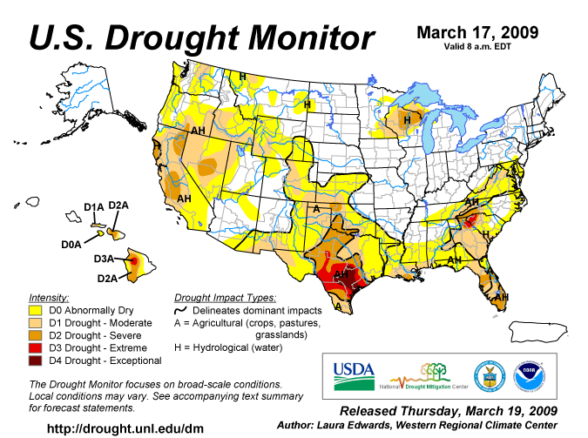

APPENDIX C

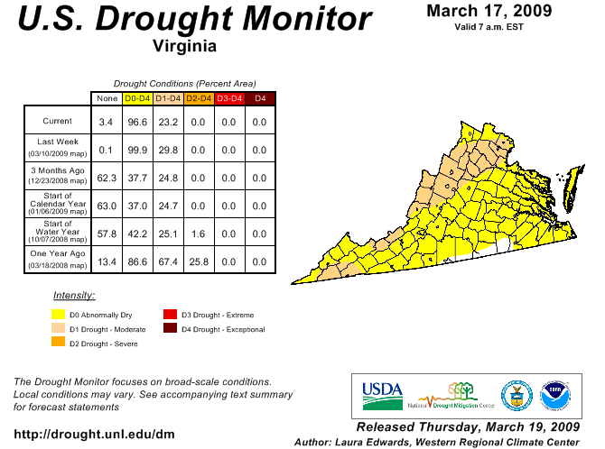

APPENDIX D

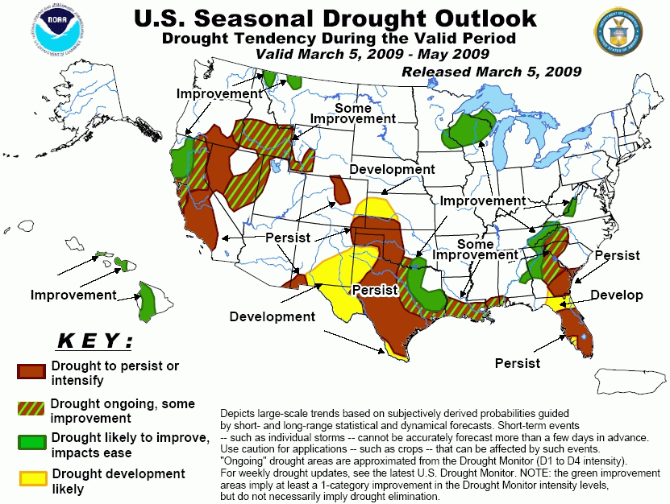

APPENDIX E
Condition of Public Water Supplies
March 13, 2009
ODW Drought Situation Report |  |  |  |  | Restriction totals
Date: | 3/13/09 |  |  | Mandatory | 3
 |  |  |  | Voluntary | 25
 |  |  |  | Total | 28
 |  |  |  | N-None | B-Better
 |  |  |  | M-Mandatory | S-Stable/Same
 |  |  |  | V-Voluntary | W-Worse
PWSID | Waterworks | Source Name |  | Restrictions | Situation | Population Served
1105400 | Lee County PSA | KVS Quarry |  | N | B 03/10/09: Water level in quarry is 139 inches below catwalk. Water level in quarry is currently 178 inches below catwalk. On 1/21/09 the water level was 178 inches below catwalk. On 3/18/08 the level was 163 inches below the catwalk. NO WATER SUPPLY PROBLEMS EXPECTED.
2023720 | Town of Troutville | Five Drilled Wells |  | N | S - Town reported the pumping rate of their No. 3 well dropped from 123 gpm to 40 gpm. The pumping rates of the other four wells are the same. | 500
2065250 | Fluvanna Correctional Center for Women | Mechunk Creek and on-site Raw Water Reservoir |  | V | S - Reservoir is nearly full again. Moderate Drought Condition continues however to conserve water. | 1,650
2660345 | City of Harrisonburg | North River, Dry River/Switzer Reservoir (Rawley Springs) |  | V | S - Voluntary conservation has been requested. This has not been implemented as a result of limited low source water quantity, but rather at the request of the Governor's letter requesting conservation. | 44,500
3053280 | DCWA Central (Dinwiddie County) | Appomattox River Water Authority (ARWA) |  | V | S - Voluntary restrictions began on 7/29/08. | 6,800
3081550 | GCWSA - Jarratt | Nottoway River |  | N | S - 03/12/09 - Waterworks production rate reduced due to lower demand; river level sufficient to allow plant operation at 2.0 mgd. | 7,190
3093120 | Isle of Wight County | Suffolk |  | V | B - 03/10/09 - Obtains water from Suffolk. Follows Suffolk's lead on conservation. | 1,284
3550050 | Chesapeake - Western Branch system | City of Portsmouth |  | V | S -03/12/09 This portion of the city is consecutive to (receives water from) the city of Portsmouth. City Council voted to go to voluntary conservation city-wide - it took effect on 24 Oct 2007. Still following Portsmouth's lead on conservation. | 36,444
3550051 | Chesapeake | Northwest River, City of Norfolk Raw Water (Lake Gaston) |  | V | B - 03/12/09 City Council voted to go to voluntary conservation city-wide - took effect on 24 Oct 2007. Continuing to follow Portsmouth's lead. Chlorides are used as an indicator of drought, the higher the levels the more concentrated the contaminant in a lesser amount of surface water. The chlorides average 55 mg/l for February 2009. | 102,095
3550052 | Chesapeake - South Norfolk system | City of Norfolk |  | V | S -03/12/09-This portion of the city is consecutive to (receives water from) the city of Norfolk. City Council voted to go to voluntary conservation city-wide - it took effect on 24 Oct 2007. Still following Norfolk's lead on conservation. | 38,611
3570150 | Colonial Heights | ARWA |  | V | S - Lifted mandatory restrictions on 12/1/07. Voluntary restrictions currently in place. | 17,286
3595250 | Emporia | Meherrin River |  | N | S - 03/10/09 - Water flowing over dam, reservoir level sufficient for normal operation. | 5,600
3670800 | Virginia-American Water Company (Hopewell) | Appomattox & James Rivers |  | N | S - 03/10/2009 - Level at intakes still sufficient to supply plant. Year-to-date rainfall down about 4.3". | 25000 - Primary / 42463 Total including Consecutive System (Ft. Lee)
3700500 | Newport News | Chickahomony River, Skiffs Creek, Diascand, Little Creek, Harwoods Mill, Lee Hall |  | N | B -- 03/11/09 - Total reservior capacity at 97.8%. Up from last report. | 406,000
3710100 | Norfolk | Lake Prince, Lake Burnt Mills, Western Branch reservoir, Nottoway River, Blackwater River, 4 western wells; Little Creek reservoir, Lakes Smith, Lawson, Whitehurst, and Wright. Lake Gaston. |  | V | B - As of 03/10/09, reservoirs at 91.2% (up from 84.2% on 01/20). Historic reservoir capacity is 94.7% at this time of year. Avg. pumping from Lake Gaston = 44.2 MGD. Called for voluntary conservation 11/1/07. | 261,250 - Primary / 755,617 - Total including consecutive systems (Va Beach + military bases).
3740600 | Portsmouth | Lakes Cohoon, Meade, Kilby, and Speights Run |  | V | B - As of 03/06/09, reservoirs at 100% (also at 100% on 01/16). Median reservoir capacity is 100% for the month and historical average capacity is 98% (period of 1969-2008). The emergency wells are off. Called for voluntary conservation on 10/10/07. | 100,400 - Primary / 120,400 Total including consecutive systems (military bases)
3800805 | Suffolk | Lone Star Lakes, Cumps Mill Pond |  | V | B - 03/12/09-Will follow Portsmouth's lead and the region as far as conservation. Average reservoir levels: Southern Lakes at 57.5% capacity, for the Northern Lakes at 90% and Crumps Mill Pond at 98.4% The Southern Lakes are for emergency use only. Overall they are at 81.9% capacity for the reservoirs for the period (December 2008-February 2009). Operator states that for the same time period last year (December 2007-February 2008) the overall capacities for the reservoirs was 64.6 %.Still purchasing water from Portsmouth per their contract, no drought measure taken to date. | 62,562
3810900 | Virginia Beach | Norfolk |  | V | B - 03/10/09 - Obtains water from Norfolk. Called for voluntary conservation on 9/19/07. | 423,743
3830850 | Williamsburg | Waller Mill Reservoir |  | N | B - 03/12/09 - The reservior had gained an inch since last report, but has since lost 1/2 an inch. At 12 inches below the spillway it is estimated at 81% usable capacity. Currently at 11.5 inches below spillway. | 16,400
4041035 | APPOMATTOX RIVER WATER AUTHORITY | Surface water; Lake Chesdin |  | N | S- Wholesaler to Chesterfield County, Prince George County, Dinwiddie County; Cities of Petersburg and Colonial Heights. Reservoir is at full level. | 200,000
4041845 | CHESTERFIELD CO CENTRAL WATER SYSTEM | Surface water; Swift Creek reservoir; purchases finished water |  | N | S- Purchases water from the City of Richmond and the Appomattox River Water Authority. Reservoir is at full level. | 286,000
4057800 | TAPPAHANNOCK, TOWN OF | Groundwater wells |  | N | S | 2,100
4073311 | GLOUCESTER CO WATER TREATMENT PLT | Surface water, Beaverdam reservoir; 2 deep groundwater wells |  | N | S-Reservoir is full. | 8,870
4075283 | EASTERN GOOCHLAND CENTRAL WATER SYSTEM | Purchased surface water |  | N | S-purchases water from Henrico County | 2,500
4075735 | JAMES RIVER CORRECTIONAL CTR | Surface water; James River |  | V | S- Conservation at all DOC facilities | 9,300
4085398 | HANOVER SUBURBAN WATER SYSTEM | Surface water; North Anna River; some groundwater wells; purchases finished water |  | V | S (see Richmond) | 71,000
4085770 | SPRING MEADOWS-MEADOW GATE | Groundwater wells |  | N | S- A replacement well has been drilled and other improvements are proposed in the PER. | 2,300
4087125 | HENRICO COUNTY WATER SYSTEM | Surface water; James River |  | V | S (see Richmond) | 289,000
4101900 | WEST POINT, TOWN OF | Groundwater wells |  | N | S | 3,000
4127110 | DELMARVA PROPERTIES | Groundwater wells |  | V | S-New Kent Co. encourages conservation at all county owned waterworks. | 7,700
4145675 | POWHATAN COURTHOUSE | Groundwater wells |  | N | S | 2,600
4193280 | COLONIAL BEACH, TOWN OF | Groundwater wells |  | N | S | 3,300
4760100 | RICHMOND, CITY OF | Surface water; James River |  | V | S- water levels do not affect intake; James River Regional Flow Management Plan set restrictions based on James River level for counties of Henrico, Chesterfield, Goochland, and Hanover counties, which purchase water from the City. | 197,000
5515050 | City of Bedford | Stoney Creek Reservoir and Wells 1 to 5 |  | N | S - good levels | 6,946
5143210 | Town of Gretna | Georges Creek Res |  | N | S- reservoir overflowing | 2,500
5031150 | CCUSA | Surface - Big Otter River |  | N | S - Current stream flow 153 cfs | 20,000
5029085 | Buckingham County | Troublesome Creek Reservoir |  | N | S | 5,751
5037300 | Town of Keysville | Keysville Reservoir |  | N | S | 800
5083550 | Town of Halifax | Bannister River Reservoir |  | N | S | 1,389
5780600 | Town of South Boston | Dan River |  | N | S | 9,726
5141640 | Town of Stuart | South Mayo River |  | N | S | 1,500
5147170 | Town of Farmville | Appomattox River |  | N | S | 7,011
5011050 | Town of Appomattox | Wells |  | V | B - Operation reports show water levels rising in the wells. | 1,708
5135160 | Town of Crewe | Crystal Lake |  | N | S - good levels | 3,500
5111450 | Town of Kenbridge | Flat Rock Creek and Offstream Reservoir |  | N | S - good levels | 1,400
5067785 | Ridgscrest | Wells |  | N | S | 52
5067265 | Hales Point | Wells |  | N | S - hauling water | 46
5067348 | Westlake Water Co | Wells |  | V | S - hauling water | 620
5067937 | Stripers Landing | Wells |  | N | S | 125
5690400 | City of Martinsville | Beaver Creek Reservoir |  | N | B
5680200 | City of Lynchburg | Pedlar Reservoir |  | N | B - Using Pedlar Reservoir. | 76,000
6033425 | Lake Caroline WTP | Lake Caroline |  | N | S - Lake is full. | 3,370
6047070 | Emerald Hill Elementary School | Groundwater |  | N | S - Well EHS-3 is onstream at a reliable production rate of 12 gpm. Well 1 has been reworked for improved production. Water hauling is no longer needed. | 977
6047500 | Town of Culpeper | Lake Pelham |  | N | S - On Wednesday, March 11, 2009, Lake Pelham was full. | 14,200
6061200 | Marshall | Groundwater |  | M | S - The WSA Alert Messaging Service maintains the Water Use Restriction Notice as of 3/11/2009. | 2,134
6061600 | Town of Warrenton | Reservoir on Cedar Run and groundwater |  | N | S - On Wednesday, 3/11/09, Warrenton Reservoir is at a surface elevation of 445.3 ft and is full with very slight overflow. | 11,160
6107150 | Town of Hamilton | Groundwater |  | M | S -3/11/09 No water supply problems. Town Council voted to maintain Mandatory water use restrictions until new Well 14 is placed in service. | 2,000
6107200 | Town of Hillsboro | Spring/Well |  | V | S - 3/11/09 Combined yield from new well and spring have been just adequate to meet current demand. Spring is being used to supplement the well supply. A leak survey revealed 10 potential leaks in the distribution system. Last ran out of water in late November. | 58
6107601 | LCSA Raspberry Falls Subdivision | Groundwater |  | V | S - 3/11/09 Both wells in service. Voluntary conservation in place beginning 3/11/08 due to concerns about possible GUDI sources. | 394
6107400 | Town of Lovettsville | Groundwater |  | V | S -3/11/09 Voluntary water use restrictions remain in place; however there is no problem with water supply. | 1,280
6107600 | Town of Purcellville | Hirst Reservoir and groundwater |  | V | B - 3/11/09 Both lakes are full. Voluntary water conservation remain in place. | 6,300
6107650 | Town of Round Hill | Groundwater |  | V | B - 3/11/09 - No water supply problems. Groundwater levels have improved. Voluntary water use restrictions replace mandatory water use restrictions on 4/1/08. | 3,156
6113200 | Town of Madison | White Oak Run |  | N | S -- Stream flow remains adequate to meet normal demands. | 778
6137300 | Rapidan Service Authority - Rt. 15 | Purchase treated surface water from Town of Orange (Rapidan River) |  | N | S - Town of Orange raw water availability is well above minimum. | 273
6137400 | Town of Gordonsville | Purchase treated surface water from RSA and Town of Orange |  | N | S--No water use restrictions are in place. | 1,800
6137500 | Town of Orange | Rapidan River |  | V | S - 3/11/09 - Fourteen day running average of Rapidan River flow is 195 cfs (withdrawal restrictions are imposed below 44 cfs). Offstream raw water reservoir is full. | 4,500
6137999 | Rapidan Service Authority - Wilderness and Lake of the Woods | Rapidan River |  | N | Rapidan River flow has been at an adequate level. | 11,331
6153260 | Woodbridge Mobile Home Park | Groundwater |  | M | S -- 3/11/09 Low water pressure problem continues. Waterworks continues to have low pressure due to inadequate sources and leaks in the distribution system. This problem is indirectly related to drought as source problems existed previously.  A new well was completed in November 2008. Developmental Testing completed in December 2008, all water quality results reviewed by VDH ODW. Awaiting action by owner. | 320
6177280 and 6177300 | Spotsylvania County | Rappahanock River, Motts Reservoir, Hunting Run Reservoir, Ni Reservoir |  | N | W - River flow averaging 432cfs over past week.  S - Motts reservoir down 2 ft.  S - Ni Reservoir is full. | 79,315
6179100 and 6179775 | Stafford County | Smith Lake and Abel Lake |  | N | S - Smith and Abel Lakes are full.  In June 2008, water supply emergency from 2007 was rescinded with county wide conservation requested. | 93,669
Notes of interest:
(1) Metropolitan Washington Council of Governments lifted the drought Watch, returning to Normal status, lifting a region-wide voluntary conservation advisory, on 4/1/08, covering DC, Maryland, and Northern Virginia.
(2) Interstate Commission on the Potomac River Basin (ICPRB) gathers meterological, drought, and water supply data from all of the major water suppliers in the Metro Washington area and determines the need for upstream reservoir releases, if any, to augment the flow in the Potomac River for water supply withdrawal. ICPRB has predicted that likelihood of releases from upstream reservoirs is slightly below normal.
APPENDIX F

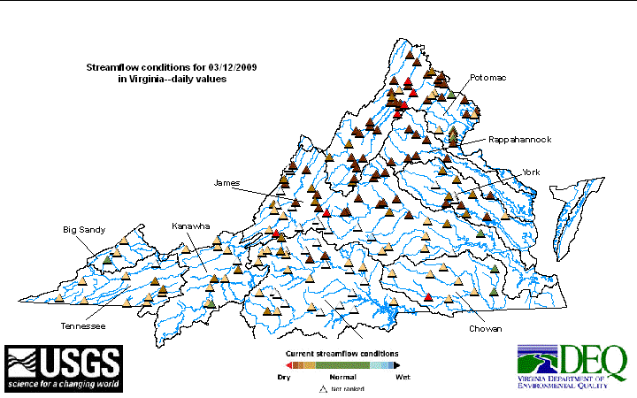
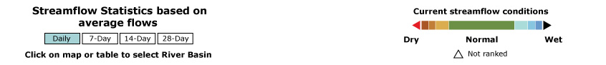

APPENDIX G
Drought Watch -- USGS State Information on Drought
Map of below normal 7-day average streamflow
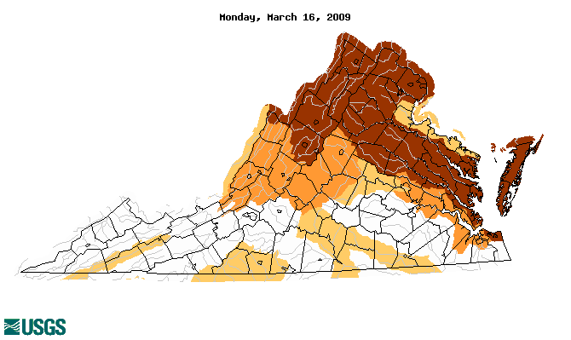
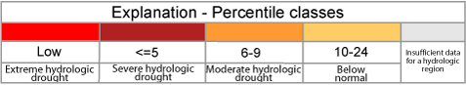
APPENDIX H
Virginia Climate Response Network
March 17, 2009


