Directions for Watershed Delineation with DEMs.
Before you use ArcMap, Turn off the Fire wall. Lower right corner of the taskbar, there is an icon for it, choose disable. Wait 30 seconds, then start ArcMap.

First time users will need to set up toolbars with ArcHydro and Edit. They will also have to enable the Spatial Analyst extension.

Layers you need to provide:
Points of the outlet of the watershed in Albers NAD 83 projection.
If your data is in some other format, please project it to Albers.
(You can also just draw the points you want to delineate, if you know approximately the area you are interested in).

GIS Laptop D:\WaterShedDLN\
Open the WatershedDelin.mxd

Layers in the map:
DEM Sheds for gages—Group of layers with batch points for many of our gages, and their general watersheds delineated already. Use as a guide, or select out a few to work with.

STREAM GRIDS: Str_James500, Str_east, Str_west, Str_poto.
ArcHydro Toolbar
Check to see that the ArcHydro Toolbar is loaded
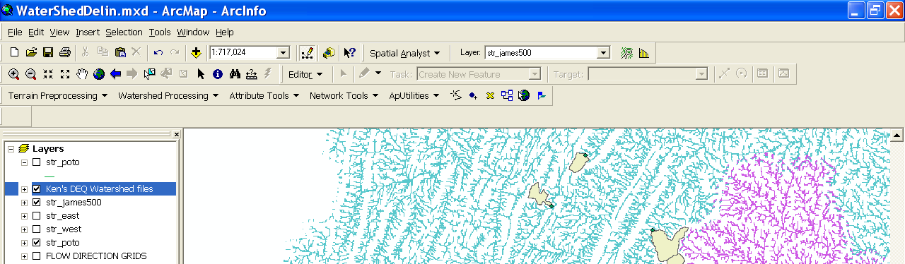
Add your point layer to the map.
Display the stream grid for the basin you are working in.

Zoom in to see if the points lie on top of a stream grid cell.
If not, you will have to create a new point layer that has the points snapped to the stream grid. (I’m working on an automatic one.)

The yellow ‘X’ button is the Batch Point tool (arrow in pict.). This will allow you to draw new points on the stream grid to create watershed outlets.

Open the table of points (you provided) and sort them. Select the first one, and orient the table so you can see the name/id/something to recognize the point. Zoom in to the point so you can see the stream grid cells.

Select the Batch Point tool, click on the stream grid where you want the new point located.
A window will open for the first point so you can name the batch point file.
A second window will open for you to add point-specific information.
Add Name, and description information. BatchDone = 0, Snap = 1. OK

Repeat for each point.

When you are finished, select the Watershed Processing Menu/ Batch Subwatershed delineation.
Flow direction grid = Basin_fd (drop down should show you choices).
Subwatershed Outlet = the name of your batch file
Subwatershed = select a new name for the watershed file created
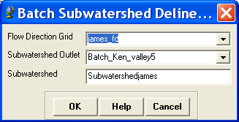

Where are the watersheds?
D:\watershedDelin\watershedDelin.mdb\layers

Within arcmap you can right click on the watershed layer, choose DATA,
Export to shapefile. Export the watershed file to a directory of your choice.

However, when each watershed is created, it received a unique GRIDCODE, but it doesn’t have the attribute information for the watershed outlet. To obtain this, a little more processing should be done.

Right click on the watershed layer and select Join
The join window will open. Select Join based upon Spatial Location.
Choose the layer to join to your watersheds = batch points

Choose the second radio button option to give each polygon the attributes of the point inside it, or the one closest to it.

Select a location and file name for the new file.

OK

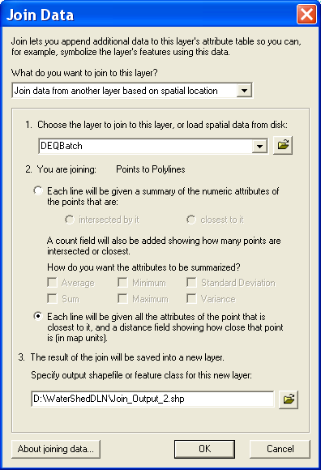

In arcmap right click on the joined watershed layer, choose DATA,
Export to shapefile. Export the watershed file to a directory of your choice.

When you are finished, remove all the files you added or created in the project. Save your Batch points File, if anything, that file you will need to re-do watersheds in the future.

In arcCatalog, go to D:\watershedDelin\watershedDelin.mdb\layers and delete any file you do not need (like the original watershed file before the spatial join).

See Jen if you need help.

What if I have watersheds in multiple basins? Each basin need to be processes separately. James, Potomac, South West, South East. I don’t have the Coastal plain around the Bay complete at present.

Once you make your Batch Point files and run the subwatersheds command, and do the spatial join with the Batch points, you can merge files together into one. Tools/Geoprocessing Wizard/ merge two layers together.

