DROUGHT MONITORING TASK FORCE
Drought Status Report
February 25, 2008

Statewide precipitation for the previous water year (October 1, 2006 through September 30, 2007) was below normal (81% of normal). Statewide precipitation for the period from October 1, 2006 until February 21, 2008 was below normal (78% of normal) and statewide precipitation in each successive shorter time period is below normal. Statewide precipitation for the period from February 1, 2008 to February 21, 2008 is 95% of normal. Precipitation greater than 85% of normal is considered to be in the normal range. The relatively wet period from February 1 until February 21has had very little effect on accumulated precipitation deficits across the Commonwealth. The following drought evaluation regions are currently below normal for the period beginning October 1, 2006; Big Sandy (72%), New River (77%), Roanoke (76%), Upper James (81%), Middle James (79%), Shenandoah (80%), Northern Virginia (76%), Northern Piedmont (74%), Chowan (83%), Northern Coastal Plain (77%), York-James (75%) and Southeast Virginia (84%). Precipitation deficits across the Commonwealth increased 1-3% in most drought evaluation regions since the last report. All drought evaluation regions now have accumulated precipitation deficits that represent below normal conditions except the Eastern Shore (92%). Appendix A contains precipitation tables for periods dating to October 1, 2006. The long-range monthly climatologic outlook calls for above normal temperatures statewide and equal chances of below normal, normal and above normal precipitation for the Commonwealth through March of 2008. The long-range seasonal outlook calls for above normal temperatures for the entire Commonwealth through May 2008. The long-range seasonal outlook calls for equal chances of below normal, normal and above normal precipitation for Southwest and Northern Virginia and below normal precipitation for the remainder of the Commonwealth through May 2008.

The latest NOAA drought monitor indicates the occurrence of drought conditions throughout the majority of the Commonwealth and is included as Appendix B. Appendix C contains information from the national drought monitor with only Virginia displayed. Drought conditions have remained relatively stable over the Commonwealth during the last month. The area of extreme drought in Southwest Virginia has improved to a rating of severe drought and a narrow band of extreme drought conditions has developed along the North Carolina border in south-central Virginia. The NOAA seasonal drought outlook through May 2008 indicates that drought conditions may improve in the majority of the Commonwealth with the potential for minor improvement in southeastern third of Virginia. The seasonal drought outlook is included as Appendix D.

Seven day average streamflows for February 24 in the majority of the Commonwealth are below normal (10th to 24th percentiles) with most areas east of a line from Danville to Washington, D.C. in the range of flows indicative of moderate hydrologic drought (6th to 9th percentiles). Areas in the Roanoke and Nottoway river basins are exhibiting flows indicative of severe hydrologic drought (< 5th percentile). While drought monitoring ground water levels data is scarce, ground water levels are generally in the lower range of expected water levels in areas east of Route 95 and are generally lower than normal in the area west of Route 95. Five dedicated drought monitoring wells are at levels indicative of moderate hydrologic drought (10th to 24th percentiles) and eight are at levels indicative of severe hydrologic drought (< 10th percentile). Ground water levels in 12 of 19 dedicated monitoring wells have shown increases in water levels in the last month indicating a short period of ground water recharge. While this period of ground water recharge is beneficial all indications are that ground water recharge will be below normal prior to the onset of the 2008 growing season. Levels of most large reservoirs have rebounded over the last month and are expected to fill before spring with the exception of Lake Anna which continues to be lower than normal.

While the Virginia Department of Health has not reported any impacts to public water supplies that have compromised their ability to provide the needs of their customers 30 systems have initiated voluntary water conservation requirements and 10 systems have initiated mandatory water conservation requirements. The reduction in conservation requirements is likely reflective of decrease water demands during the winter season and it is likely that additional systems will initiate water conservation requirements with the onset of the growing season. Appendix E contains a table of waterworks that have initiated water conservation requirements.

The Department of Forestry reports that the most intense single day of wildfire activity in the preceding 70 years occurred on February 10, 2008. During this event wildfires driven by unusually high winds were reported in 62 localities across the Commonwealth. There were 357 reported fires that burned almost 14,000 acres, and damaged or destroyed 9 homes, 19 other structures and 7 vehicles. March and April are historically the most active portion of Virginia's spring fire season. The potential for wildfires can change quickly in the short term, however, all indications are that this years activity will be higher than average. Extended drought into the summer can also create wildfire issues with ground fires in the south east part of the state that can contribute to substantial smoke issues in terms of public health as well as with road closures.

The Department of Game and Inland Fisheries reports no significant change in the past month in streamflows or reservoir levels related to recreational activities. Recreation has been impacted minimally due primarily to the limited seasonal demand. All boat access ramps are open in spite of the lower water levels. There have been some delays in trout stockings due to low streamflows in the western portion of the state. The trout raised in Department facilities are smaller then average due to the prolonged drought. Significant winter/spring precipitation events are needed to provide adequate recreational opportunity and aquatic habitat during the spring fishing and fish spawning period.

The intensity of drought impacts has remained constant during the last month. Current moisture deficits will likely result in significant drought impacts across all socio-economic sectors in the spring of 2008 without significant additional precipitation in the next 4-6 weeks.

Reports from the Climatology Office of the University of Virginia, the National Weather Service, the Virginia Department of Agriculture and Consumer Services, the Virginia Department of Environmental Quality, and the United States Geological Survey follow.

Report of the Climatology Office of the University of Virginia

February has been marked by consistent winter storm activity, which has led to significant precipitation in most of the Commonwealth. Only those regions in the central portions of Virginia failed to get at least 90% of normal precipitation during the first three weeks of the month, and most of the remaining regions received above normal precipitation.

Throughout the month, upper-air circulation has kept winter storms on track for Virginia, and more widespread precipitation is expected before the month ends, though the amounts are expected to be relatively small. Outlooks through the first week in March also suggest a continuation of this storm activity. Longer-range outlooks are not encouraging, however. The March through May period is forecast to bring below normal precipitation for almost the entire state, while no specific forecast for March precipitation is given.

As has been emphasized in previous reports, precipitation during the colder months of the year is critical to the moisture status throughout the upcoming growing season. An analysis of the long-term climatological record was performed to estimate the probability of receiving average precipitation totals on a state-wide basis between now and the end of March.

Based upon that analysis, the current probability that the statewide average precipitation total for the period October 2007 through March 2008 will reach that normal level has dropped to near zero. The probability of reaching 85% of normal (low end of the "normal range") is only about 27 percent. Since this is based upon precipitation averaged across Virginia, it does not indicate its likely distribution across the individual Drought Regions. It is clear, however that the opportunity for long-term deficits to be eliminated prior to the start of the growing season is vanishing rapidly.

Report of the National Weather Service

After a dry January, many areas of the Commonwealth received average to above average precipitation in the first three weeks of February. There is one additional opportunity for rainfall on February 26 as a cold front crosses the area. At this point, precipitation amounts with this system are anticipated to be in the range of one-half to three-quarters of an inch. Looking forward, the drier than normal signal associated with cold season LaNina events disappears after April. Summer pattern convective rainfall is extremely difficult to forecast long-term, and seasonal forecasts from late spring into fall are non-committal regarding precipitation tendencies during that period. In addition, it's too early to predict any potential tropical storm activity this summer/early fall. Finally, the most significant concern in the next 60 to 90 days is the fire weather potential. The tendency over the last 3-4 weeks has been for fuels to dry rapidly after recent rainfalls, with fire danger increasing rapidly 5-7 days after significant rainfall. A dry period of 7-10 days preceded the significant fire/wind day on February 10th. Since March and April are usually windy months, it's quite likely that additional significant fire danger days will occur unless we begin receiving significant rainfalls on a "regular" 3-6 day schedule.

Virginia Department of Agriculture and Consumer Services
Status of Agricultural Drought

According to the USDA Crop Weather Report released on February 4, 2008, topsoil moisture was adequate. However, producers are concerned about low subsoil moisture, and the dry trend does not help prospects for the 2008 growing season. Significant rainfall over the last month has helped to relieve drought conditions in the western part of the state. Small grain crops are in pretty good condition and farmers are beginning to top dress the crops. Animal feeding is in full swing though hay is still in short supply, and hay prices are elevated. While the Commonwealth is still experiencing deficit rainfall, the future impact of the continued drought cannot be determined at this time.

Impact on Dairy Industry
Hay is in short supply, and hay prices are high. Many farmers are preparing areas of land not usually grazed by cattle so that cattle may graze those areas, thus reducing the requirements for winter hay. Some dairymen who normally have hay to carry over from year to year have begun to use their reserves. Dairymen are continuing to stretch their feed supply and are culling more cows than usual.

Even though milk prices are high, dairymen's budgets are strained because of the high cost of feed, seed, and fertilizer. One dairyman has sold out due to the lack of feed caused by the drought. The dairyman intends to return to shipping milk as soon as he can acquire or raise enough feed.

Nursery/Horticulture
The Virginia Nursery and Landscape industries do not have any additional drought updates at this time since the spring growing season is just beginning. Although most growers now have access to sufficient water, it will be another couple of months before the extent of last year's drought damage becomes fully evident in over-wintered plants.

Disaster Designations
Due to the extreme agricultural drought, 93 Virginia counties and 34 independent cities received a Secretarial disaster designation in 2007 as a primary natural disaster area. York and Arlington counties and the independent cities of Alexandria, Bristol, Falls Church, Poquoson, and Norton were named contiguous disaster areas.

Waivers for Hauling of Emergency Supplies
At the request of the Department of Agriculture and Consumer Services, the Department of Transportation and Department of Motor Vehicle have jointly authorized a temporary waiver of registration and license requirements along with normal weight and width restrictions for the hauling of hay and feed to the counties that have been designated natural disaster areas by the U.S. Secretary of Agriculture. The waiver also pertains to contiguous counties. In addition, the Department of Emergency Management has authorized appropriate motor carrier exemptions to hours worked as prescribed by the Code of Federal Regulations and corresponding state regulations throughout the Commonwealth for carriers transporting emergency supplies destined for the affected localities. Both waivers became effective at 6 a.m. on August 11 and will remain in effect through April 15, 2008.

Virginia Department of Environmental Quality
Condition of Major Reservoirs

Despite lower than normal inflows reservoir conditions have improved over the past month.

The slowest lake to respond has been Lake Anna, which is to be expected because of its relatively small watershed. The lake is still 1.2 feet from full and may not be full by the end of spring. Dominion has yet to complete its instream flow study downstream of the lake and may release more than the minimum amount of water that is required by permit in order to collect medium and high flow habitat data.

Lake Moomaw in western Virginia is full and is back to normal releases.

Kerr Reservoir is at 297.6 feet, a foot above guide curve and 1.7 feet higher than a month ago. Because of low inflows, the Southeastern Power Administration (SEPA) is making the minimum amount of hydroelectric power to fulfill their contracts. The current release of 2200 cfs is enough to keep the salt wedge from moving up the Roanoke River from the Albemarle Sound, thereby preserving the water supply of a paper mill in eastern North Carolina. The Kerr Lake Guide Curve changes in the spring and will rise to 301 feet at the end of March. It is unlikely that the actual lake level will rise to that level in time. If we do get to that level the Corps of Engineers can augment flow in the lower Roanoke River to enhance the spawning of anadromous fish.

The other large Corps of Engineers Lake, Lake Philpott, is at 966.9 feet, 1.3 feet up from a month ago. SEPA is making only half of the normal release from Philpott in order to bring that lake back up to a more normal level.

Smith Mountain Lake is full. The lake has gained 1.1 feet in the past month. The lake level is currently steady as outflows are close to inflows. We continue to manage releases in variance mode due to the abnormally low inflows.

United States Geological Survey
Streamflow and Ground Water Levels

Most streamflows in the Coastal Plain Physiographic Province and the central and southern Piedmont Physiographic Province are well below normal. These low flow levels are not unexpected considering current precipitation deficits. Most streamgages in the rest of the State show flow values in the normal or just below normal ranges.

The majority of water-table monitoring wells still show water levels below normal; however, 12 of 19 wells have shown indications of ground-water recharge in the last month. In most of the 12 wells with increasing water levels, the upward trend in water-levels can not be considered strong. Water levels in the remaining wells are either constant or still declining.

It appears that leaf-out in eastern and central Virginia is one to two weeks ahead of normal. This earlier than normal budding of plants, in addition to a late leaf drop last fall, has reduced the potential ground-water recharge period by about a month. Without significant precipitation in the next four to six weeks, it is unlikely that ground-water levels will maintain normal streamflow through the summer.

Streamflow conditions based on daily values for February 24 are presented in Appendix F. Area summaries of 7-day average streamflows from the USGS drought watch web page show similar flow conditions and are presented in Appendix G. Current conditions are generally lower than depicted by seven day average stream flows as flows continue to decline. Ground water levels based on conditions on February 20 are presented in Appendix H.

APPENDIX A

Precipitation departures by Drought Evaluation Region.

 | PRELIMINARY PRECIPITATION SUMMARY |  |  |  | Prepared:
 |  |  |  |  | 02/22/08
 | DROUGHT |  | Feb 1, 2008 | - Feb 21, 2008
 | REGION | OBSERVED | NORMAL | DEPARTURE | % OF NORM.
1 | Big Sandy | 2.84 | 2.66 | 0.18 | 107%
2 | New River | 1.96 | 2.18 | -0.22 | 90%
3 | Roanoke | 1.97 | 2.46 | -0.49 | 80%
4 | Upper James | 1.61 | 2.12 | -0.51 | 76%
5 | Middle James | 2.07 | 2.32 | -0.25 | 89%
6 | Shenandoah | 1.70 | 1.79 | -0.09 | 95%
7 | Northern Virginia | 2.30 | 1.98 | 0.32 | 116%
8 | Northern Piedmont | 2.40 | 2.21 | 0.19 | 109%
9 | Chowan | 2.42 | 2.36 | 0.07 | 103%
10 | Northern Coastal Plain | 2.52 | 2.33 | 0.19 | 108%
11 | York-James | 2.40 | 2.62 | -0.22 | 91%
12 | Southeast Virginia | 2.99 | 2.60 | 0.38 | 115%
13 | Eastern Shore | 2.93 | 2.37 | 0.56 | 124%
 | Statewide | 2.21 | 2.33 | -0.12 | 95%
 | DROUGHT |  | Jan 1, 2008 | - Feb 21, 2008
 | REGION | OBSERVED | NORMAL | DEPARTURE | % OF NORM.
1 | Big Sandy | 4.81 | 6.39 | -1.58 | 75%
2 | New River | 3.06 | 5.39 | -2.33 | 57%
3 | Roanoke | 2.89 | 6.38 | -3.49 | 45%
4 | Upper James | 3.16 | 5.40 | -2.24 | 59%
5 | Middle James | 2.88 | 5.98 | -3.10 | 48%
6 | Shenandoah | 2.52 | 4.64 | -2.12 | 54%
7 | Northern Virginia | 3.45 | 5.26 | -1.82 | 65%
8 | Northern Piedmont | 5.18 | 5.73 | -0.55 | 90%
9 | Chowan | 3.53 | 6.47 | -2.93 | 55%
10 | Northern Coastal Plain | 3.38 | 6.08 | -2.70 | 56%
11 | York-James | 3.59 | 6.76 | -3.17 | 53%
12 | Southeast Virginia | 4.40 | 6.76 | -2.36 | 65%
13 | Eastern Shore | 4.65 | 5.93 | -1.28 | 78%
 | Statewide | 3.46 | 5.97 | -2.51 | 58%

 | DROUGHT |  | Dec 1, 2007 | - Feb 21, 2008
 | REGION | OBSERVED | NORMAL | DEPARTURE | % OF NORM.
1 | Big Sandy | 7.73 | 10.03 | -2.31 | 77%
2 | New River | 5.51 | 8.10 | -2.59 | 68%
3 | Roanoke | 6.11 | 9.63 | -3.52 | 63%
4 | Upper James | 6.13 | 8.35 | -2.22 | 73%
5 | Middle James | 5.56 | 9.15 | -3.59 | 61%
6 | Shenandoah | 5.47 | 7.23 | -1.77 | 76%
7 | Northern Virginia | 6.49 | 8.36 | -1.88 | 78%
8 | Northern Piedmont | 8.08 | 9.01 | -0.92 | 90%
9 | Chowan | 7.67 | 9.49 | -1.81 | 81%
10 | Northern Coastal Plain | 6.13 | 9.36 | -3.24 | 65%
11 | York-James | 7.70 | 10.15 | -2.45 | 76%
12 | Southeast Virginia | 8.06 | 9.94 | -1.89 | 81%
13 | Eastern Shore | 9.22 | 9.17 | 0.05 | 101%
 | Statewide | 6.53 | 9.09 | -2.56 | 72%
 | DROUGHT |  | Nov 1, 2007 | - Feb 21, 2008
 | REGION | OBSERVED | NORMAL | DEPARTURE | % OF NORM.
1 | Big Sandy | 9.42 | 13.31 | -3.89 | 71%
2 | New River | 5.95 | 11.13 | -5.18 | 53%
3 | Roanoke | 6.59 | 12.99 | -6.40 | 51%
4 | Upper James | 6.53 | 11.71 | -5.18 | 56%
5 | Middle James | 6.08 | 12.66 | -6.58 | 48%
6 | Shenandoah | 6.57 | 10.28 | -3.71 | 64%
7 | Northern Virginia | 8.07 | 11.77 | -3.71 | 69%
8 | Northern Piedmont | 8.95 | 12.81 | -3.86 | 70%
9 | Chowan | 8.12 | 12.60 | -4.47 | 64%
10 | Northern Coastal Plain | 7.23 | 12.50 | -5.27 | 58%
11 | York-James | 8.52 | 13.52 | -5.00 | 63%
12 | Southeast Virginia | 8.62 | 13.01 | -4.39 | 66%
13 | Eastern Shore | 10.06 | 12.11 | -2.05 | 83%
 | Statewide | 7.33 | 12.32 | -4.99 | 60%

 | DROUGHT |  | Oct 1, 2007 | - Feb 21, 2008
 | REGION | OBSERVED | NORMAL | DEPARTURE | % OF NORM.
1 | Big Sandy | 11.38 | 16.19 | -4.81 | 70%
2 | New River | 9.66 | 14.30 | -4.64 | 68%
3 | Roanoke | 10.20 | 16.70 | -6.50 | 61%
4 | Upper James | 8.90 | 14.96 | -6.06 | 60%
5 | Middle James | 9.70 | 16.50 | -6.80 | 59%
6 | Shenandoah | 8.78 | 13.47 | -4.69 | 65%
7 | Northern Virginia | 11.31 | 15.25 | -3.94 | 74%
8 | Northern Piedmont | 11.96 | 16.80 | -4.84 | 71%
9 | Chowan | 11.22 | 16.18 | -4.96 | 69%
10 | Northern Coastal Plain | 12.61 | 16.01 | -3.41 | 79%
11 | York-James | 12.36 | 17.05 | -4.69 | 72%
12 | Southeast Virginia | 13.89 | 16.67 | -2.78 | 83%
13 | Eastern Shore | 13.43 | 15.32 | -1.90 | 88%
 | Statewide | 10.64 | 15.82 | -5.18 | 67%
 | DROUGHT |  | Sep 1, 2007 | - Feb 21, 2008
 | REGION | OBSERVED | NORMAL | DEPARTURE | % OF NORM.
1 | Big Sandy | 12.64 | 19.65 | -7.01 | 64%
2 | New River | 11.30 | 17.71 | -6.41 | 64%
3 | Roanoke | 12.28 | 20.93 | -8.65 | 59%
4 | Upper James | 11.16 | 18.46 | -7.30 | 60%
5 | Middle James | 10.51 | 20.63 | -10.12 | 51%
6 | Shenandoah | 10.72 | 17.14 | -6.42 | 63%
7 | Northern Virginia | 12.48 | 19.32 | -6.85 | 65%
8 | Northern Piedmont | 12.95 | 21.08 | -8.13 | 61%
9 | Chowan | 12.18 | 20.61 | -8.42 | 59%
10 | Northern Coastal Plain | 13.85 | 20.10 | -6.25 | 69%
11 | York-James | 14.26 | 21.95 | -7.69 | 65%
12 | Southeast Virginia | 14.62 | 21.10 | -6.48 | 69%
13 | Eastern Shore | 14.99 | 18.93 | -3.95 | 79%
 | Statewide | 12.06 | 19.82 | -7.76 | 61%

 | DROUGHT |  | Aug 1, 2007 | - Feb 21, 2008
 | REGION | OBSERVED | NORMAL | DEPARTURE | % OF NORM.
1 | Big Sandy | 13.82 | 23.48 | -9.66 | 59%
2 | New River | 12.49 | 21.02 | -8.52 | 59%
3 | Roanoke | 13.11 | 24.65 | -11.54 | 53%
4 | Upper James | 12.60 | 21.79 | -9.19 | 58%
5 | Middle James | 13.23 | 24.45 | -11.22 | 54%
6 | Shenandoah | 13.50 | 20.47 | -6.97 | 66%
7 | Northern Virginia | 14.34 | 23.17 | -8.84 | 62%
8 | Northern Piedmont | 15.33 | 24.90 | -9.57 | 62%
9 | Chowan | 14.19 | 24.92 | -10.73 | 57%
10 | Northern Coastal Plain | 15.30 | 23.96 | -8.67 | 64%
11 | York-James | 16.59 | 26.82 | -10.24 | 62%
12 | Southeast Virginia | 18.10 | 26.22 | -8.13 | 69%
13 | Eastern Shore | 17.48 | 22.80 | -5.32 | 77%
 | Statewide | 13.93 | 23.65 | -9.72 | 59%
 | DROUGHT |  | Jul 1, 2007 | - Feb 21, 2008
 | REGION | OBSERVED | NORMAL | DEPARTURE | % OF NORM.
1 | Big Sandy | 18.31 | 27.96 | -9.65 | 65%
2 | New River | 15.42 | 24.81 | -9.39 | 62%
3 | Roanoke | 16.39 | 29.04 | -12.65 | 56%
4 | Upper James | 14.94 | 25.83 | -10.89 | 58%
5 | Middle James | 15.59 | 28.86 | -13.27 | 54%
6 | Shenandoah | 15.50 | 24.23 | -8.74 | 64%
7 | Northern Virginia | 16.80 | 26.94 | -10.14 | 62%
8 | Northern Piedmont | 16.86 | 29.30 | -12.44 | 58%
9 | Chowan | 17.25 | 29.43 | -12.18 | 59%
10 | Northern Coastal Plain | 16.72 | 28.41 | -11.70 | 59%
11 | York-James | 20.03 | 31.92 | -11.89 | 63%
12 | Southeast Virginia | 21.41 | 31.29 | -9.89 | 68%
13 | Eastern Shore | 19.57 | 26.80 | -7.23 | 73%
 | Statewide | 16.66 | 27.99 | -11.33 | 60%

 | DROUGHT |  | Jun 1, 2007 | - Feb 21, 2008
 | REGION | OBSERVED | NORMAL | DEPARTURE | % OF NORM.
1 | Big Sandy | 21.06 | 32.10 | -11.05 | 66%
2 | New River | 18.46 | 28.66 | -10.20 | 64%
3 | Roanoke | 19.31 | 32.93 | -13.62 | 59%
4 | Upper James | 18.69 | 29.54 | -10.84 | 63%
5 | Middle James | 18.94 | 32.37 | -13.43 | 59%
6 | Shenandoah | 18.77 | 27.94 | -9.17 | 67%
7 | Northern Virginia | 18.74 | 30.80 | -12.06 | 61%
8 | Northern Piedmont | 19.01 | 33.31 | -14.30 | 57%
9 | Chowan | 19.46 | 33.08 | -13.61 | 59%
10 | Northern Coastal Plain | 18.57 | 31.97 | -13.40 | 58%
11 | York-James | 22.22 | 35.33 | -13.12 | 63%
12 | Southeast Virginia | 24.63 | 34.90 | -10.28 | 71%
13 | Eastern Shore | 24.82 | 29.78 | -4.96 | 83%
 | Statewide | 19.52 | 31.78 | -12.26 | 61%
 | DROUGHT |  | May 1, 2007 | - Feb 21, 2008
 | REGION | OBSERVED | NORMAL | DEPARTURE | % OF NORM.
1 | Big Sandy | 22.80 | 36.92 | -14.12 | 62%
2 | New River | 20.24 | 32.87 | -12.63 | 62%
3 | Roanoke | 21.28 | 37.26 | -15.98 | 57%
4 | Upper James | 20.72 | 33.82 | -13.10 | 61%
5 | Middle James | 21.40 | 36.61 | -15.21 | 58%
6 | Shenandoah | 20.96 | 31.78 | -10.82 | 66%
7 | Northern Virginia | 20.01 | 35.14 | -15.14 | 57%
8 | Northern Piedmont | 21.10 | 37.53 | -16.43 | 56%
9 | Chowan | 22.35 | 37.17 | -14.82 | 60%
10 | Northern Coastal Plain | 19.82 | 36.13 | -16.32 | 55%
11 | York-James | 23.77 | 39.60 | -15.83 | 60%
12 | Southeast Virginia | 26.59 | 38.76 | -12.17 | 69%
13 | Eastern Shore | 26.56 | 33.30 | -6.74 | 80%
 | Statewide | 21.55 | 36.04 | -14.49 | 60%

 | DROUGHT |  | Apr 1, 2007 | - Feb 21, 2008
 | REGION | OBSERVED | NORMAL | DEPARTURE | % OF NORM.
1 | Big Sandy | 27.27 | 40.68 | -13.41 | 67%
2 | New River | 23.36 | 36.42 | -13.06 | 64%
3 | Roanoke | 24.50 | 41.06 | -16.56 | 60%
4 | Upper James | 24.22 | 37.22 | -13.00 | 65%
5 | Middle James | 24.63 | 39.95 | -15.31 | 62%
6 | Shenandoah | 24.54 | 34.70 | -10.17 | 71%
7 | Northern Virginia | 23.73 | 38.44 | -14.71 | 62%
8 | Northern Piedmont | 24.19 | 40.82 | -16.62 | 59%
9 | Chowan | 26.78 | 40.60 | -13.81 | 66%
10 | Northern Coastal Plain | 23.53 | 39.22 | -15.70 | 60%
11 | York-James | 27.81 | 42.90 | -15.09 | 65%
12 | Southeast Virginia | 31.11 | 42.01 | -10.91 | 74%
13 | Eastern Shore | 31.11 | 36.22 | -5.11 | 86%
 | Statewide | 25.19 | 39.46 | -14.27 | 64%
 | DROUGHT |  | Mar 1, 2007 | - Feb 21, 2008
 | REGION | OBSERVED | NORMAL | DEPARTURE | % OF NORM.
1 | Big Sandy | 30.40 | 44.93 | -14.53 | 68%
2 | New River | 27.39 | 40.09 | -12.69 | 68%
3 | Roanoke | 28.18 | 45.33 | -17.15 | 62%
4 | Upper James | 27.85 | 41.01 | -13.16 | 68%
5 | Middle James | 27.69 | 44.01 | -16.32 | 63%
6 | Shenandoah | 27.41 | 37.90 | -10.49 | 72%
7 | Northern Virginia | 26.89 | 42.10 | -15.22 | 64%
8 | Northern Piedmont | 26.62 | 44.63 | -18.00 | 60%
9 | Chowan | 29.35 | 44.97 | -15.62 | 65%
10 | Northern Coastal Plain | 26.34 | 43.50 | -17.17 | 61%
11 | York-James | 29.53 | 47.59 | -18.06 | 62%
12 | Southeast Virginia | 33.05 | 46.21 | -13.16 | 72%
13 | Eastern Shore | 32.89 | 40.53 | -7.64 | 81%
 | Statewide | 28.26 | 43.50 | -15.24 | 65%

 | DROUGHT |  | Feb 1, 2007 | - Feb 21, 2008
 | REGION | OBSERVED | NORMAL | DEPARTURE | % OF NORM.
1 | Big Sandy | 31.80 | 48.51 | -16.71 | 66%
2 | New River | 29.05 | 43.02 | -13.97 | 68%
3 | Roanoke | 30.24 | 48.64 | -18.41 | 62%
4 | Upper James | 30.31 | 43.86 | -13.55 | 69%
5 | Middle James | 29.66 | 47.13 | -17.47 | 63%
6 | Shenandoah | 29.47 | 40.31 | -10.84 | 73%
7 | Northern Virginia | 29.73 | 44.77 | -15.05 | 66%
8 | Northern Piedmont | 29.07 | 47.60 | -18.53 | 61%
9 | Chowan | 31.52 | 48.14 | -16.62 | 65%
10 | Northern Coastal Plain | 28.84 | 46.64 | -17.80 | 62%
11 | York-James | 31.28 | 51.12 | -19.85 | 61%
12 | Southeast Virginia | 35.32 | 49.71 | -14.40 | 71%
13 | Eastern Shore | 35.68 | 43.72 | -8.04 | 82%
 | Statewide | 30.35 | 46.63 | -16.28 | 65%
 | DROUGHT |  | Jan 1, 2007 | - Feb 21, 2008
 | REGION | OBSERVED | NORMAL | DEPARTURE | % OF NORM.
1 | Big Sandy | 34.98 | 52.24 | -17.26 | 67%
2 | New River | 32.01 | 46.23 | -14.22 | 69%
3 | Roanoke | 34.11 | 52.56 | -18.45 | 65%
4 | Upper James | 33.31 | 47.14 | -13.83 | 71%
5 | Middle James | 33.23 | 50.79 | -17.56 | 65%
6 | Shenandoah | 31.03 | 43.16 | -12.13 | 72%
7 | Northern Virginia | 31.97 | 48.05 | -16.08 | 67%
8 | Northern Piedmont | 31.58 | 51.12 | -19.53 | 62%
9 | Chowan | 34.04 | 52.25 | -18.21 | 65%
10 | Northern Coastal Plain | 33.08 | 50.39 | -17.31 | 66%
11 | York-James | 33.89 | 55.26 | -21.38 | 61%
12 | Southeast Virginia | 38.49 | 53.87 | -15.39 | 71%
13 | Eastern Shore | 37.85 | 47.28 | -9.43 | 80%
 | Statewide | 33.41 | 50.27 | -16.86 | 66%

 | DROUGHT |  | Dec 1, 2006 | - Feb 21, 2008
 | REGION | OBSERVED | NORMAL | DEPARTURE | % OF NORM.
1 | Big Sandy | 36.98 | 55.88 | -18.90 | 66%
2 | New River | 33.79 | 48.94 | -15.15 | 69%
3 | Roanoke | 36.29 | 55.81 | -19.52 | 65%
4 | Upper James | 35.31 | 50.09 | -14.78 | 70%
5 | Middle James | 34.82 | 53.96 | -19.14 | 65%
6 | Shenandoah | 32.15 | 45.75 | -13.60 | 70%
7 | Northern Virginia | 33.64 | 51.15 | -17.52 | 66%
8 | Northern Piedmont | 33.34 | 54.40 | -21.06 | 61%
9 | Chowan | 36.21 | 55.27 | -19.06 | 66%
10 | Northern Coastal Plain | 34.78 | 53.67 | -18.89 | 65%
11 | York-James | 35.71 | 58.65 | -22.95 | 61%
12 | Southeast Virginia | 40.94 | 57.05 | -16.12 | 72%
13 | Eastern Shore | 40.60 | 50.52 | -9.92 | 80%
 | Statewide | 35.26 | 53.39 | -18.13 | 66%
 | DROUGHT |  | Nov 1, 2006 | - Feb 21, 2008
 | REGION | OBSERVED | NORMAL | DEPARTURE | % OF NORM.
1 | Big Sandy | 39.73 | 59.16 | -19.43 | 67%
2 | New River | 37.75 | 51.97 | -14.22 | 73%
3 | Roanoke | 41.69 | 59.17 | -17.48 | 70%
4 | Upper James | 39.09 | 53.45 | -14.36 | 73%
5 | Middle James | 40.55 | 57.47 | -16.92 | 71%
6 | Shenandoah | 36.30 | 48.80 | -12.50 | 74%
7 | Northern Virginia | 39.43 | 54.56 | -15.13 | 72%
8 | Northern Piedmont | 39.64 | 58.20 | -18.56 | 68%
9 | Chowan | 43.58 | 58.38 | -14.80 | 75%
10 | Northern Coastal Plain | 40.08 | 56.81 | -16.73 | 71%
11 | York-James | 41.37 | 62.02 | -20.65 | 67%
12 | Southeast Virginia | 48.55 | 60.12 | -11.57 | 81%
13 | Eastern Shore | 45.48 | 53.46 | -7.98 | 85%
 | Statewide | 40.42 | 56.62 | -16.20 | 71%

 | DROUGHT |  | Oct 1, 2006 | - Feb 21, 2008
 | REGION | OBSERVED | NORMAL | DEPARTURE | % OF NORM.
1 | Big Sandy | 44.71 | 62.04 | -17.33 | 72%
2 | New River | 42.73 | 55.14 | -12.41 | 77%
3 | Roanoke | 47.72 | 62.88 | -15.16 | 76%
4 | Upper James | 46.02 | 56.70 | -10.68 | 81%
5 | Middle James | 48.24 | 61.31 | -13.07 | 79%
6 | Shenandoah | 41.54 | 51.99 | -10.45 | 80%
7 | Northern Virginia | 44.22 | 58.04 | -13.83 | 76%
8 | Northern Piedmont | 46.17 | 62.19 | -16.02 | 74%
9 | Chowan | 51.28 | 61.96 | -10.67 | 83%
10 | Northern Coastal Plain | 46.16 | 60.32 | -14.16 | 77%
11 | York-James | 49.37 | 65.55 | -16.19 | 75%
12 | Southeast Virginia | 53.62 | 63.78 | -10.16 | 84%
13 | Eastern Shore | 52.41 | 56.67 | -4.26 | 92%
 | Statewide | 46.66 | 60.12 | -13.46 | 78%

APPENDIX B

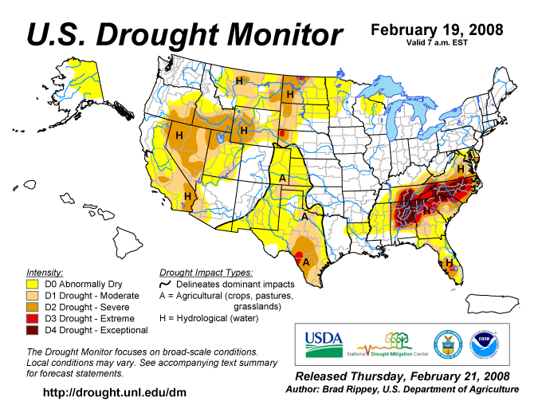

APPENDIX C

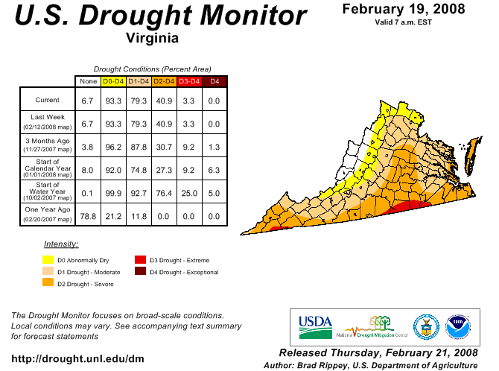
APPENDIX D

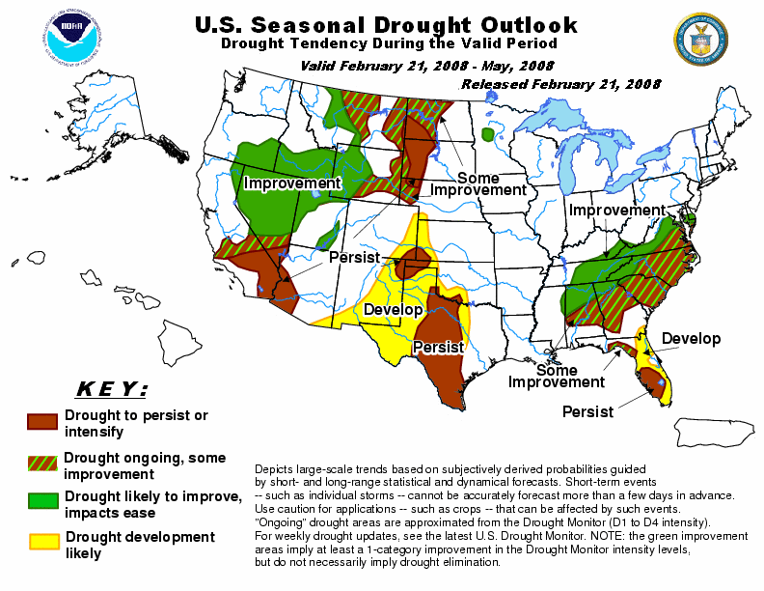

APPENDIX E
Condition of Public Water Supplies
February 22, 2008

ODW Drought Situation Report |  |  |  | Restriction totals
Date: | 2/22/08 |  | Mandatory | 10
 |  |  | Voluntary | 30
 |  |  | Total | 40
 |  |  | N-None | B-Better
 |  |  | M-Mandatory | S-Stable/Same
 |  |  | V-Voluntary | W-Worse
PWSID | Waterworks | Source Name | Restrictions | Situation | Population Served
1105200 | Town of Jonesville | Wynn Spring #1 and Slemp Spring | N | S 1/09/08: Springs' flowrates are stable. Normal WTP operating rate = 380 gpm; down to 300 gpm. WTP running 18 hrs/day. Using all of Wynne Spring production and part of the production of Slemp spring. | 1,100
1105400 | Lee County PSA | Blue Springs | N | B 01/11/08: Spring flow has increased significantly. Currently treating 244,800 gpd with a lot of flow-by. At this rate, tank levels are staying at about full. | 2,500
1105400 | Lee County PSA | KVS Quarry | N | S 01/11/08: Water level in quarry is rising; currently at 204 inches below catwalk . Level was 206 inches below catwalk on 01/08/08. In process of building a floating raw water pump station. | 2,500
1155635 | Town of Pulaski | Two impoundments and Peak Creek | N | B 1/11/07: Hogans Reservoir lowered to repair dam. Gatewood down 4 ft. Hogans down 15 ft. Working on drought response plan with NRV PDC/Kevin Byrd. This plan identified 20 ft down as the critical point for reservoir level. In good shape; may remove from drought report soon. | 9,452
1169725 | Town of Nickelsville | Wells | V | S 01/09/08: Well production had dropped and voluntary conservation notice issued 8/31/07. Well #1 is used occasionally now (about 4 hours/day). Well #3 drops to ~ 6 gpm(safe yield=13). Well #6 drops to ~8-10 gpm(safe yield=21 gpm). Well #5 began pumping muddy water on 01/06/08, however they have now decreased the pumping time to 8 - 9 hours/day and the well appears to be doing fine. Well #4 has no drop in output. Repairing leaks (accountability is satisfactory). Working on adding two new wells: (1) Park well's bacts were all negative. Park well now being used. (2) New Tank well is drilled and grouted; yield and drawdown done (28 gpm) and waiting on test results and the plans & Specs from engineer. | 900
1195050 | Town of Appalachia | reservoir | M | B 01/09/08: down 15'-7.5" from overflow. 29 MG left, 64 days ± 10 left. Pumping from Powell River to reservoir @ approx. 350 gpm. | 3,280
1195100 | Town of Big Stone Gap | Big Cherry Reservoir | M | B 01/09/08: Reservoir down 17.5 ft from overflow. 130 MG left, 48 days, including 1 MGD for flow-by. Are preparing to construct a permanent emergency pump station to get 0.25 MGD of water from Pennington Gap via Dryden via Eastern Lee (are waiting on an easement issue to be resolved). At this time they are no longer considering construction of: the temporary pump station to get 0.15 MGD of water from Duffield; or the 1,500 ft for above ground temporary pipe to get 0.25 MGD of water from Wise County PSA via Norton. At this time, Big Stone Gap has not purchased any water. | 9,000
1195950 | Town of Wise | reservoir | N | S 01/09/08: Reservoir down 11.1 ft, 99 MG left, 165 days left (@ 0.6 MGD). Slightly below average for this time of year. Auxiliary mine well source being pumped into reservoir. | 6,375
1720076 | City of Norton | reservoirs | N | S 1/10/08: Upper reservoir down 19 ft; lower reservoir down 15.5 ft from overflow. 50.2 MG, approx 110 days left based on 0.45 MGD production. Purchasing more water from Wise County PSA. Worse than normal for this time of year. | 4,247
2003250 | Albemarle County / Crozet | Beaver Creek Reservoir | V | B - Beaver Creek Reservoir is full. Drought Watch in effect 1/2/08 | 25
2003600 | Charlottesville/Albemarle County | Sugar Hollow and Ragged Mountain Reservoirs (Observatory WTP) | V | B - Sugar Hollow reservoir is full. Ragged Mountain reservoir is 0.4 feet below full. Drought Watch in effect 1/2/08 | 25
2003675 | Albemarle County / Scottsville | Totier Creek Reservoir | V | S - Totier Creek reservoir is full. Drought Watch in effect 1/2/08 | 25
2003725 | Charlottesville/Albemarle County | South Fork Rivanna (South Rivanna WTP) | V | S - South Fork Rivanna reservoir is full. Drought Watch in effect 1/2/08 | 25
2023720 | Town of Troutville | Five Drilled Wells | N | New - Town reported the pumping rate of their No. 3 well dropped from 123 gpm to 40 gpm. The pumping rates of the other four wells are the same. | 500
2023730 | Dal-Nita Hills | Drilled Well | V | S - Well yield has dropped to 4 to 5 gpm. Owner is hauling water, as needed, to keep storage tank full. Letter provided to the customers advising them of the situation. | 35 homes
2043125 | Berryville, Town of | Shenandoah River | V | S - Voluntary conservation requested on 11 December 2007. | 2,965
2065250 | Fluvanna Correctional Center for Women | Mechunk Creek and on-site Raw Water Reservoir | V | S - Reservoir is 3 feet below full (~35 MG stored). Moderate Drought Condition continues. | 1,650
2069250 | Frederick County Sanitation Authority | Stephens City and Clearbrook Quarries; City of Winchester | V | S - Voluntary conservation has been requested. | 33,330
2125325 | NCSA - Lovingston | Black Creek Reservoir and Wells | N | S - All restrictions lifted; will be deleted from next report if no change | 900
2125065 | NCSA - Gladstone | Spring | N | S - All restrictions lifted; will be deleted from next report if no change | 90
2125650 | NCSA - Schuyler | Johnson's Branch | N | S - All restrictions lifted; will be deleted from next report if no change | 300
2125910 | NCSA - Wintergreen | Lake Monacan | N | S - All restrictions lifted; will be deleted from next report if no change | 3,800
2171750 | Town of Strasburg | North Fork Shenandoah River | V | S - Voluntary conservation has been requested. Stream flow approx 449 cfs on 20 Feburary. | 4,500
2187406 | Front Royal | South Fork Shenandoah River | N | B - Stream flow reported at 74.75% mean stream flow (14 day avg) or approx 1197 cfs on 20 February. Conservation controls lifted on/about 1 January 2008. VWPP requires conservation controls to be implemented at 24% (voluntary) and 17% (mandatory) of mean stream flow based on 14-day running average. | 12,500
2560100 | Town of Clifton Forge | Smith Creek | V | S - Voluntary conservation has been requested. | 4,679
2660345 | City of Harrisonburg | North River, Dry River/Switzer Reservoir (Rawley Springs) | V | S - Voluntary conservation has been requested. This has not been implemented as a result of limited low source water quantity, but rather at the request of the Governor's letter requesting conservation. | 44,500
2840500 | Winchester, City of | North Fork Shenandoah River | V | S - Voluntary conservation requested on 1 October. Stream flow approx 496 cfs on 20 February. | 27,485
3053280 | DCWA Central (Dinwiddie County) | Appomattox River Water Authority (ARWA) | N | S - Lifted restrictions on 12/27/07. | 6,800
3081550 | GCWSA - Jarratt | Nottoway River | N | S - Waterworks has increased work hours per day to decrease withdrawal rate, performed work at the intake to maximize capacity, and inquired about future use of existing inactive groundwater sources. | 7,190
3093120 | Isle of Wight County | Suffolk | V | B - follows Suffolk's lead on conservation. | 1,284
3095490 | JCSA Central | wells | N | B - No restrictions at this time. | 44,760
3149700 | Puddledock Road (Prince George County) | ARWA | N | S - Lifted restrictions on 12/28/07. | 6,525
3550050 | Chesapeake - Western Branch system | City of Portsmouth | V | S -This portion of the city is consecutive to (receives water from) the city of Portsmouth. City Council voted to go to voluntary conservation city-wide - it took effect on 24 Oct 2007. Still following Portsmouth's lead on conservation. | 36,381
3550051 | Chesapeake | Northwest River, City of Norfolk Raw Water (Lake Gaston) | V | S - City Council voted to go to voluntary conservation city-wide - took effect on 24 Oct 2007. Chlorides are used as an indicator of drought, the higher the levels the more concentrated the contaminant in a lesser amount of surface water. The levels have hovered around 500-700 mg/l. The recent rains have reduced the levels to approximately 86 mg/l. City is still encouraging voluntary conservation measures. | 105,525
3550052 | Chesapeake - South Norfolk system | City of Norfolk | V | S - This portion of the city is consecutive to (receives water from) the city of Norfolk. City Council voted to go to voluntary conservation city-wide - it took effect on 24 Oct 2007. Still following Norfolk's lead on conservation. | 33,602
3570150 | Colonial Heights | ARWA | N | S - Lifted restrictions on 12/1/07. | 17,286
3595250 | Emporia | Meherrin River | N | S - Water is going over the dam. | 5,600
3670800 | Virginia-American Water Company (Hopewell) | Appomattox & James Rivers | N | S - Raw water quality is biggest concern at this time as higher salinity is reaching the intake from the Bay. | 25000 - Primary / 42463 Total including Consecutive System (Ft. Lee)
3700500 | Newport News | Chickahomony River, Skiffs Creek, Diascand, Little Creek, Harwoods Mill, Lee Hall | N | B - reservoir levels are rising (2-18-08 at 88% full). | 406,000
3710100 | Norfolk | Lake Prince, Lake Burnt Mills, Western Branch reservoir, Nottoway River, Blackwater River, 4 western wells; Little Creek reservoir, Lakes Smith, Lawson, Whitehurst, and Wright. Lake Gaston. | V | B - As of 02/19, reservoirs at 94.2% (up from 88.0% on 01/14). Historic reservoir capacity is 92.7%. Avg. pumping: Lake Gaston = 36.2 MGD; Blackwater River = 8.8 MGD; Nottoway River = 10.2 MGD; Deep wells = 0 MGD; Spillway elev.: Western Branch -1.3 ft; Lake Prince 0.2 ft; Burnt Mils -2.8 ft; Lake Wright 0.2 ft; Lake Smith +0.6 ft; Blackwater River +8.8 ft; Nottoway River +10.2 ft. Called for voluntary conservation 11/1/07. | 261,250 - Primary / 755,617 - Total including consecutive systems (Va Beach + military bases).
3730750 | Petersburg | ARWA | N | S - Lifted restrictions on 1/8/08. | 39,386
3740600 | Portsmouth | Lakes Cohoon, Meade, Kilby, and Speights Run | V | B - As of 02/15, reservoirs at 100% (up from 97% on 01/11). Median reservoir capacity is 100%, average capacity is 96% (period of 1969-2006). Both emergency wells are OFF. Estimated 262 days of reservoir storage remaining at current pumpage and no rainfall, up from 239 days on 01/11. Called for voluntary conservation on 10/10/07. | 100,400 - Primary / 120,400 Total including consecutive systems (military bases)
3800805 | Suffolk | Lone Star Lakes, Cumps Mill Pond | V | B - Will follow Portsmouth's lead and the region as far as conservation. As of 02/19/08-Reservoir levels look good. Southern Lakes at 30% capacity, 88% for the Northern Lakes and Crumps Mill Pond at 93% The Southern Lakes are for emergency use only. Still purchasing water from Portsmouth per their contract, no modifications. | 62,562
3810900 | Virginia Beach | Norfolk | V | B - obtains water from Norfolk. Called for voluntary conservation on 9/19/07. | 423,743
4041035 | APPOMATTOX RIVER WATER AUTHORITY | Surface water; Lake Chesdin | N | Wholesaler to Chesterfield County, Prince George County, Dinwiddie County; Cities of Petersburg and Colonial Heights. | 200,000
4041845 | CHESTERFIELD CO CENTRAL WATER SYSTEM | Surface water; Swift Creek reservoir; purchases finished water | N | Purchases water from the City of Richmond and the Appomattox River Water Authority. | 263,000
4057800 | TAPPAHANNOCK, TOWN OF | Groundwater wells | N |  | 2,100
4073311 | GLOUCESTER CO WATER TREATMENT PLT | Surface water, Beaverdam reservoir; 2 deep groundwater wells | N | Reservoir at 100%. | 8,870
4075283 | EASTERN GOOCHLAND CENTRAL WATER SYSTEM | Purchased surface water | N | purchases water from Henrico County | 2,500
4075735 | JAMES RIVER CORRECTIONAL CTR | Surface water; James River | N |  | 9,300
4085398 | HANOVER SUBURBAN WATER SYSTEM | Surface water; North Anna River; some groundwater wells; purchases finished water | N |  | 71,000
4085770 | SPRING MEADOWS-MEADOW GATE | Groundwater wells | N |  | 2,300
4087125 | HENRICO COUNTY WATER SYSTEM | Surface water; James River | N | Similar to City of Richmond | 289,000
4101900 | WEST POINT, TOWN OF | Groundwater wells | N |  | 3,000
4127110 | DELMARVA PROPERTIES | Groundwater wells | V | New Kent Co. encourages conservation. Still in place. | 7,700
4145675 | POWHATAN COURTHOUSE | Groundwater wells | N |  | 2,600
4193280 | COLONIAL BEACH, TOWN OF | Groundwater wells | N |  | 3,300
4760100 | RICHMOND, CITY OF | Surface water; James River | N | Improved water levels in the James River; under James River Regional Flow Management Plan; counties of Henrico, Chesterfield, Goochland, and Hanover counties purchases water from the City. | 197,000
5515050 | City of Bedford | Stoney Creek Reservoir and Wells 1 to 5 | N | B | 6,946
5143210 | Town of Gretna | Georges Creek Res | N | S | 2,500
5029085 | Buckingham County | Troublesome Creek Reservoir | N | B | 5,751
5037300 | Town of Keysville | Keysville Reservoir | N | B | 800
5083550 | Town of Halifax | Bannister River Reservoir | N | B | 1,389
5780600 | Town of South Boston | Dan River | N | B | 9,726
5141640 | Town of Stuart | South Mayo River | N | B | 1,500
5147170 | Town of Farmville | Appomattox River | N | B | 7,011
5011050 | Town of Appomattox | Wells | V | S - The Town has noted a significant water level drop in many of their wells. The town is actively looking for additional water sources. | 1,708
5031150 | Campbell County Central System | Big Otter River | N | B - stream flow at 142 cfs (well above plant capicity) and they also have an interconnection with Lynchburg. | 20,000
5025450 | Town of Lawrenceville | Great Creek (with upstream reservoir) | N | B - reservoir level 2" above full pond | 4,806
5135160 | Town of Crewe | Crystal Lake | N | B | 3,500
5111450 | Town of Kenbridge | Flat Rock Creek and Offstream Reservoir | N | B | 1,400
5067785 | Ridgscrest | Wells | N | B - no longer hauling water | 52
5067265 | Hales Point | Wells | V | B - system still hauling in water to meet demand. | 46
5067937 | Stripers Landing | Wells | N | B | 125
5680200 | City of Lynchburg | Pedlar Reservoir | N | B Water level about 5 ft below spillway. | 76,000
6033425 | Lake Caroline | Lake Caroline | N | S - Lake level is steady | 3,370
6047070 | Emerald Hill Elementary School | Groundwater | N | S - Well EHS-3 is onstream at a reliable production rate of 12 gpm. Well 1 has been reworked for improved production. Water hauling is no longer needed. | 977
6047500 | Town of Culpeper | Lake Pelham | N | B - On Saturday, February 2, 2008, Lake Pelham, the main reservoir for the Town of Culpeper, was observed to be overflowing. | 14,200
6059501 | Fairfax County Water Authority | Potomac River and Occoquan Reservoir | V | B - 2/21/08 Fairfax Water has reduced withdrawals to about 75 MGD from Potomac River, limited by half of Corbalis WTP out of service (scheduled outages for construction of tie-ins), with the balance taken from Occoquan Reservoir. Potomac River flows have increased due to recent rains. Occoquan Reservoir is 100% full. Metro Washington area-wide voluntary conservation went into effect 10/3/07. | 823,216
6061200 | Marshall | Groundwater | M | S - Well production not capable of meeting demands, including significant system leakage. 40 loads of water were hauled in January to suppliment well production. New owner (FCWSA) has performed some well work and will be conducting water line repairs/replacement and addition of new sources and storage. As of 2/19/2008, no change in status. | 2,134
6061600 | Town of Warrenton | Reservoir on Cedar Run and groundwater | N | S - Warrenton Reservoir surface elevation is at 445.1 feet vs full level at 445.3 feet. Reservoir level is about 2" from overflowing. Water use restriction have been lifted. | 11,160
6107150 | Town of Hamilton | Groundwater | V | S | 2,000
6107200 | Town of Hillsboro | Spring/Well | M | S - 2/19/08 Reduced flow in spring and well barely adequate to meet demand. Distribution system has been shut off from storage occasionally as needed to conserve water supply. A leak in the distribution system is suspected. Water is being hauled to meet demand as needed | 58
6107221 | LCSA Lenah Farms | Groundwater | V | S | 810
6107300 | Town of Leesburg | Potomac River | N | S - 2/19/08 Potomac River supply is adequate | 37,000
6107350 | Loudoun County Sanitation Authority | Purchase treated surface water from FCWA (Potomac River) and City of Fairfax (Goose Creek Reservoir) | M | S - 2/19/08 Recent rains maintaining flow in Goose Creek, sufficient for 6 MGD treatment rate. LCSA moving water from 410 zone to 438 zone via pump station. | 167,904
6107400 | Town of Lovettsville | Groundwater | V | S - 2/19/08 Voluntary water use restrictions remain in place; however there is no problem with water supply. | 1,280
6107450 | Town of Middleburg | Groundwater | M | S - 2/19/08 Mandatory Water Use Restrictions remain in place, beginning 10/11/07 | 590
6107600 | Town of Purcellville | Hirst Reservoir and groundwater | M | S -- 2/19/08 Recent rains have resulted in an increase in flows from the springs and increased water level in the reservoir, to approximately 50% full. Wells are being closely monitored and production remains consistent without any impacts from drought thus far. Groundwater levels are increasing. | 6,300
6107650 | Town of Round Hill | Groundwater | M | S | 3,156
6113200 | Town of Madison | White Oak Run | N | S -- Stream flow remains adequate to meet normal demands. | 778
6137300 | Rapidan Service Authority - Rt. 15 | Purchase treated surface water from Town of Orange (Rapidan River) | N | S - 2/19/08 - Town of Orange raw water availability is well above minimum. | 273
6137400 | Town of Gordonsville | Purchase treated surface water from RSA and Town of Orange | N | S--No water use restrictions are in place. | 1,800
6137500 | Town of Orange | Rapidan River | V | S - 2/20/08 - Fourteen day running average of Rapidan River flow is 464 cfs (withdrawal restrictions are imposed below 44 cfs) Offstream raw water reservoir is more than 2/3 full. | 4,500
6137999 | Rapidan Service Authority - Wilderness and Lake of the Woods | Rapidan River | N | Rapidan River flow has been steady at an adequate level. | 11,331
6153260 | Woodbridge Mobile Home Park | Groundwater | M | S -- 2/19/08 Waterworks continues to have episodes of low pressure due to inadequate sources and leaks in the distribution system. This problem is indirectly related to drought as source problems existed previously. | 320
6153675 | Quantico Marine Corps Base - Mainside | Breckenridge, Lunga, and Gray Reservoirs | N | S | 14,525
6600100 | City of Fairfax | Goose Creek Reservoir | V | B -- 2/19/08 Adequate flows coming down Goose Creek. WTP is producing approx 6-9 MGD with approx 1-2 mgd of the treated water going to LCSA, balance to the City. No longer purchasing water from FCWA. Pumping into Beaver Dam Reservoir at approx 2 MGD, which has risen about six feet due to pumping plus recent rains. Reservoir is still about 12 feet below full, is less than 50% full. Based on Beaver Dam Reservoir being approximately 40% full, approximately 15 inches of rain are needed to fill it, which may be unlikely. | 45,000
6685100 | City of Manassas | Lake Manassas | N | B -- 2/21/08 Mandatory restrictions were lifted 2/15/08. Water level in Lake Manassas has risen to 4.5 feet below the spillway due to recent rains. Withdrawals from Lake Manassas have risen to 12 - 13 MGD. Wholesale customers PWCSA and Manassas Park have resumed taking water from the City. | 37,000
6177280 and 6177300 | Spotsylvania County | Motts Run Reservoir, Rappahannock River, Ni River Reservoir, and Hunting Run Reservoir (Rapidan River off-stream reservoir) | N | S | 37,506
6179100 and 6179775 | Stafford County | Smith Lake and Abel Lake | M | B -- Abel Lake is full, Smith Lake levels are increasing. Mandatory restrictions went into effect 9/17/07 and were increased on 10/8/07. Currently remain on mandatory restriction., but the level of restriction has been reduced effective 2/19/08. | 53,086

APPENDIX F

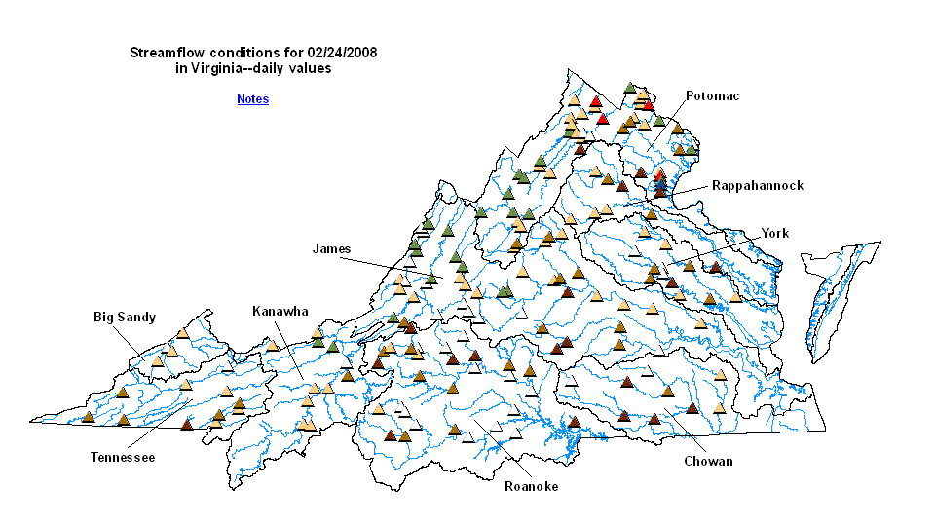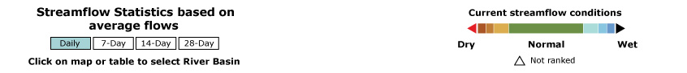

APPENDIX G
Drought Watch -- USGS State Information on Drought
Map of below normal 7-day average streamflow

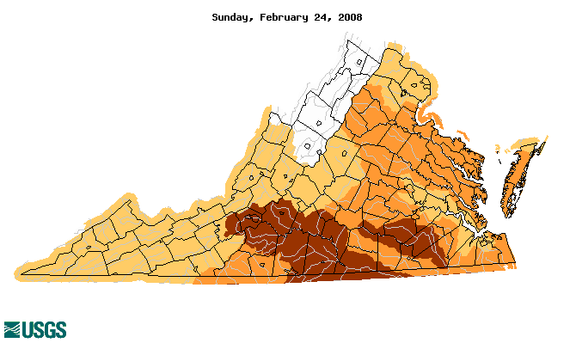
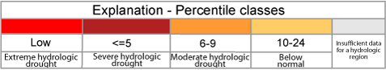

APPENDIX H
Virginia Climate Response Network
February 20, 2008



