VIRGINIA DROUGHT MONITORING TASK FORCE
Drought Status Report
October 8, 2010

Statewide precipitation for the current water year, October 1, 2009 September 30, 2010 was in the normal range (113% of normal) with all drought evaluation regions greater than 100% normal except the Big Sandy Region (98%). Normal precipitation is defined as the mean precipitation for a thirty year period of record. Precipitation greater than 85% and less than 115% of normal is considered to be in the normal range. Statewide precipitation is now within the normal range (97%) for the calendar year. Statewide precipitation is 97% of normal since June 1st with all drought evaluation regions except the York-James Region having greater than 85% of normal. All drought regions remain under the “Drought Watch” status announced this July. Appendix A contains precipitation tables for periods dating from July 1, 2009 through September 30, 2010 provided by the Climatology Office of the University of Virginia.

The National Weather Service Climate Prediction Center 6-10 day climatologic outlooks call for below normal precipitation for the entire Commonwealth and below normal temperatures for all but western third of the state. For the 8-14 day period, normal precipitation is predicted for all but the western third of the state, which is anticipated to have below normal precipitation. Below normal temperatures are anticipated over the 8-14 day period for the entire state. The one month outlook calls for equal chances of below normal, normal and above normal precipitation for the entire Commonwealth. The one month temperature outlook calls for equal chances of below normal, normal and above normal temperatures statewide. The three month outlook calls for equal chances of below normal, normal and above normal temperatures and precipitation for the entire Commonwealth.

The latest NOAA U.S. National Drought Monitor indicates “abnormally dry” to “moderate drought” conditions exist in approximately 56% of the Commonwealth. Southwest Virginia, a portion of South-central Virginia and the Coastal Plain are the areas that are not in an “abnormally dry” or “moderate drought” condition. Approximately 1% of Virginia (Frederick County) is experiencing “severe drought” conditions, as designated in the U.S. National Drought Monitor. The Seasonal Drought Outlook for the United States from now through December 2010 forecasts “some improvement” in the drought conditions along the Valley and Ridge portion of the state that is currently classified as “abnormally dry” to “severe”. (Appendix D).

The number of public water supply systems under some sort of drought related restriction have been decreasing in October. While the Virginia Department of Health (VDH) has not reported any impacts to public water supplies that have compromised their ability to provide the needs of their customers, 12 systems are under voluntary water conservation requirements and 9 systems are under mandatory water conservation requirements. Of the 49 systems listed in the VDH report, 26 are rated as having a “Better” overall water supply situation, one is rated as having a “Worse” overall water supply situation and all other systems are rated as being in a “Stable” situation (Appendix F).

The Virginia Department of Forestry (VDOF) continues to report an above normal rate of wildfire occurrence, with 122 fires reported in the month of July alone. The DOF is becoming increasingly concerned about the potential for a significant fall fire season.

The Department of Game and Inland Fisheries reports that recent rain events increased water supply flows to the trout hatcheries and all facilities are reporting better than normal water levels. Lake and stream levels have also improved, and all boat access sites across the Commonwealth are open. Trout stocking began October 1, and it currently appears that all waters have adequate flows for Fall stockings.

Reports from the Climatology Office of the University of Virginia, the Virginia Department of Environmental Quality, the United States Geological Survey, the Virginia Department of Forestry and the Virginia Department of Agriculture and Consumer Services, follow.

Virginia Department of Forestry
Wildfire Conditions

Summertime wildfire activity has remained at more elevated levels than what would be considered normal for Virginia. For the month of July 2010, the VDOF responded to 122 wildfires which burned 543 acres. The leading cause of wildfire continues to be human carelessness.

Observed fire behavior over the last few weeks indicates that wildfire occurrence, rates of spread and fire intensity is much greater than would normally be expected during this time of the year. The low fuel moisture conditions overall make suppression operations more difficult and lead to increased long term monitoring which can place a drain on firefighter resources. This has not been a significant problem up to this point, however it can have significant problem if the drought conditions persist moving in to our normal fall wildfire season

At least 26 counties across the Commonwealth have enacted local burning bans due to the increased risk of wildfire. The Department of Forestry’s Cumulative Severity Index (CSI), which is a detailed measure of soil moisture conditions taken at six location across the Commonwealth indicate the driest conditions that we have seen within the last ten years.

The DOF is becoming increasingly concerned about the potential for a significant fall fire season. The official fall wildfire season runs from October 15 – November 30. Current predictions of warmer and drier than normal conditions through December indicate that little relief is expected through the end of the year and that the fall wildfire season could more troublesome than any we have faced in the last ten years. The agency has begun early contingency planning to be better prepared for higher than normal levels of wildfire activity headed into October.

Report of the Climatology Office of the University of Virginia

October 10, 2010

In the last few days of September, storm activity, supported by a generous feed of tropical moisture, brought significant widespread rainfall to the Commonwealth. This turned the month from one of the driest Septembers on record into one with above normal rainfall for all but the far southwestern portions of Virginia.

Moving into the colder months (October through March) brings us a shift in precipitation mechanisms from (often scattered) thunderstorm activity to larger-scale mid-latitude storm systems and associated frontal passages. This source has a much higher potential to bring ample widespread precipitation across the state.

These colder months also mark a distinct decline in the rate of moisture loss to evaporation, and allow precipitation an opportunity to penetrate the soil layers and replenish long-term reserves. Thus, storm activity from late fall to early spring is crucial to water supplies. A season with relatively few such systems often leads to a summer with long-term moisture difficulties.

In addition, hurricane season remains in session, and conditions are still favorable for the development and strengthening of tropical systems in the Atlantic Basin, but their movements are crucial to bringing moisture to the Commonwealth. Nonetheless, just one or two well-aimed systems, can provide impressive precipitation amounts in a brief period of time.

United States Geological Survey
Streamflow and Ground Water Levels

Last week’s tropical precipitation brought several inches of rain to the western portions of Virginia and increasing to 12-15 inches along the eastern coast over approximately a two day period. Streamflow at most gages began increasing almost immediately and gages generally are recording levels in the normal to above normal range. Recession from the peak flow has been more gradual than anticipated which indicates that there was recharge to the groundwater system.

Water levels increased at almost all wells that monitor levels in the surficial aquifers. Fourteen of twenty wells are recording levels in the normal range for this time of year. Six wells are recording levels in the below normal range. At least some of the water-level increase is because of moisture entering the groundwater system rather than simply a pressure response generated by moisture in the upper layers of soil. This is indicated by a rise of water level following the storm event with a slow recession from the peak. If most of the water-level increase was caused by a pressure response, the recession would be faster.

Virginia Department of Environmental Quality
Conditions of Major Reservoirs

Four large multi-purpose reservoirs are identified as drought indicators in the Virginia Drought Assessment and Response Plan (Plan); Smith Mountain Lake, Lake Moomaw, Lake Anna and Kerr Reservoir. Of these four reservoirs only Lake Moomaw is currently at a level below defined drought watch status. Below is a summary of large reservoir conditions:

- As of October 8th Lake Moomaw on the Jackson River is at 1562.8 feet, and is dropping at a rate of ~0.12 ft per day. Approximately 27.8% of conservation storage remains. Lake Moomaw is 2.2 ft below the Drought Watch level (1565 feet MSL).
- As of October 8th Kerr Reservoir is currently approximately 1.01 ft above the Guide Curve and is anticipated to drop 0.47 ft by October 15th. Drought Watch status is reached at greater than 3 ft below the Guide Curve.
- As of October 8th Smith Mountain Lake is at elevation 794.5 ft which is 0.5 ft below full pond . The Drought Watch stage for Smith Mountain Lake is elevation 793 ft and below.
- As of October 8th, Lake Anna was at elevation 248.6 feet (1.4 feet below full) and dropped approximately 0.1 ft since October 4th^{th}. The Drought Watch stage for Lake Anna Lake is elevation 248 feet and below.

Virginia Department of Agriculture and Consumer Services
Status of Agricultural Drought

Overview
According to the USDA Crop Weather Report released on October 4, 2010, 22% of topsoil moisture ranged from short to very short. Much needed rain fell over most of the state ranging from as little as a few inches to as much as 16 inches. The rainfall had a varied impact on the agricultural community around the state. In some cases the rainfall provided enough rain to benefit producers as they prepare for fall planting. In other cases the rain caused flooding and damaged crops in the field.

As of October 14, 2010, sixty-three Virginia localities have formally requested the Governor’s assistance in obtaining federal agricultural disaster designation due to drought conditions. The USDA/Farm Service Agency has completed the official loss assessment reports (LARs) for 60 of these localities – Accomack, Albemarle, Amelia, Amherst, Appomattox, Bedford, Brunswick, Buckingham , Campbell, Caroline, Carroll, Charlotte, Clarke, Culpeper, Cumberland, Dinwiddie, Essex, Fauquier, Fluvanna, Franklin, Frederick, Goochland, Greene, Greensville, Halifax, Hanover, Isle of Wight, James City, King and Queen, King George, King William, Lancaster, Louisa, Lunenburg, Mecklenburg, Middlesex, Montgomery, Nelson, Northampton, Northumberland, Nottoway, Orange, Page, Patrick, Pittsylvania, Powhatan, Prince Edward, Pulaski, Rappahannock, Richmond (County), Rockbridge, Shenandoah, Southampton, Spotsylvania, Stafford, Suffolk (City),Surry, Warren, Westmoreland and York. LARs are pending for the three remaining localities – Henrico, Mathews and New Kent.

South Central Virginia
In South Central Virginia, rainfall varied from five to eight inches. Overall, the rain was beneficial, but rain did not have a great impact on crops as it was too late in the growing season. The rainfall will benefit the remaining tobacco crop to be harvested by putting more sap into the leaf which will improve the quality of the cured tobacco. Recent rains will help prepare the soil for fall planting of small grains. Recent rainfall will probably not have any impact on improving soybean yields as most fields had already begun to turn brown or mature.

Northern Neck
The rain was extremely helpful for the rather large broccoli crop in the Northern Neck. The moisture coupled with cooler temperatures will certainly help to improve crop yields and quality.

Eastern Virginia
In Eastern Virginia, rainfall last week ranged from seven inches to 18.5 inches with most growers receiving around 15 or 16 inches. That much rain will likely have a negative impact on crops.

Cotton growers estimate a loss of lint (fiber) from the heavy rain and winds. With all the rain, leaf growth will be a problem and a second spray of defoliant will likely be necessary. Many growers that contracted cotton will have to buy back their contracts if they don't have enough cotton to fulfill their obligations.

Peanuts that had been dug prior to the rain will no longer have bright shells and some may mold with the cool, wet weather we are now experiencing.

Strawberry growers that have not planted will have to delay planting and the optimum planting dates were last week and this week. Fields are too muddy to plant.

U-Pick pumpkins operations report that there may be delayed opening due to the recent rains. Producers are ready to sell the pumpkins, but field and parking lot conditions made it difficult for customers to park and shop.

Impact on Dairies
Rains across the rest of the state brought much needed moisture; however the annual amount is still well short of our averages. Recent rains have greened up pastures and allowed dairymen to cease feeding hay.

Impact on Livestock
The rain improved pasture grass enough to allow livestock to graze in many parts of the state. This temporarily provided producers a break from feeding hay. Unfortunately pasture grasses are so low or have been grazed off, therefore, it is expected that producers will have to return to hay to supplement grazing.

Impact on Streams, Wells & Springs
Outside of southwest Virginia, much of the state suffered from the water shortage with low streams and dry springs. Recent rains seemed to have provided at least temporary relief there. Rivers, creeks, and lake levels have increased but are not yet back to normal levels.
APPENDIX A
Precipitation Departures by Drought Evaluation Region

 | PRELIMINARY PRECIPITATION SUMMARY |  |  |  | Prepared:
 |  |  |  |  | 10/04/10
 | DROUGHT |  | Sep 1, 2010 | - Sep 30, 2010
 | REGION | OBSERVED | NORMAL | DEPARTURE | % OF NORM.
1 | Big Sandy | 2.31 | 3.46 | -1.15 | 67%
2 | New River | 3.96 | 3.41 | 0.55 | 116%
3 | Roanoke | 6.25 | 4.23 | 2.02 | 148%
4 | Upper James | 5.52 | 3.50 | 2.02 | 158%
5 | Middle James | 6.11 | 4.13 | 1.98 | 148%
6 | Shenandoah | 5.00 | 3.67 | 1.33 | 136%
7 | Northern Virginia | 6.42 | 4.07 | 2.35 | 158%
8 | Northern Piedmont | 6.29 | 4.28 | 2.01 | 147%
9 | Chowan | 8.30 | 4.43 | 3.87 | 187%
10 | Northern Coastal Plain | 7.68 | 4.09 | 3.59 | 188%
11 | York-James | 9.27 | 4.90 | 4.37 | 189%
12 | Southeast Virginia | 13.28 | 4.43 | 8.85 | 300%
13 | Eastern Shore | 4.56 | 3.61 | 0.95 | 126%
 | Statewide | 6.04 | 4.00 | 2.04 | 151%
 | DROUGHT |  | Aug 1, 2010 | - Sep 30, 2010
 | REGION | OBSERVED | NORMAL | DEPARTURE | % OF NORM.
1 | Big Sandy | 7.45 | 7.29 | 0.16 | 102%
2 | New River | 9.20 | 6.72 | 2.48 | 137%
3 | Roanoke | 12.69 | 7.95 | 4.74 | 160%
4 | Upper James | 8.49 | 6.83 | 1.66 | 124%
5 | Middle James | 10.29 | 7.95 | 2.34 | 129%
6 | Shenandoah | 7.69 | 7.00 | 0.69 | 110%
7 | Northern Virginia | 10.68 | 7.92 | 2.76 | 135%
8 | Northern Piedmont | 9.70 | 8.10 | 1.60 | 120%
9 | Chowan | 12.57 | 8.74 | 3.83 | 144%
10 | Northern Coastal Plain | 12.02 | 7.95 | 4.07 | 151%
11 | York-James | 10.97 | 9.77 | 1.20 | 112%
12 | Southeast Virginia | 16.48 | 9.55 | 6.93 | 173%
13 | Eastern Shore | 9.34 | 7.48 | 1.86 | 125%
 | Statewide | 10.41 | 7.83 | 2.58 | 133%
 | DROUGHT |  | Jul 1, 2010 | - Sep 30, 2010
 | REGION | OBSERVED | NORMAL | DEPARTURE | % OF NORM.
1 | Big Sandy | 11.18 | 11.77 | -0.59 | 95%
2 | New River | 12.04 | 10.51 | 1.53 | 115%
3 | Roanoke | 15.94 | 12.34 | 3.60 | 129%
4 | Upper James | 12.15 | 10.87 | 1.28 | 112%
5 | Middle James | 12.16 | 12.36 | -0.20 | 98%
6 | Shenandoah | 11.08 | 10.76 | 0.32 | 103%
7 | Northern Virginia | 14.14 | 11.69 | 2.45 | 121%
8 | Northern Piedmont | 12.03 | 12.50 | -0.47 | 96%
9 | Chowan | 14.25 | 13.25 | 1.00 | 108%
10 | Northern Coastal Plain | 13.48 | 12.40 | 1.08 | 109%
11 | York-James | 14.33 | 14.87 | -0.54 | 96%
12 | Southeast Virginia | 20.20 | 14.62 | 5.58 | 138%
13 | Eastern Shore | 11.43 | 11.48 | -0.05 | 100%
 | Statewide | 13.18 | 12.17 | 1.01 | 108%
 | DROUGHT |  | Jun 1, 2010 | - Sep 30, 2010
 | REGION | OBSERVED | NORMAL | DEPARTURE | % OF NORM.
1 | Big Sandy | 15.96 | 15.91 | 0.05 | 100%
2 | New River | 14.61 | 14.36 | 0.25 | 102%
3 | Roanoke | 18.03 | 16.23 | 1.80 | 111%
4 | Upper James | 14.00 | 14.58 | -0.58 | 96%
5 | Middle James | 14.03 | 15.87 | -1.84 | 88%
6 | Shenandoah | 12.90 | 14.47 | -1.57 | 89%
7 | Northern Virginia | 15.49 | 15.55 | -0.07 | 100%
8 | Northern Piedmont | 14.44 | 16.51 | -2.07 | 87%
9 | Chowan | 16.77 | 16.90 | -0.13 | 99%
10 | Northern Coastal Plain | 15.49 | 15.96 | -0.47 | 97%
11 | York-James | 15.26 | 18.28 | -3.02 | 83%
12 | Southeast Virginia | 23.44 | 18.23 | 5.21 | 129%
13 | Eastern Shore | 12.95 | 14.46 | -1.51 | 90%
 | Statewide | 15.55 | 15.96 | -0.41 | 97%
 | DROUGHT |  | May 1, 2010 | - Sep 30, 2010
 | REGION | OBSERVED | NORMAL | DEPARTURE | % OF NORM.
1 | Big Sandy | 21.41 | 20.73 | 0.68 | 103%
2 | New River | 18.42 | 18.57 | -0.15 | 99%
3 | Roanoke | 22.68 | 20.56 | 2.12 | 110%
4 | Upper James | 17.80 | 18.86 | -1.06 | 94%
5 | Middle James | 18.08 | 20.11 | -2.03 | 90%
6 | Shenandoah | 15.96 | 18.31 | -2.35 | 87%
7 | Northern Virginia | 20.13 | 19.89 | 0.24 | 101%
8 | Northern Piedmont | 18.11 | 20.73 | -2.62 | 87%
9 | Chowan | 22.19 | 20.99 | 1.20 | 106%
10 | Northern Coastal Plain | 17.89 | 20.12 | -2.23 | 89%
11 | York-James | 20.16 | 22.55 | -2.39 | 89%
12 | Southeast Virginia | 27.64 | 22.09 | 5.55 | 125%
13 | Eastern Shore | 15.07 | 17.98 | -2.91 | 84%
 | Statewide | 19.71 | 20.22 | -0.51 | 97%
 | DROUGHT |  | Apr 1, 2010 | - Sep 30, 2010
 | REGION | OBSERVED | NORMAL | DEPARTURE | % OF NORM.
1 | Big Sandy | 24.09 | 24.49 | -0.40 | 98%
2 | New River | 20.27 | 22.12 | -1.85 | 92%
3 | Roanoke | 24.44 | 24.36 | 0.08 | 100%
4 | Upper James | 19.51 | 22.26 | -2.75 | 88%
5 | Middle James | 19.83 | 23.45 | -3.62 | 85%
6 | Shenandoah | 17.31 | 21.23 | -3.92 | 82%
7 | Northern Virginia | 21.72 | 23.19 | -1.47 | 94%
8 | Northern Piedmont | 19.64 | 24.02 | -4.38 | 82%
9 | Chowan | 23.63 | 24.42 | -0.79 | 97%
10 | Northern Coastal Plain | 19.48 | 23.21 | -3.73 | 84%
11 | York-James | 21.11 | 25.85 | -4.74 | 82%
12 | Southeast Virginia | 28.83 | 25.34 | 3.49 | 114%
13 | Eastern Shore | 16.25 | 20.90 | -4.65 | 78%
 | Statewide | 21.43 | 23.64 | -2.21 | 91%
 | DROUGHT |  | Mar 1, 2010 | - Sep 30, 2010
 | REGION | OBSERVED | NORMAL | DEPARTURE | % OF NORM.
1 | Big Sandy | 26.96 | 28.74 | -1.78 | 94%
2 | New River | 24.33 | 25.79 | -1.46 | 94%
3 | Roanoke | 29.57 | 28.63 | 0.94 | 103%
4 | Upper James | 23.61 | 26.05 | -2.44 | 91%
5 | Middle James | 24.97 | 27.51 | -2.54 | 91%
6 | Shenandoah | 22.03 | 24.43 | -2.40 | 90%
7 | Northern Virginia | 25.46 | 26.85 | -1.39 | 95%
8 | Northern Piedmont | 24.56 | 27.83 | -3.27 | 88%
9 | Chowan | 28.22 | 28.79 | -0.57 | 98%
10 | Northern Coastal Plain | 25.63 | 27.49 | -1.86 | 93%
11 | York-James | 26.72 | 30.54 | -3.82 | 88%
12 | Southeast Virginia | 35.14 | 29.54 | 5.60 | 119%
13 | Eastern Shore | 22.48 | 25.21 | -2.73 | 89%
 | Statewide | 26.12 | 27.68 | -1.56 | 94%
 | DROUGHT |  | Feb 1, 2010 | - Sep 30, 2010
 | REGION | OBSERVED | NORMAL | DEPARTURE | % OF NORM.
1 | Big Sandy | 29.74 | 32.32 | -2.58 | 92%
2 | New River | 26.75 | 28.72 | -1.97 | 93%
3 | Roanoke | 32.22 | 31.94 | 0.28 | 101%
4 | Upper James | 25.93 | 28.90 | -2.97 | 90%
5 | Middle James | 28.19 | 30.63 | -2.44 | 92%
6 | Shenandoah | 24.91 | 26.84 | -1.93 | 93%
7 | Northern Virginia | 29.51 | 29.52 | -0.01 | 100%
8 | Northern Piedmont | 27.09 | 30.80 | -3.71 | 88%
9 | Chowan | 31.47 | 31.96 | -0.49 | 98%
10 | Northern Coastal Plain | 28.93 | 30.63 | -1.70 | 94%
11 | York-James | 30.41 | 34.07 | -3.66 | 89%
12 | Southeast Virginia | 38.89 | 33.04 | 5.85 | 118%
13 | Eastern Shore | 26.36 | 28.40 | -2.04 | 93%
 | Statewide | 29.09 | 30.81 | -1.72 | 94%
 | DROUGHT |  | Jan 1, 2010 | - Sep 30, 2010
 | REGION | OBSERVED | NORMAL | DEPARTURE | % OF NORM.
1 | Big Sandy | 33.97 | 36.05 | -2.08 | 94%
2 | New River | 31.26 | 31.93 | -0.67 | 98%
3 | Roanoke | 37.29 | 35.86 | 1.43 | 104%
4 | Upper James | 30.25 | 32.18 | -1.93 | 94%
5 | Middle James | 32.58 | 34.29 | -1.71 | 95%
6 | Shenandoah | 28.72 | 29.69 | -0.97 | 97%
7 | Northern Virginia | 32.21 | 32.80 | -0.59 | 98%
8 | Northern Piedmont | 31.02 | 34.32 | -3.30 | 90%
9 | Chowan | 35.49 | 36.07 | -0.58 | 98%
10 | Northern Coastal Plain | 32.63 | 34.38 | -1.75 | 95%
11 | York-James | 34.84 | 38.21 | -3.37 | 91%
12 | Southeast Virginia | 43.21 | 37.20 | 6.01 | 116%
13 | Eastern Shore | 29.38 | 31.96 | -2.58 | 92%
 | Statewide | 33.30 | 34.45 | -1.15 | 97%
 | DROUGHT |  | Dec 1, 2009 | - Sep 30, 2010
 | REGION | OBSERVED | NORMAL | DEPARTURE | % OF NORM.
1 | Big Sandy | 39.66 | 39.69 | -0.03 | 100%
2 | New River | 38.55 | 34.64 | 3.91 | 111%
3 | Roanoke | 44.86 | 39.11 | 5.75 | 115%
4 | Upper James | 37.64 | 35.13 | 2.51 | 107%
5 | Middle James | 40.73 | 37.46 | 3.27 | 109%
6 | Shenandoah | 33.96 | 32.28 | 1.68 | 105%
7 | Northern Virginia | 38.45 | 35.90 | 2.55 | 107%
8 | Northern Piedmont | 37.51 | 37.60 | -0.09 | 100%
9 | Chowan | 43.43 | 39.09 | 4.34 | 111%
10 | Northern Coastal Plain | 40.54 | 37.66 | 2.88 | 108%
11 | York-James | 41.79 | 41.60 | 0.19 | 100%
12 | Southeast Virginia | 51.02 | 40.38 | 10.64 | 126%
13 | Eastern Shore | 37.91 | 35.20 | 2.71 | 108%
 | Statewide | 40.44 | 37.57 | 2.87 | 108%
 | DROUGHT |  | Nov 1, 2009 | - Sep 30, 2010
 | REGION | OBSERVED | NORMAL | DEPARTURE | % OF NORM.
1 | Big Sandy | 41.91 | 42.97 | -1.06 | 98%
2 | New River | 43.55 | 37.67 | 5.88 | 116%
3 | Roanoke | 53.04 | 42.47 | 10.57 | 125%
4 | Upper James | 42.53 | 38.49 | 4.04 | 110%
5 | Middle James | 49.30 | 40.97 | 8.33 | 120%
6 | Shenandoah | 37.82 | 35.33 | 2.49 | 107%
7 | Northern Virginia | 42.39 | 39.31 | 3.08 | 108%
8 | Northern Piedmont | 43.57 | 41.40 | 2.17 | 105%
9 | Chowan | 53.07 | 42.20 | 10.87 | 126%
10 | Northern Coastal Plain | 49.29 | 40.80 | 8.49 | 121%
11 | York-James | 51.05 | 44.97 | 6.08 | 114%
12 | Southeast Virginia | 61.40 | 43.45 | 17.95 | 141%
13 | Eastern Shore | 45.46 | 38.14 | 7.32 | 119%
 | Statewide | 47.08 | 40.80 | 6.28 | 115%
 | DROUGHT |  | Oct 1, 2009 | - Sep 30, 2010
 | REGION | OBSERVED | NORMAL | DEPARTURE | % OF NORM.
1 | Big Sandy | 44.95 | 45.85 | -0.90 | 98%
2 | New River | 46.24 | 40.84 | 5.40 | 113%
3 | Roanoke | 55.60 | 46.18 | 9.42 | 120%
4 | Upper James | 45.31 | 41.74 | 3.57 | 109%
5 | Middle James | 52.36 | 44.81 | 7.55 | 117%
6 | Shenandoah | 40.57 | 38.52 | 2.05 | 105%
7 | Northern Virginia | 47.20 | 42.79 | 4.41 | 110%
8 | Northern Piedmont | 46.99 | 45.39 | 1.60 | 104%
9 | Chowan | 55.12 | 45.78 | 9.34 | 120%
10 | Northern Coastal Plain | 53.50 | 44.31 | 9.19 | 121%
11 | York-James | 54.14 | 48.50 | 5.64 | 112%
12 | Southeast Virginia | 63.71 | 47.11 | 16.60 | 135%
13 | Eastern Shore | 49.83 | 41.35 | 8.48 | 121%
 | Statewide | 50.08 | 44.30 | 5.78 | 113%
 | DROUGHT |  | Sep 1, 2009 | - Sep 30, 2010
 | REGION | OBSERVED | NORMAL | DEPARTURE | % OF NORM.
1 | Big Sandy | 50.13 | 49.31 | 0.82 | 102%
2 | New River | 50.25 | 44.25 | 6.00 | 114%
3 | Roanoke | 58.66 | 50.41 | 8.25 | 116%
4 | Upper James | 48.59 | 45.24 | 3.35 | 107%
5 | Middle James | 55.53 | 48.94 | 6.59 | 113%
6 | Shenandoah | 42.79 | 42.19 | 0.60 | 101%
7 | Northern Virginia | 49.45 | 46.86 | 2.59 | 106%
8 | Northern Piedmont | 49.87 | 49.67 | 0.20 | 100%
9 | Chowan | 59.43 | 50.21 | 9.22 | 118%
10 | Northern Coastal Plain | 56.58 | 48.40 | 8.18 | 117%
11 | York-James | 60.05 | 53.40 | 6.65 | 112%
12 | Southeast Virginia | 71.02 | 51.54 | 19.48 | 138%
13 | Eastern Shore | 56.31 | 44.96 | 11.35 | 125%
 | Statewide | 53.72 | 48.30 | 5.42 | 111%
 | DROUGHT |  | Aug 1, 2009 | - Sep 30, 2010
 | REGION | OBSERVED | NORMAL | DEPARTURE | % OF NORM.
1 | Big Sandy | 54.62 | 53.14 | 1.48 | 103%
2 | New River | 54.76 | 47.56 | 7.20 | 115%
3 | Roanoke | 63.00 | 54.13 | 8.87 | 116%
4 | Upper James | 51.97 | 48.57 | 3.40 | 107%
5 | Middle James | 59.05 | 52.76 | 6.29 | 112%
6 | Shenandoah | 45.83 | 45.52 | 0.31 | 101%
7 | Northern Virginia | 53.41 | 50.71 | 2.70 | 105%
8 | Northern Piedmont | 53.02 | 53.49 | -0.47 | 99%
9 | Chowan | 63.28 | 54.52 | 8.76 | 116%
10 | Northern Coastal Plain | 61.84 | 52.26 | 9.58 | 118%
11 | York-James | 65.52 | 58.27 | 7.25 | 112%
12 | Southeast Virginia | 80.47 | 56.66 | 23.81 | 142%
13 | Eastern Shore | 60.90 | 48.83 | 12.07 | 125%
 | Statewide | 57.90 | 52.13 | 5.77 | 111%
 | DROUGHT |  | Jul 1, 2009 | - Sep 30, 2010
 | REGION | OBSERVED | NORMAL | DEPARTURE | % OF NORM.
1 | Big Sandy | 60.23 | 57.62 | 2.61 | 105%
2 | New River | 58.82 | 51.35 | 7.47 | 115%
3 | Roanoke | 67.36 | 58.52 | 8.84 | 115%
4 | Upper James | 56.86 | 52.61 | 4.25 | 108%
5 | Middle James | 62.54 | 57.17 | 5.37 | 109%
6 | Shenandoah | 48.77 | 49.28 | -0.51 | 99%
7 | Northern Virginia | 55.07 | 54.48 | 0.59 | 101%
8 | Northern Piedmont | 55.94 | 57.89 | -1.95 | 97%
9 | Chowan | 67.29 | 59.03 | 8.26 | 114%
10 | Northern Coastal Plain | 66.70 | 56.71 | 9.99 | 118%
11 | York-James | 71.50 | 63.37 | 8.13 | 113%
12 | Southeast Virginia | 84.45 | 61.73 | 22.72 | 137%
13 | Eastern Shore | 66.69 | 52.83 | 13.86 | 126%
 | Statewide | 61.95 | 56.47 | 5.48 | 110%

APPENDIX B

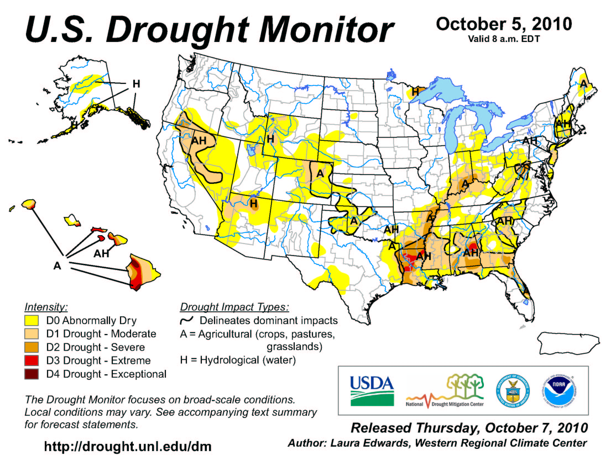
APPENDIX C

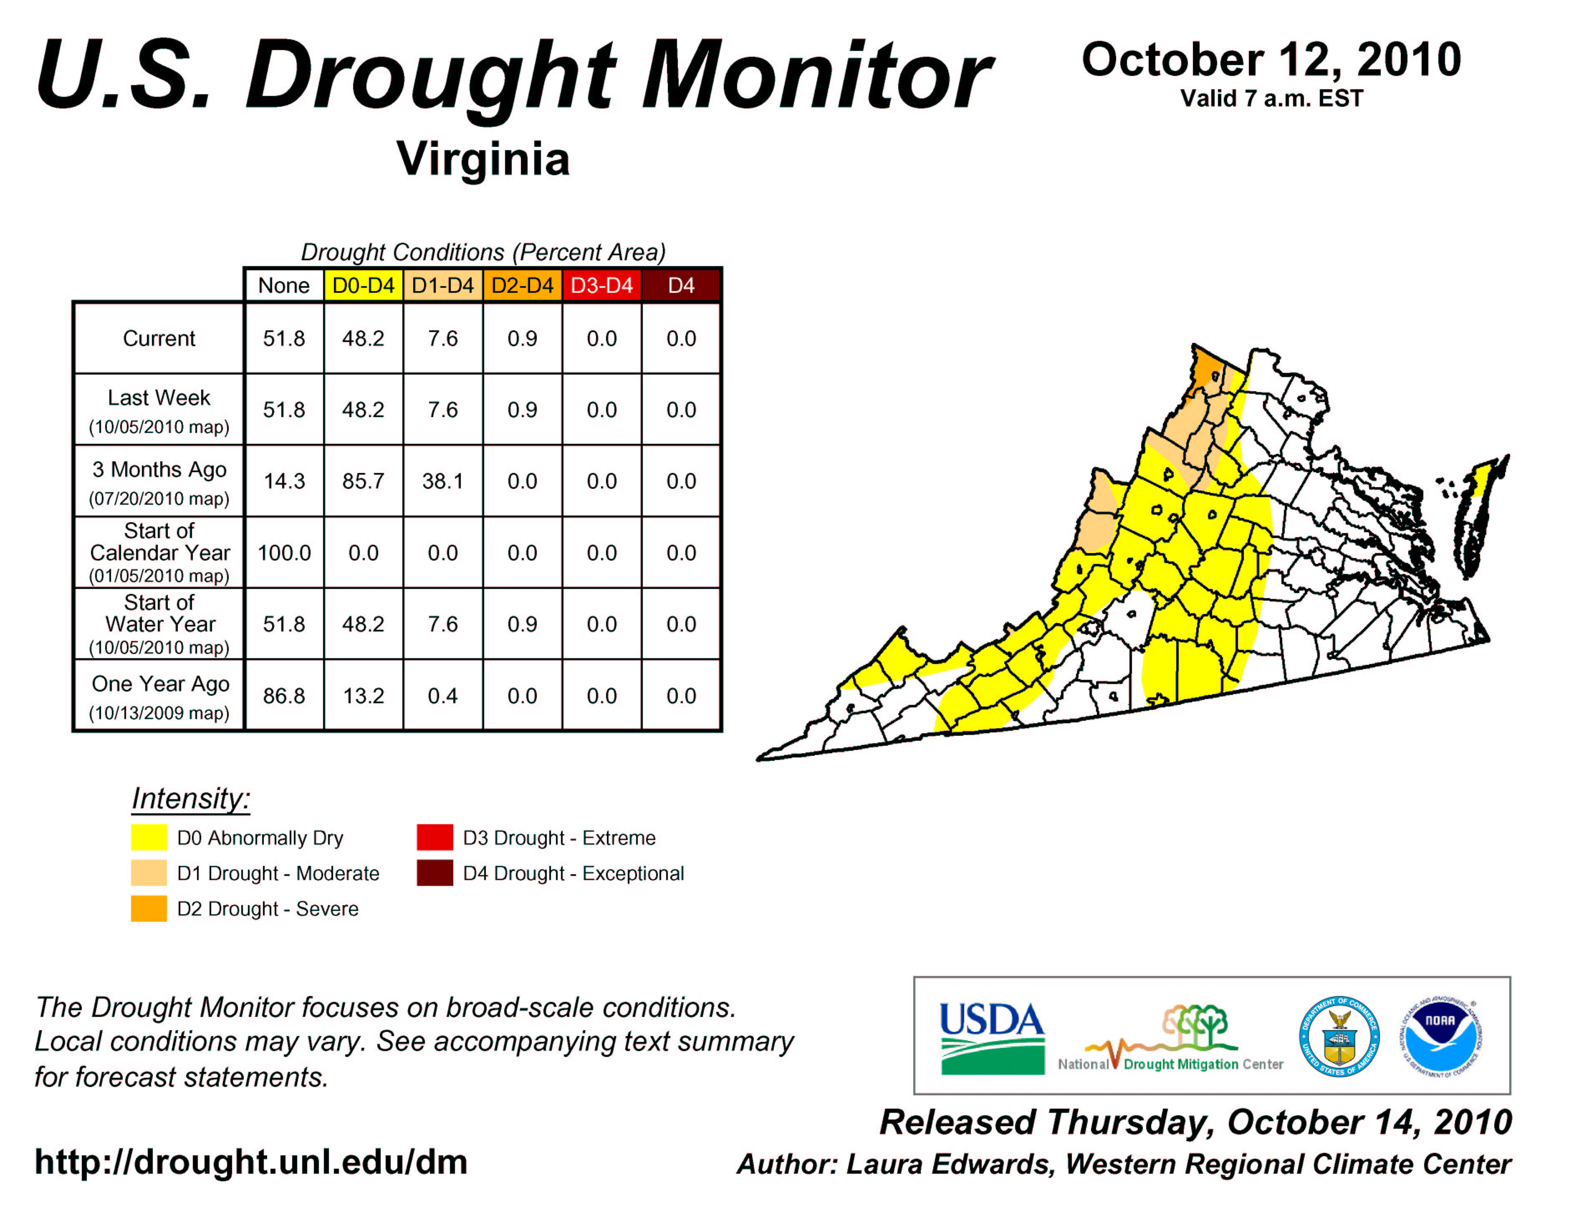

APPENDIX D

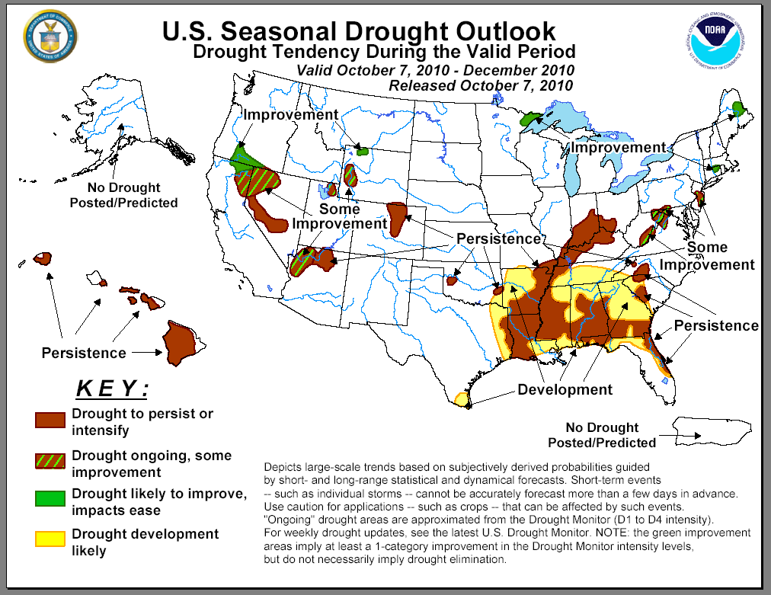
APPENDIX E
30-Day Departure from Normal Precipitation
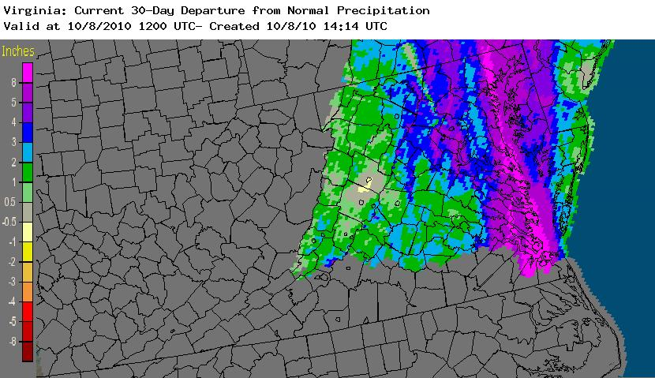
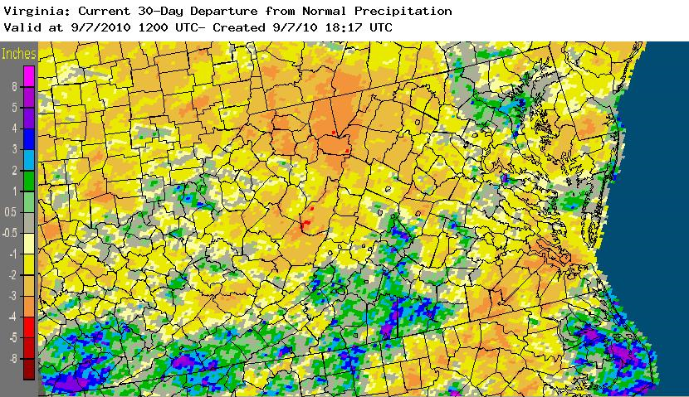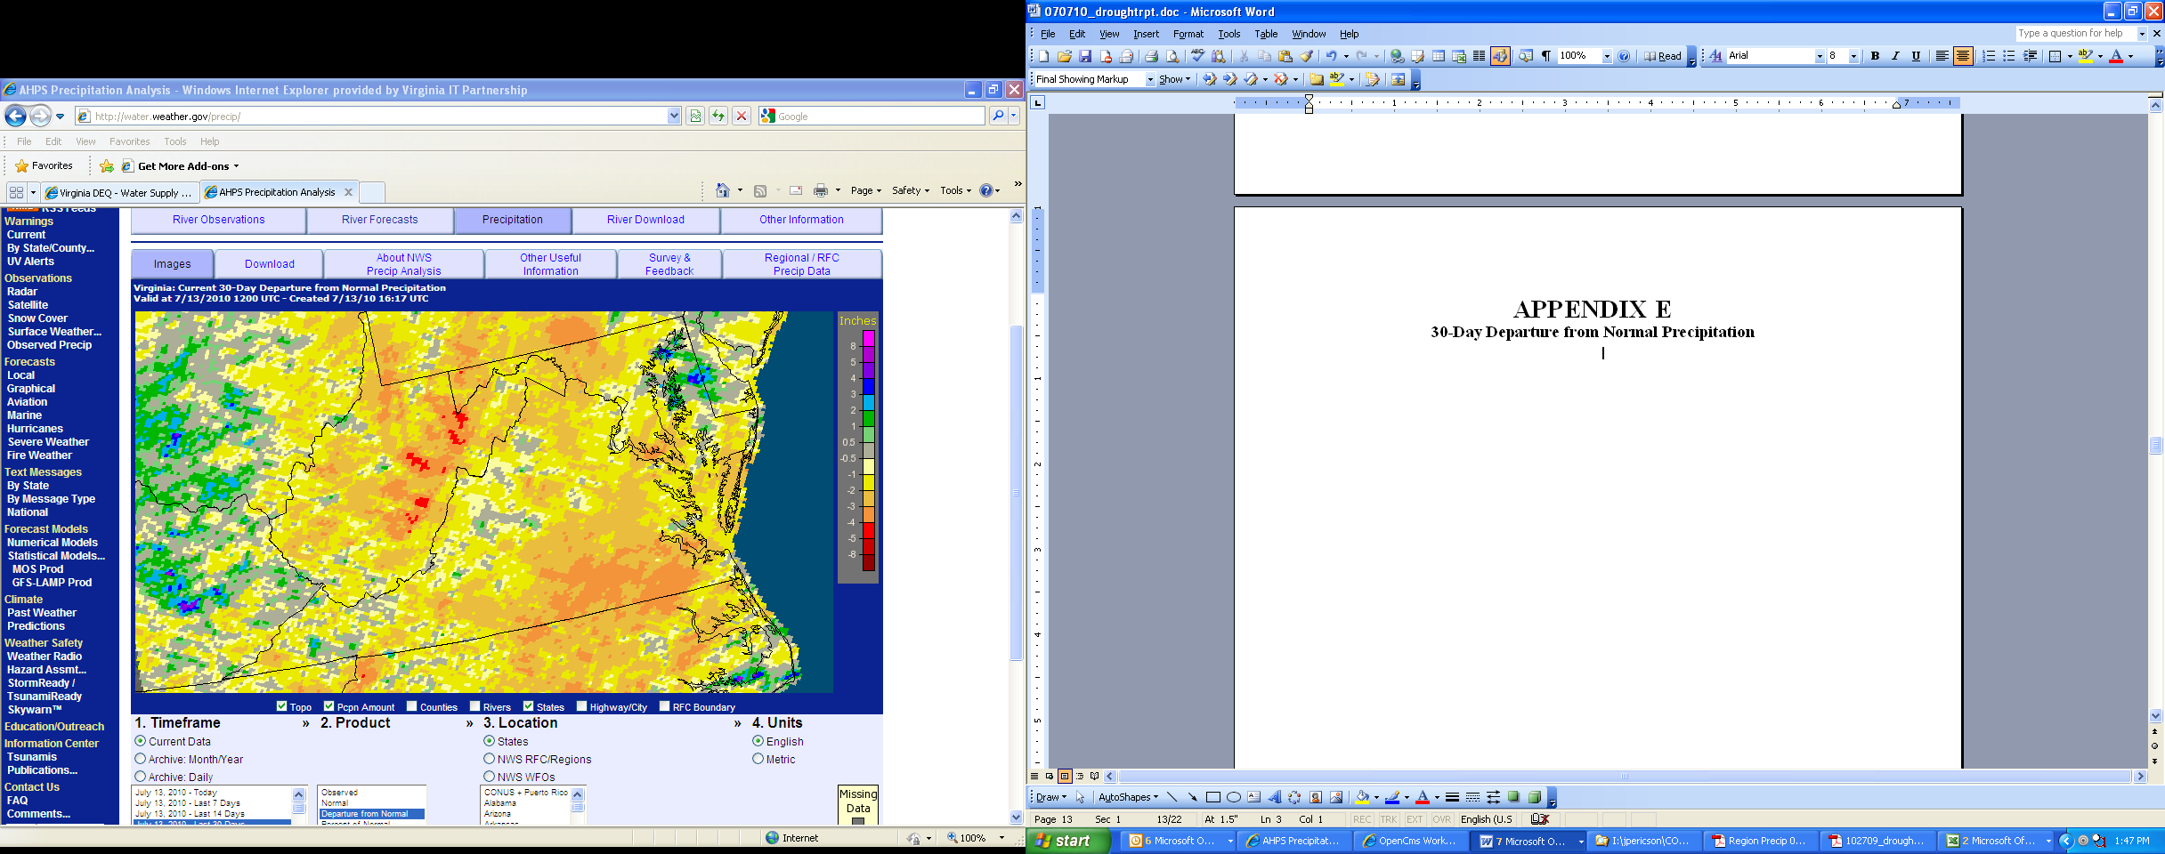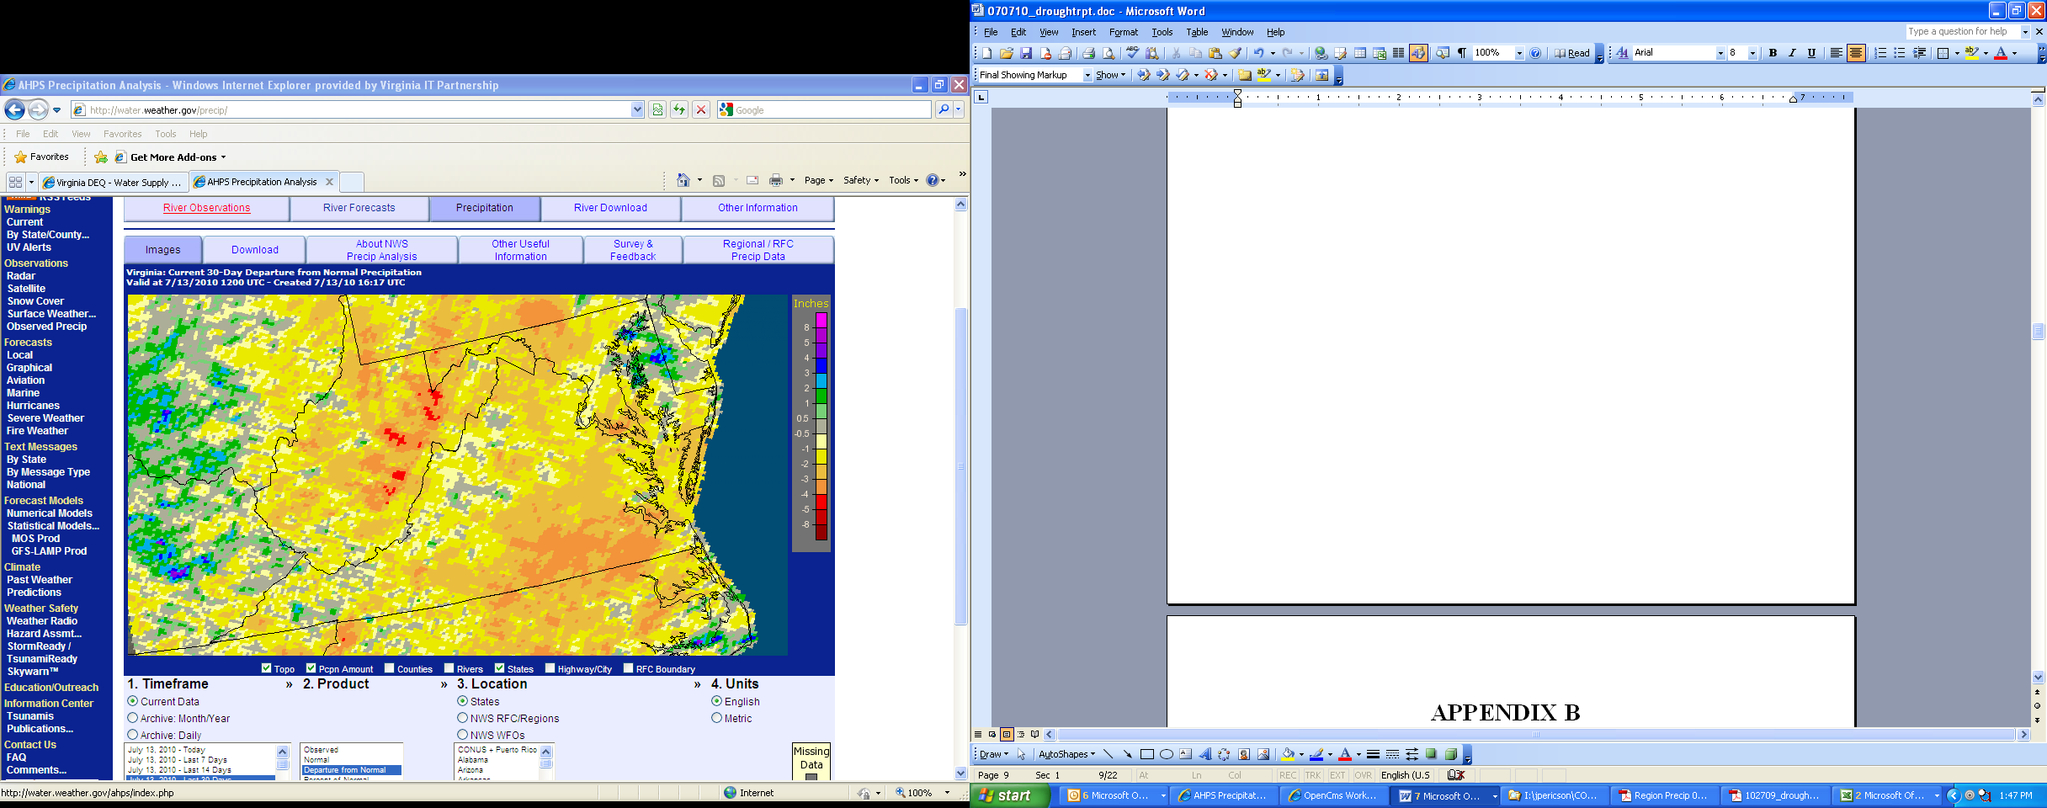Top of Form
Bottom of Form
APPENDIX F
Condition of Public Water Supplies
October 5, 2010

ODW Drought Situation Report |  |  |  | Restriction totals | Population Totals
Date: | 10/5/10 |  | Mandatory | 9 | 558,839
 |  |  | Voluntary | 12 | 732,870
 |  |  | Total | 21 | 1,291,709
 |  |  | N-None | B-Better
 |  |  | M-Mandatory | S-Stable/Same
 |  |  | V-Voluntary | W-Worse
PWSID | Waterworks | Source Name | Restrictions | Situation | Population Served
2003050 | ACSA - Crozet | Beaver Creek Reservoir | V | B - 10/5/10 - Will continue voluntary conservation. | 6,310
2003051 | ACSA - Scottsville | Totier Creek Reservoir | V | B - 10/5/10 - Will continue voluntary conservation. | 723
2003053 | ACSA - Urban Area | Sugar Hollow, Ragged Mtn., South Rivanna, North Rivanna | V | B - 10/5/10 - Will continue voluntary conservation. | 55,510
2187406 | Town of Front Royal | South Fork Shenandoah River | N | B - 10/4/10 - No Water restrictions | 12,500
2540500 | City of Charlottesville | Sugar Hollow, Ragged Mtn., South Rivanna, North Rivanna | V | B - 10/5/10 - Will continue voluntary conservation. | 41,487
3053280 | DCWA Central (Dinwiddie County) | Appomattox River Water Authority (ARWA) | M | S- 10/04/2010 - Phase III emergency restrictions. ARWA reservior level triggered call for mandatory restrictions on 9/7/2010 and emergency restrictions on 9/24/2010. | 6,800
3081550 | GCWSA - Jarratt | Nottoway River | N | S - 10/04/2010 - Waterworks production rate reduced due to lower demand; river level sufficient to allow plant operation at 1.9 mgd. Gage at Stony Creek indicates 4.4 feet. | 7,190
3093120 | Isle of Wight County | Suffolk | N | B - 10/04/10 - Obtains water from Suffolk. Follows Suffolk's lead on conservation. | 1,284
3095490 | James City Service Authority | Ground water | V | B - 10/4/10 - Will continue with voluntary conservaton. Rains have lowered demand. | 49,880
3149700 | Puddledock Road | ARWA | M | S- 10/04/2010 - Emergency restrictions. ARWA reservior level triggered call for mandatory restrictions on 9/7/2010 and emergency restrictions on 9/24/2010. Level at 126" below top of dam as of 10/1/2010. | 9,723
3550050 | Chesapeake - Western Branch system | City of Portsmouth | N | S -10/4/2010 This portion of the city is consecutive to (receives water from) the city of Portsmouth. Will follow Portsmouth's lead on conservation. | 36,642
3550051 | Chesapeake | Northwest River, City of Norfolk Raw Water (Lake Gaston) | N | S -10/5/2010 Total rainfall for September 16.85 inches. They received 11.4 inches of rain on 9/30/2010. For October the total to date is 2.15 inches. There are no water restrictions in Chesapeake. Chlorides are used as an indicator of drought, the higher the levels the more concentrated the contaminant in a lesser amount of surface water. Chlorides are slightly elevated 338 ppm (max). The range between 31-106 mg/l. Continuing to purchase raw water from Norfolk (7.5 MGD average). NWR averages 4.4 MGD. The Intown Lakes remain full and there are no irregularities in the tidal patterns in NWR. | 103,504
3550052 | Chesapeake - South Norfolk system | City of Norfolk | N | S -10/4/2010-This portion of the city is consecutive to (receives water from) the city of Norfolk. Will follow Norfolk's lead on conservation. | 38,709
3570150 | Colonial Heights | ARWA | M | S - 10/04/2010 - Phase III Emergency restrictions as of 9/27/2010. Generally follow ARWA recommendations on water restrictions. | 17,286
3595250 | Emporia | Meherrin River | N | S - 10/04/2010 - Reservoir level sufficient for normal operation. ILUKA and power plant also withdrawing from river. | 5,600
3670800 | Virginia-American Water Company (Hopewell) | Appomattox & James Rivers | N | S - 10/04/2010 - Level at intakes sufficient to supply plant. Received 7.5" of rain last week. Still experiencing taste and odor issues (MIB in raw and finished water, but decreasing). Fort Lee being supplied from Hopewell due to ARWA water restrictions. | 28000 - Primary / 45463 Total including Consecutive System (Ft. Lee)
3700500 | Newport News | Chickahomony River, Skiffs Creek, Diascand, Little Creek, Harwoods Mill, Lee Hall | N | B - 10/04/10 - Total reservoir capacity now up to 78% (was at 63% on 9/27/10). At current delivery rate range 37 - 40 MGD, there is about 221 days of stored water available at current demand. Chickahominy flow is above normal. Skiffs, Diascand, Lee Hall and Harwoods Mill dams have overflowed in the past few days. Pumping from Chickahominy and Diascund to Little Creek, so that it can be re-filled (currently about 9 feet down, but level is rising). | 414,000
3710100 | Norfolk | Lake Prince, Lake Burnt Mills, Western Branch reservoir, Nottoway River, Blackwater River, 4 western wells; Little Creek reservoir, Lakes Smith, Lawson, Whitehurst, and Wright. Lake Gaston. | N | B - As of 10/04/10, reservoirs at 103.7% (up from 81.6% on 09/27/10) - at least three of the western reservoirs are flowing over the spillway. Historic reservoir capacity is 83.4% at this time of year. Avg. pumping from Lake Gaston = 21.5 MGD. Total Reservoir Storage = 15,768 MG. Approx. 325 days of storage remaining under current demand with 21.5 MGD pumping from Lake Gaston, and approx. 225 days of storage remaining under current demand with no pumping from Lake Gaston. Current demand of approx. 70 MGD. | 261,250 - Primary / 755,617 - Total including consecutive systems (Va Beach + military bases).
3730750 | Petersburg | ARWA | M | S - 10/04/2010 - Phase III emergency restrictions requested 09/26/2010. Generally follow ARWA recommendations on water restrictions. | 33,740
3740600 | Portsmouth | Lakes Cohoon, Meade, Kilby, and Speights Run | N | B - As of 10/01/10, reservoirs at 100% (up from from 67% on 09/24/10 ) - at least three of reservoirs are flowing over the spillways. Median reservoir capacity is 92% for the month and historical average capacity is 85% (period of 1969-2008). The emergency wells are OFF. Estimated 257 days of storage remaining at current pumpage and rainfall is 171 days (avg. pumpage is 15.1 MGD). | 100,400 - Primary / 120,400 Total including consecutive systems (military bases)
3800805 | Suffolk | Lone Star Lakes, Cumps Mill Pond | N | B 10/4/2010-Will follow Portsmouth's lead and the region as far as conservation. Received 12.69 inches of rain from 9/26/2010 through 10/3/2010. Average reservoir levels : Southern Lakes at 105% capacity, for the Northern Lakes at 82.35% and Crumps Mill Pond at 66.67% (9/27/10). The Southern Lakes are for emergency use only. The operator states that they are in better condition since the last report. No conservation measures implemented at this time but will continue to monitor. | 62,562
3810900 | Virginia Beach | Norfolk | N | B - 10/04/10 - Obtains water from Norfolk. | 423,743
3830850 | Williamsburg | Waller Mill Reservoir | N | B 10/03/10: 9.5" above primary spillway - about 98% of usable capacity. 375 days of usable storage based on 1498 MG at 4 mgd. | 16,400
4041035 | APPOMATTOX RIVER WATER AUTHORITY | Surface water; Lake Chesdin | M | B- Wholesaler to Chesterfield County, Prince George County, Dinwiddie County; Cities of Petersburg and Colonial Heights. Within the past week, the reservoir has risen from 140" below top of dam to 36" below top of dam. Emergency restrictions are still in place. | 200,000
4041845 | CHESTERFIELD CO CENTRAL WATER SYSTEM | Surface water; Swift Creek reservoir; purchases finished water | M | B- Purchases water from the City of Richmond and the Appomattox River Water Authority. Within the past week, the Swift Creek Reservoir has risen from 2.3 feet below top of dam to 1.0 feet below top of dam. Emergency restrictions are still in place because of the low water level in Lake Chesdin (ARWA). | 286,000
4057800 | TAPPAHANNOCK, TOWN OF | Groundwater wells | N | S | 2,100
4073311 | GLOUCESTER CO WATER TREATMENT PLT | Surface water, Beaverdam reservoir; 2 deep groundwater wells | N | S-Reservoir is about 5 inches below overflow level. | 8,870
4075283 | EASTERN GOOCHLAND CENTRAL WATER SYSTEM | Purchased surface water | V | W-purchases water from Henrico County | 2,500
4075735 | JAMES RIVER CORRECTIONAL CTR | Surface water; James River | N | S- Conservation at all DOC facilities | 9,300
4085398 | HANOVER SUBURBAN WATER SYSTEM | Surface water; North Anna River; some groundwater wells; purchases finished water | V | B (see Richmond) | 71,000
4085770 | SPRING MEADOWS-MEADOW GATE | Groundwater wells | N | S | 2,300
4087125 | HENRICO COUNTY WATER SYSTEM | Surface water; James River | V | B (see Richmond) | 289,000
4101900 | WEST POINT, TOWN OF | Groundwater wells | N | S | 3,000
4127110 | DELMARVA PROPERTIES | Groundwater wells | N | S-New Kent Co. encourages conservation at all county owned waterworks. | 7,700
4145675 | POWHATAN COURTHOUSE | Groundwater wells | N | S | 2,600
4193280 | COLONIAL BEACH, TOWN OF | Groundwater wells | N | S | 3,300
4760100 | RICHMOND, CITY OF | Surface water; James River | V | B- water levels do not affect intake; James River Regional Flow Management Plan set restrictions based on James River level for counties of Henrico, Chesterfield, Goochland, and Hanover counties, which purchase water from the City. Voluntary restrictions implemented. Recent rains has improved the situation. | 197,000
6033085 | Caroline Utility | Groundwater | M | S - Mandatory water use restriction of High-Level 3 went into effect 7/13/2010. On 9/14/2010, restriction level was reduced to Low - Level 1 due to decreased customer demand. (Updated 10/1/10) | 3,600 Primary
6047500 | Town of Culpeper | Surface water - Lake Pelham | N | B - On Oct 4, Lake Pelham level was 3" above invert of overflow. | 14,200
6059501 | Fairfax Water | Surface Water - Potomac River and Occoquan Reservoir | N | B - 10/05/10 - Rains have increased river flows significantly | 823,216 primary 1.8MM total
6061200 | Marshall | Groundwater | M | S - The WSA Alert Messaging Service maintains the Water Use Restriction Notice as of 10/5/2010. The mandatory water use restriction is not directly drought related but depends on water source development. | 2,134
6061600 | Town of Warrenton | Surface (Cedar Run) and groundwater | V | B-On Tuesday, October 5,Warrenton Reservoir surface was at 441.1 ft vs full level of 445.3 ft. | 11,160
6107150 | Town of Hamilton | Groundwater | V | S - 10/5/10 Voluntary water use restrictions initiated 7/6/2010 | 2,000
6107300 | Town of Leesburg | Surface Water - Potomac River | N | B - 10/05/10 - Rains have increased river flows significantly | 46,300
6107600 | Town of Purcellville | Surfce water/groundwater | V | B - 10/5/10 - Water levels in surface reservoir improving. Two new groundwater sources may become available for use in October. Voluntary water conservation initiated 7/2/10. | 6,300
6107650 | Town of Round Hill | Groundwater | M | S - 10/5/10 - Mandatory water use restrictions effective 9/20/10. | 3,156
6137500 | Town of Orange | Surface: Rapidan River | N | B | 4,500
6137999 | Wilderness | Surface - Rapidan River | N | B | 11,331
6600100 | City of Fairfax | Surface Water | N | B - Goose Creek flow has increased sufficiently | 24,000
APPENDIX G
USGS Streamflow Conditions for October 6, 2010
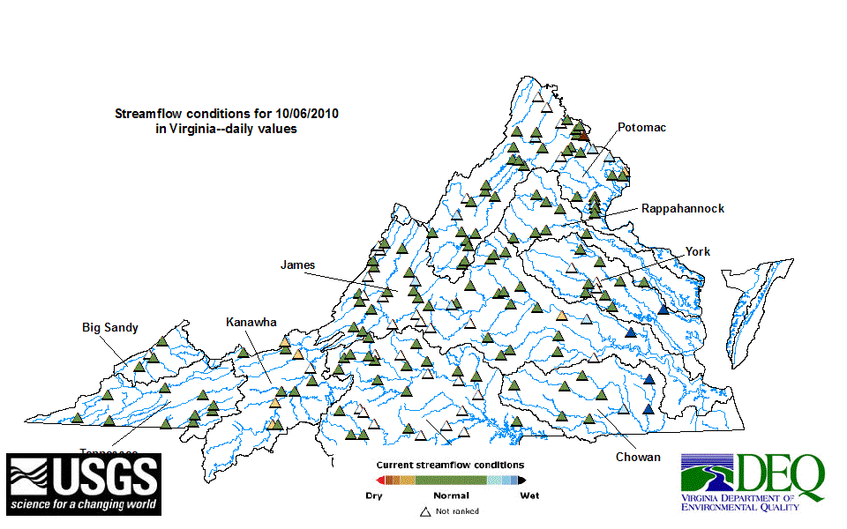

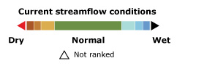
APPENDIX H
Drought Watch -- USGS State Information on Drought
Map of below normal daily average streamflow

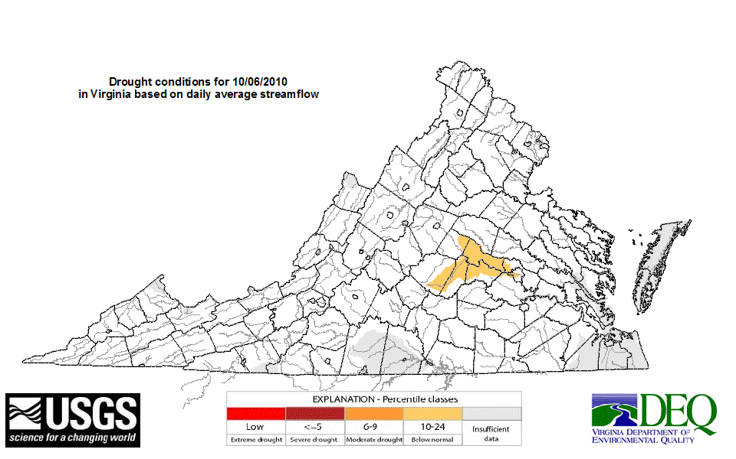
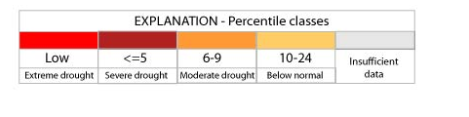
APPENDIX I
Virginia Climate Response Network
October 6, 2010



