North Fork Shenandoah River
Instream-Flow Study
Jennifer Krstolic, Donald Hayes, and Dr. Donald Orth

Instream Flow techniques were used in the North Fork Shenandoah River Basin to enhance understanding of low-flow conditions, to relate water availability to physical habitat needs of fish, and to provide science-based information for water management.
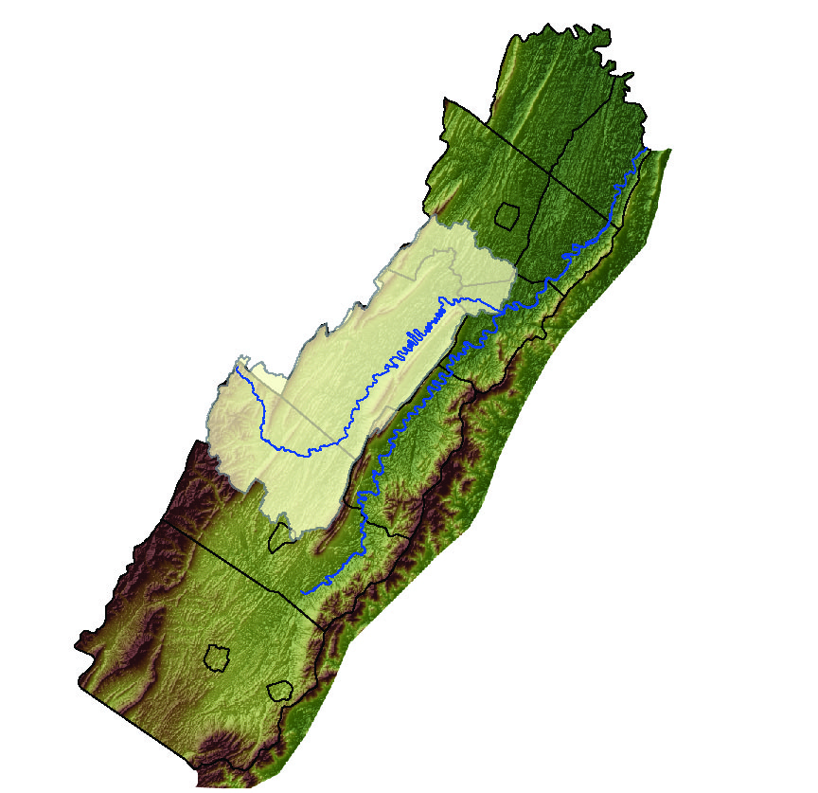
North Fork Basin study area

Physical-Habitat Mapping: Detailed mapping of physical habitat provided an accurate representation of river conditions for habitat-flow modeling. The river was classified by the relative amount of physical habitat present. The majority of the river is made up of runs (67%), followed by pools (19%), and riffles (14%).

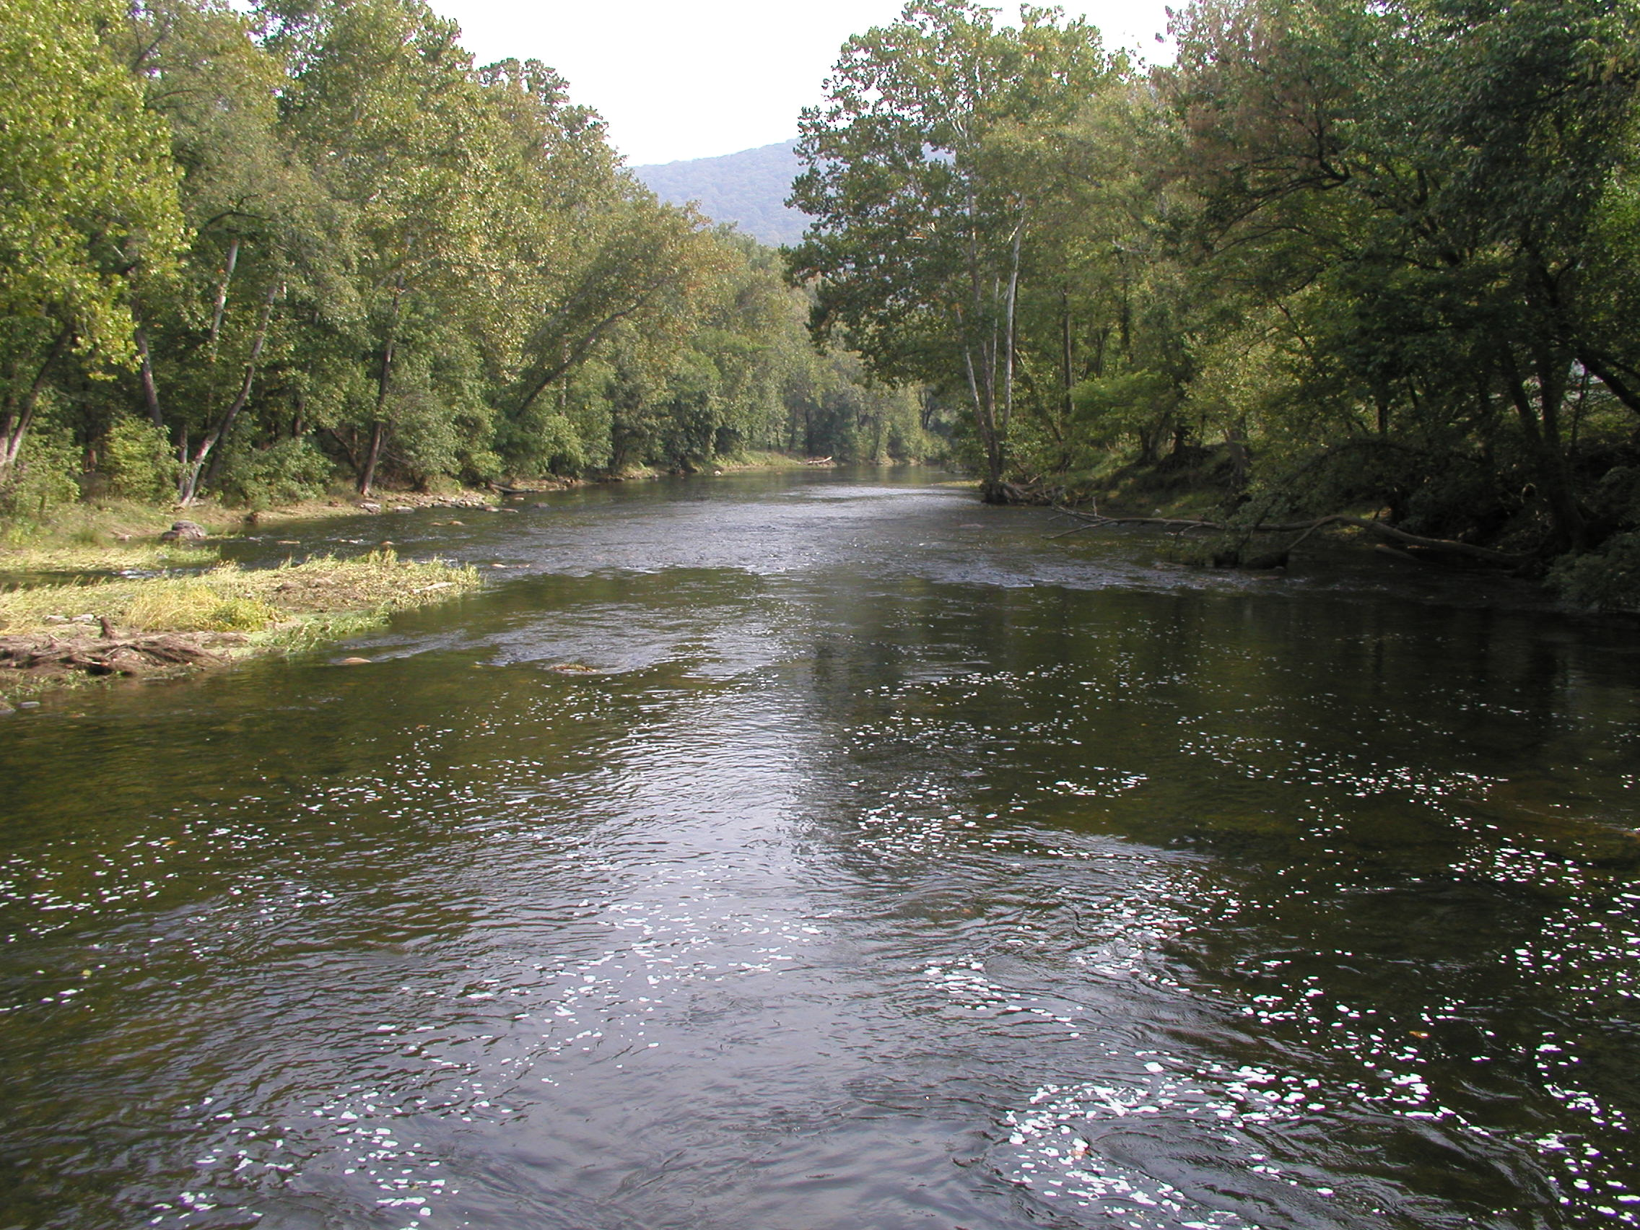

Fish Community Habitat Needs: Prior to this study, fish species composition was yet to be described in full; Dr. Donald Orth (VPI) and students studied the fish community, and grouped species into four guilds (groups of species using similar types of habitat). The depth, velocity, and substrate needs, or preferences, of each guild were combined to produce habitat-suitability curves. We now know how fish use habitat, but need more information about fish health, population numbers, and juvenile success.
Water-Quality Synoptic Survey: Diurnal (daily) fluctuations of dissolved-oxygen (DO) concentrations were monitored during low-flow conditions in July, 1999. DO fluctuated daily 5–10 mg/L above the daily minimum. DO concentrations were equal to or less than the State water-quality minimum of 4.0 mg/in the upstream portion of the river. pH values greater than the State water-quality maximum of 9.0 were found in the downstream portion of the river. Water-quality monitoring during normal flows, and investigation into the location of fractures, springs, and ground-water discharges to the river may help put these values into perspective. USGS Scientific Investigations Report-5153 available on-line http://water.usgs.gov/pubs/sir/2004/5153
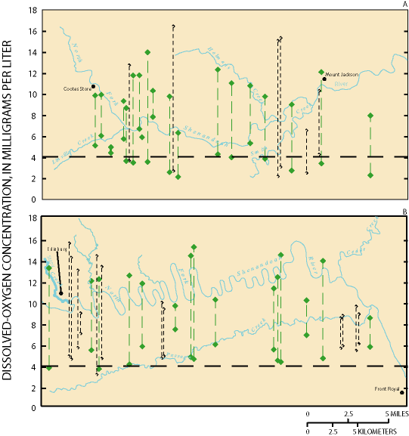
Dissolved-Oxygen concentrations

Reach-specific Hydraulic-data Collection: Stage and discharge were measured along transects representative of the physical habitat on the North Fork. Depth, velocity, and substrate were measured at 3-5 ft intervals for six study reaches during low, medium, and high flows. Reach-specific hydraulic measurements, physical habitat-mapping, and fish habitat-suitability curves are the substantive, scientific-information input to physical habitat simulation models (PHABSIM).

Modeling Results: PHABSIM provided habitat-availability curves for a wide range of flows for three sections of the North Fork (lower, middle, upper). The habitat-flow relations can be used to select maintenance flows for water-conservation during low-flow periods or as indicators of low-flow or stressful instream conditions.

Proposed Research:
South Fork Shenandoah River
Instream-Flow Study

The South Fork Shenandoah River, and its counterpart, the North Fork Shenandoah River, join to form the Shenandoah River, and drain an area that many in the State refer to simply as “The Valley”. With Shenandoah National Park to the East, and Massanutten Mountain to the West, the South Fork basin is an area with much beauty, and is a draw for outdoor enthusiasts, tourists, and people who want to take up residency “away from the city”. The South Fork basin shares a similar geology with the North Fork, in that it is underlain by karst, making the ground-water and surface-water highly connected.
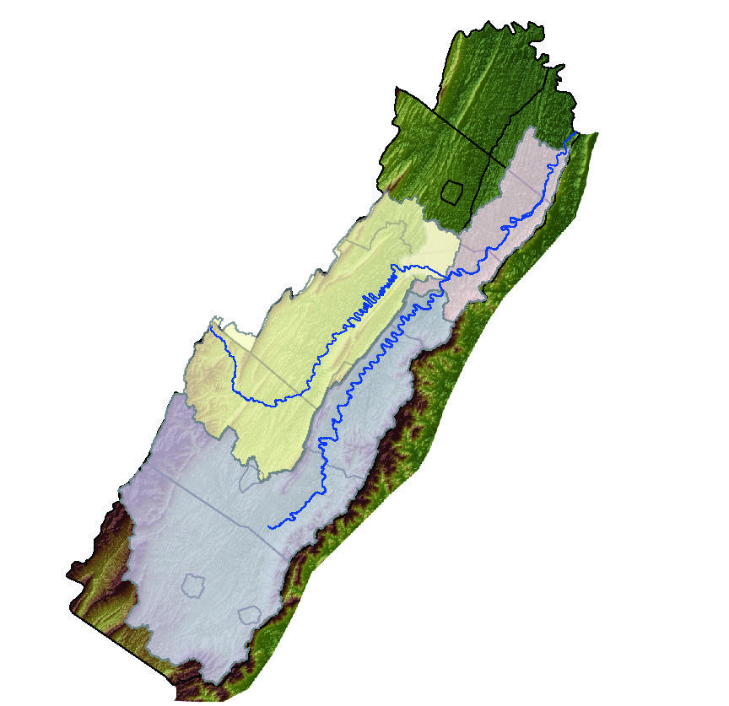
North Fork, South Fork, and Shenandoah Basins

South Fork Study Components:
The South Fork is a large river, at least two times the width of the North Fork, which will require more than double the effort toward field work as the North Fork study, with much research done by boat.

Physical-Habitat Mapping: Along the mainstem South Fork from Linnwood, Va. to Front Royal, Va. habitat mapping will provide the foundational information used to select hydraulic reaches and fish assessment sites. The geomorphology, channel slope, and the refuges present for the aquatic community will be examined during low-flow periods.

Fish Community Habitat Needs: The fish species assessment and South Fork-specific habitat-suitability curves need to be created. Fish habitat-suitability curves for the South Fork are essential to ensure the applicability of the modeling results. The size of the South Fork, will limit the study focus to the mainstem portion of the river.

Water-Quality Synoptic Survey: A low-flow study of diurnal water-quality conditions, as well as a comparison dataset measured during normal-flows will be useful to assess the relative stress on the aquatic community. In addition to the synoptic survey, water temperature and other water-quality parameters will be measured at the hydraulic-data reaches for use in modeling.

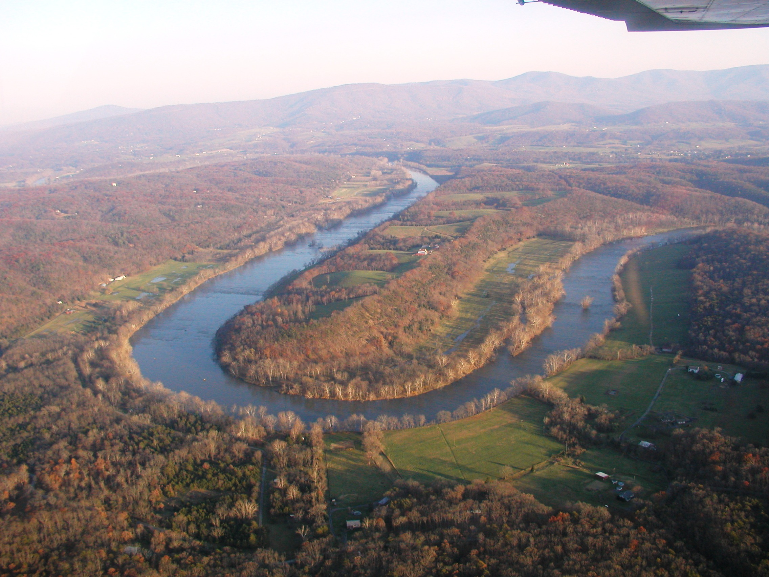
South Fork meander with Blue Ridge mountains in the background

Reach-specific Hydraulic-data Collection: Four or more reaches will be selected for hydraulic-data collection. Stage, discharge, depth, velocity, and substrate characteristics along transects representative of the physical habitat on the South Fork will be measured. Hydraulic-data is used by PHABSIM to link flow with habitat, and habitat to the historical record of the stream gaging stations.

Modeling Results: PHABSIM habitat-availability curves will be simulated for a wide range of flows representing three sections of the South Fork associated with stream gaging stations (01628500, 01629500, 01631000). With habitat-flow relations for both the South Fork and the North Fork, timing of water-conservation during low-flow periods can be managed for each river individually, and at a basin level. With science-based monitoring, data collection, and modeling results, for all basins, the Valley will have the tools to manage water-resources as a unit, and to prepare for the future.

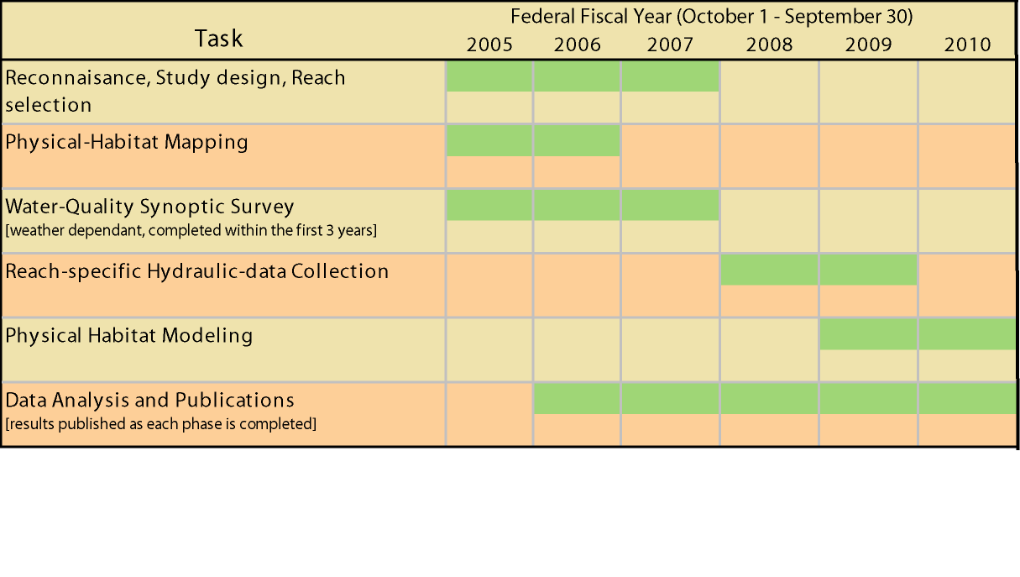
Proposed budget and timeline for South Fork Study

